**HOW TO CHANGE FY2024 VOUCHERS AND SC VOUCHERS TO FY2025**

If you have a FY2024 voucher or SC voucher (Accounting Date: 09/01/23 through 08/31/24) that needs to be changed to FY2025, you must take the following steps:

Note: The University will be changing to Chase as of September 1st. In order to reflect this change if you changed a local voucher to FY2025 you will also have to change the bank.

**Step 1**: **Go to the Invoice Information page on the voucher.**

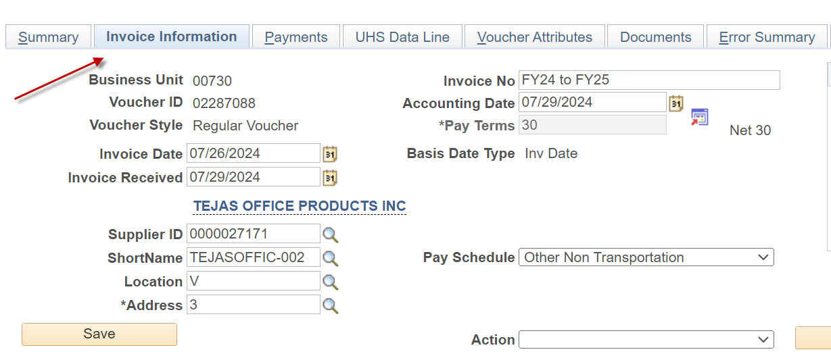

**Step 2: Do not change the Accounting Date to FY2025 yet.**

**Change the voucher gross amount and voucher lines to $0 and save the voucher. Then, re-budget check it with a FY2024 Accounting Date.**

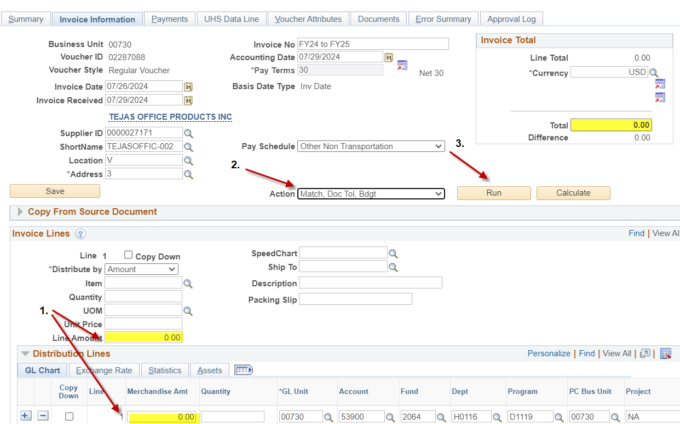

**Step 3: Change the Accounting Date and the Scheduled Due Date to FY2024 (09/01/24). Then save the voucher.**

On Invoice Information Tab: 

On Payments Tab: 

**Step 4: The system displays the following message:**

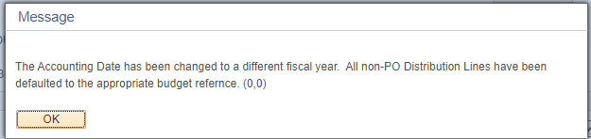

The message indicates the following:

Non-PO Voucher 🡪Budget Reference is automatically changed to BP2025.

PO Voucher 🡪Budget Reference is not changed because it is tied to the corresponding PO.

**Click on** **.**

**Step 5: Change bank to Chase for payments made with local funds. Go to the Payment tab under Payment Options change Bank from BOAH to JPMC.** 

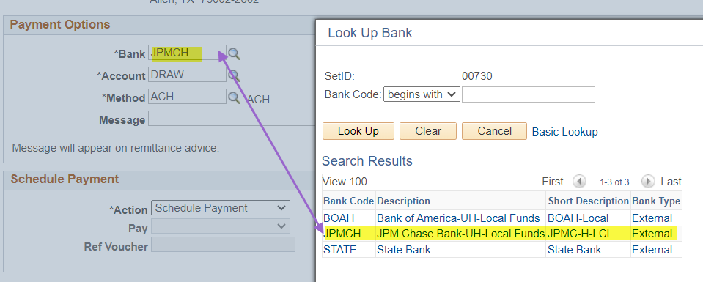

**Now you have a FY2025 voucher. You may enter the voucher gross and voucher line amounts and budget check the voucher.**

**Voucher Change Due Dates:**

|  |  |  |
| --- | --- | --- |
| Tuesday, August 27, 2024 | 8:00 AM | Departments can begin creating and submitting FY25 vouchers (Accounting Date and Scheduled Due Date equal to or after 09-01-24). However, users cannot create FY25 vouchers for prior-year PO's (BP2024 and earlier) on non-project cost centers until September 1, after the PO Carryforward process is completed. |
| Friday, August 30, 2023 | 5:00 PM | Deadline for departments to convert all unprocessed FY24 vouchers to FY25 by changing the Accounting Date to 09-01-24 and budget checking the voucher. FY24 vouchers that will not be used should be deleted. |