HOW TO CHANGE FY2023 VOUCHERS AND SC VOUCHERS TO FY2024

If you have a FY2023 voucher or SC voucher (Accounting Date: 09/01/22 through 08/31/23) that needs to be changed to FY2024, you must take the following steps:

Step 1: Go to the Invoice Information page on the voucher.

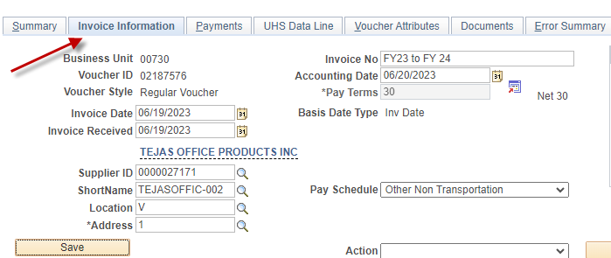

Step 2: Do not change the Accounting Date to FY2024 yet.
Change the voucher gross amount and voucher lines to $0 and save the voucher. Then, re-budget check it with a FY2023 Accounting Date.
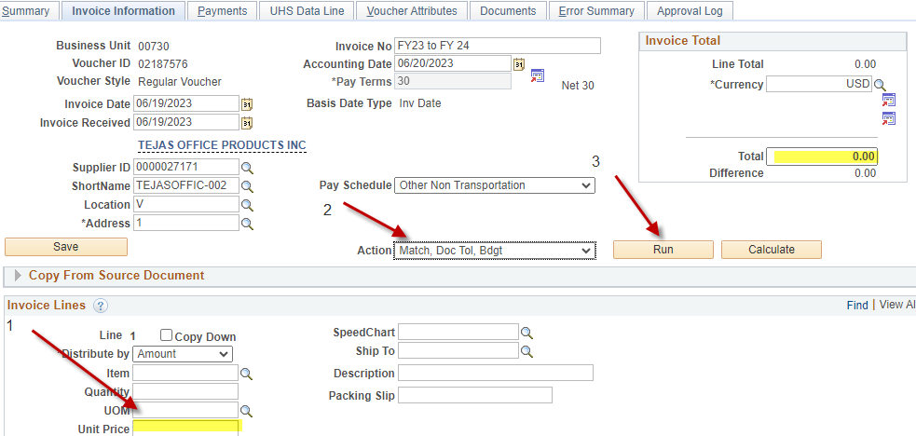

Step 3: Change the Accounting Date and the Scheduled Due Date to FY2024 (09/01/23). Then save the voucher.
On Invoice Information Tab:

On Payments Tab:

Step 4: The system displays the following message:

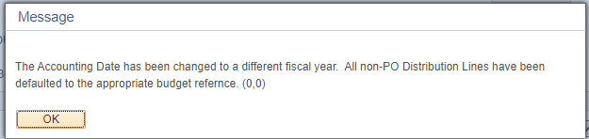

The message indicates the following:
Non-PO Voucher Budget Reference is automatically changed to BP2024.
PO Voucher Budget Reference is not changed because it is tied to the corresponding PO.

Click on .

Now you have a FY2024 voucher. You may enter the voucher gross and voucher line amounts and budget check the voucher.

Voucher Change Due Dates:

Friday, August 25, 2023 | 8:00 AM | Departments can begin creating and submitting FY24 vouchers (Accounting Date and Scheduled Due Date equal to or after 09-01-23). However, users cannot create FY24 vouchers for prior-year PO's (BP2023 and earlier) on non-project cost centers until September 1, after the PO Carryforward process is completed.
Wednesday, August 30, 2023 | 5:00 PM | Deadline for departments to convert all unprocessed FY23 vouchers to FY24 by changing the Accounting Date to 09-01-23 and budget checking the voucher. FY23 vouchers that will not be used should be deleted.

