Subscribing and Unsubscribing to the Finance ListServ

Subscribe to the Finance ListServ to receive e-mail reports and notices concerning the Financial database. Send an e-mail* to LISTSERV@LISTSERV.UH.EDU with the following command as the body of the message (leave the subject line blank): sub fast-financial "your name" (do not include quotes)

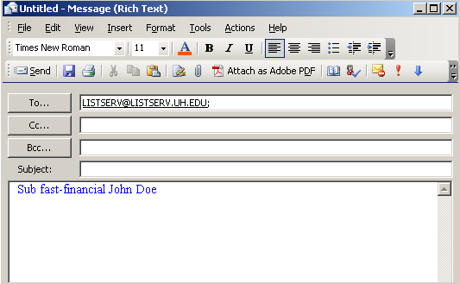

Unsubscribe to the Finance ListServ Send an e-mail* to LISTSERV@LISTSERV.UH.EDU with the following command as the body of the message (leave the subject line blank): SIGNOFF FAST-FINANCIAL

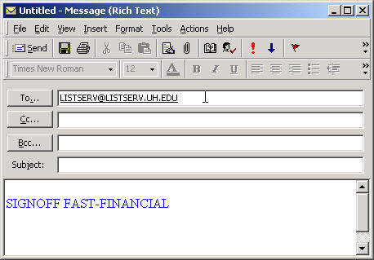

*Note: E-mail cannot contain any pictures or backgrounds. The ListServ will reject these e-mails.

