Step | Action | Documentation/Example
1. | Remote deposit scanners must be obtained through the University Treasurer’s Office. Contact Robbi Puryear, Treasurer, for information on requesting a scanner.  These scanners are used to scan checks for deposit electronically.  Checks are retained by the department and are not submitted for deposit pick up by the UH Police Department.  Journals are still required.
2. | Remote deposit scanners plug in to your desktop computer. An internet connection is required.  A picture of the scanner is on the right. | 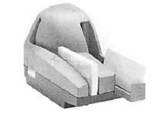
3. | Determine how many batches of checks you need to deposit. A batch of checks is the checks that go with one deposit ticket or one deposit ID if you are making a physical deposit.
4. | Complete Page 2 of the Cash Deposit Summary Form to list, calculate, and verify the total of the checks to be deposited. | Foreign checks, copies/faxes of checks, and remotely created checks cannot be scanned.
5. | Review the checks to be sure that they can be scanned. | No paper clips or staples  Checks should all be straight (no bent pages)  Bottom and leading edge of checks should be aligned and facing in the same direction
6. | Log in to CashPro Online  Treasury will request CashPro access for your users when you obtain a scanner. | cashproonline.bankofamerica.com/
7. | In CashPro Online, navigate to the Remote Deposit Screen (Receipts > Remote Deposit) and select “Create New Deposit”. | 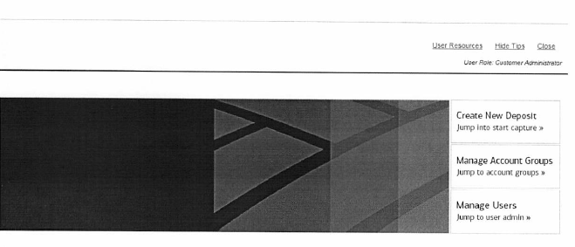
8. | IN the Remote Deposit screen, select  Account Group – your area (only Account Groups in your area will be shown)  Account Number – for your deposit ticket  Deposit Type = Simple  Clearing Channel = Image | You MUST select the correct account group and account number for your deposit ticket(s).
9. | Enter the number of items to be deposited (total number of checks) plus one for the deposit ticket. This is not required by the bank, but is required by UH. | The maximum number of items per transaction is 499. However, Treasury recommends only scanning 25 checks at a time. If there is a problem scanning one of the checks, it will be easier to resolve with smaller batches of checks. Also, if you have checks of different sizes, you might want to do a separate scan for short checks and long checks.  There is no limit on the number of transactions that can be performed.
10. | Enter the total deposit amount for this Account Number.  You must enter decimals or the system will create them out of your last two digits. | The maximum declared amount cannot exceed $99,999,999.99
11. | Place your checks in the Scanner entry tray with the front of the checks facing out. The maximum number of items to place in the tray is 499. If you have more checks you must do them in two separate deposits. However, Treasury recommends doing smaller batches of checks in case there is a problem with scanning one of the checks. Also, it is suggested to do a separate scan for short checks and long checks.
12. | Slide the checks up to the line mark in the scanner.  Do not push or insert items past the line.
13. | Click “Start Capture” on the CashPro screen and items will begin to scan.  Remote deposit will capture each item and populate a count and an amount, which is the total number of checks scanned and the total dollar amount of checks scanned. This will show in the Deposit Item List screen.  The scanner will print on the back of each check. These checks do not need to be stamped “For Deposit Only” or otherwise endorsed, since the scanner endorses the check.
14. | If the deposit does not balance, you will need to look through the images on the screen.  If the image was not scanned properly by the scanner, a yellow triangle with an exclamation point in the middle will appear on the check, or a red triangle will appear on the check.  Click on that particular check, and the program will ask you to key in the amount of the check and the routing number. Once this is complete, you should see a green deposit light on the CashPro screen.
15. | Once the deposit is transmitted and balanced, the Complete button will turn green on the CashPro screen.  Click “Complete”.  Then click “OK” to transmit the deposit.
16. | In CashPro, go to the Remote Deposit Reports tab.  Request Report “Summary of Deposits by Account Report”  Enter the date range, account group and your user ID (so that it only selects deposits that you made) and then select “Create Report”.  This report will list all deposits during that date range for the user and account selected. | 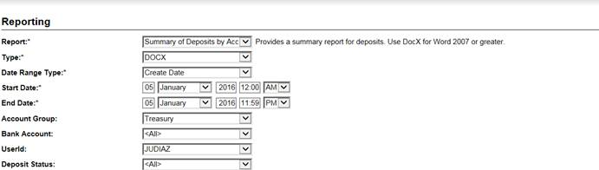
17. | Retain the “Summary of Deposits By Account Report” and completed page 2 of the Cash Deposit Summary Form as support for the journal entry. This report is your deposit ticket for remote deposits. If there is more than one deposit listed for the user/day, highlight the deposit being recorded with the journal.  Do not include the copies of check images with your deposit journal. | 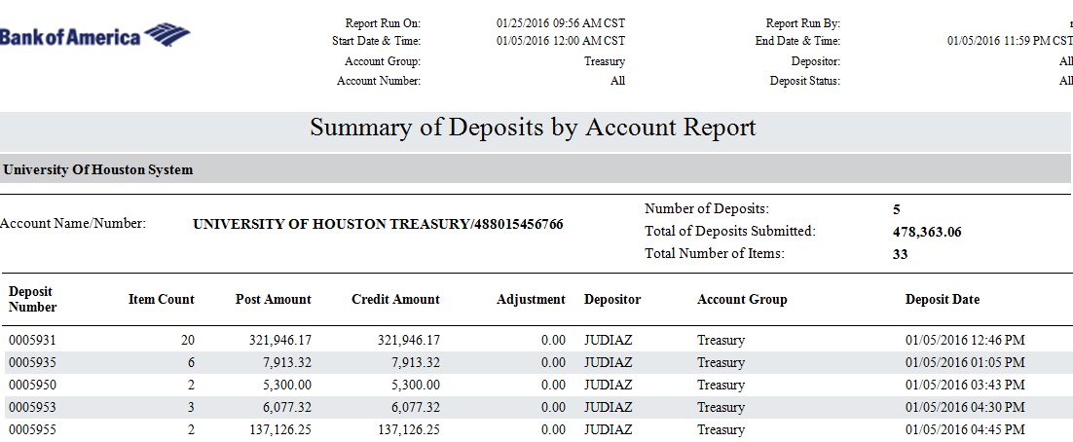
18. | Prepare your cash/check deposit using standard deposit procedures for checks and cash to be presented for deposit.  Record each remote deposit transaction on a separate GL Journal Line.  It is fine to include these with other cash, check, or credit card deposits. However, the Journal Path will depend on whether or not there is a physical deposit.  - Deposit to Account 10510, Fund BANK  - Do not combine with other cash, check, ACH, or credit card BANK lines. Separate bank lines for other sections of the deposit are okay.  - BANK Journal Line Description will read RCD, XXXX (last four digits of the Bank Account Number (from your Summary of Deposits by Account Report), the MM.DD.YYYY (the month, day, and year of the processing), and your department ID.  - Line amount must equal total amount in Summary of Deposits by Account Report from Bank of America.  Journal Support  See panel to right. requirements apply, including a signed Cash Deposit Form with the Check section completed. | Do NOT enter deposit bag number in Journal Header Reference if a deposit bag is not used. Only use a deposit bag if deposit includes cash that is picked up by UHPD.  Example of BANK Journal Line Description:  RCD, 6766, 04.15.2021, H0156  RCD = stands for Remote Cash Deposit  6766 = Last four digits of bank account from Summary of Deposits by Account Report  04.15.2021 = date checks were scanned  H0156 = Dept ID of department making the deposit  Journal Support to INCLUDE:  - Cash Deposit Summary Form (signed by two people)  - Summary of Deposits by Account Report (without copies of checks) with the deposit being recorded highlighted.  - Cash register/sales system report or receipts, if applicable  Journal Support NOT to Include:  - Handwritten Deposit Ticket  - Copies of checks
19. | Checks must be retained, in a secure location (same as cash) for 14 business days.  After 14 business days checks must be shredded. Shredding must be done in a cross-cut shredder. | Departments that do not have a cross cut shredder can send their canceled checks to the Treasurer’s Office. If the department write’s void on the checks and cuts out the signature, the checks can be sent by interoffice mail. Otherwise, the checks must be delivered by the UH Police Department.
20. | If Remote Deposit items are returned by the bank, notification will be sent to the Cashier’s Office and funds will be withdrawn from the bank automatically. | Within 48 hours of the receipt of notification of a return, the Cashier’s Office will prepare a journal to reverse the deposit. Journals will be processed against the standard NSF check cost centers provided by all campus departments using remote deposit scanners. The department will receive notification of the journal and information regarding the returned check
21. | Departments using remote deposit scanners must include the scanners in their cash handling procedures. | - Secure storage and retention of checks  - Destruction of checks  - Retention and destruction of original checks and copies of checks (if any are made) as well as check images attached to Summary of Depsit By Account reports  - Deposit journals  - Employee training
22. | If you notice that you selected the incorrect deposit account for your deposit via CashPro, please email Bank Reconciliations to notify them of the account you selected AND the account you intended to select.

