How to Use State Contracted Rental Car Vendors

- Travelers are strongly encouraged to book a rental car from state-contracted vendors because the rate is fixed, and LDW (liability and loss/damage waiver) insurance is included in the base rate.
- Per MAPP 04.02.01B, if a non-contracted rental car vendor is used, the traveler should purchase liability insurance unless covered by their own car insurance, and the collision damage waiver for non-contracted rental cars.
- The university is contracted with Enterprise, Avis, and Hertz. Website information and directions on how to book with each are noted below:
Enterprise
https://www.enterprise.com/
1. Go to the Enterprise website, select pick up & return location and date, enter the Corporate Account Number (please contact the AP Travel Group for this information), and then click “Browse Vehicles.”
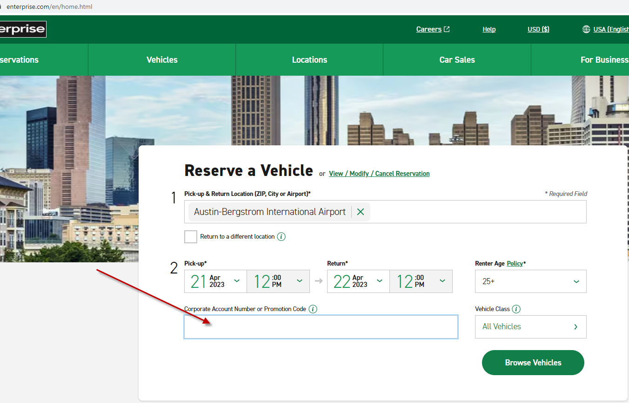
2. Enter the PIN. (Please contact AP Travel Group for this information.)
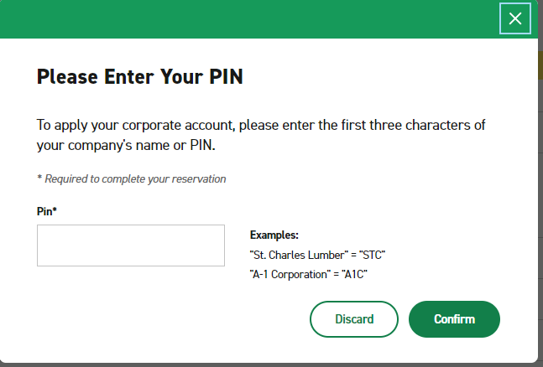
3. Select the car. (Please make sure you are following UH policy.)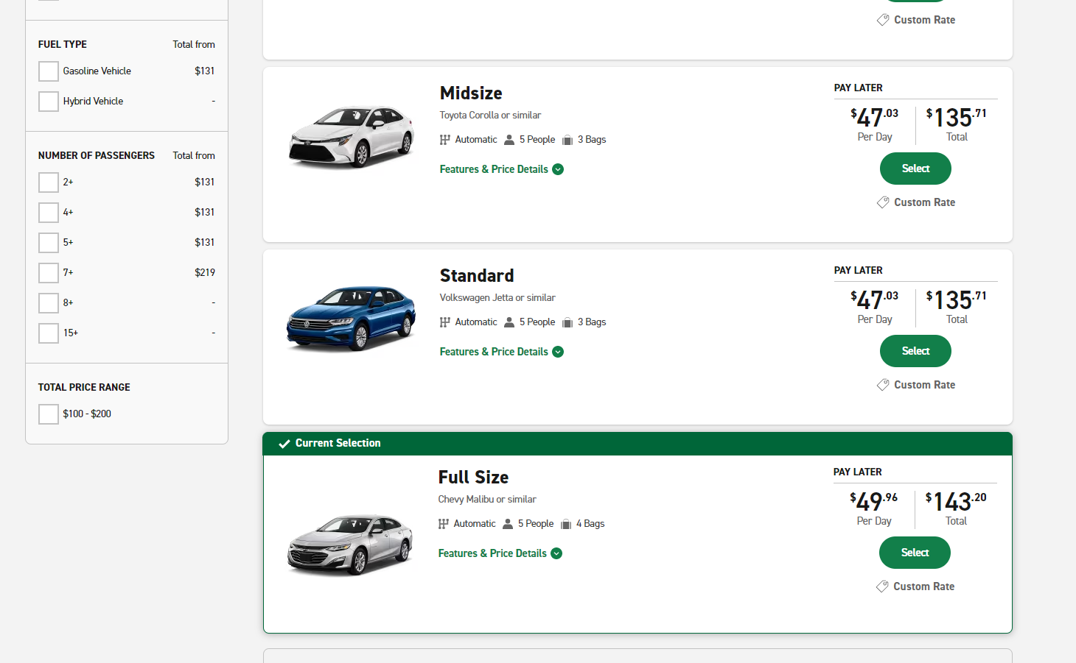

4. DO NOT select any equipment on this page. Click “Continue to Review.”
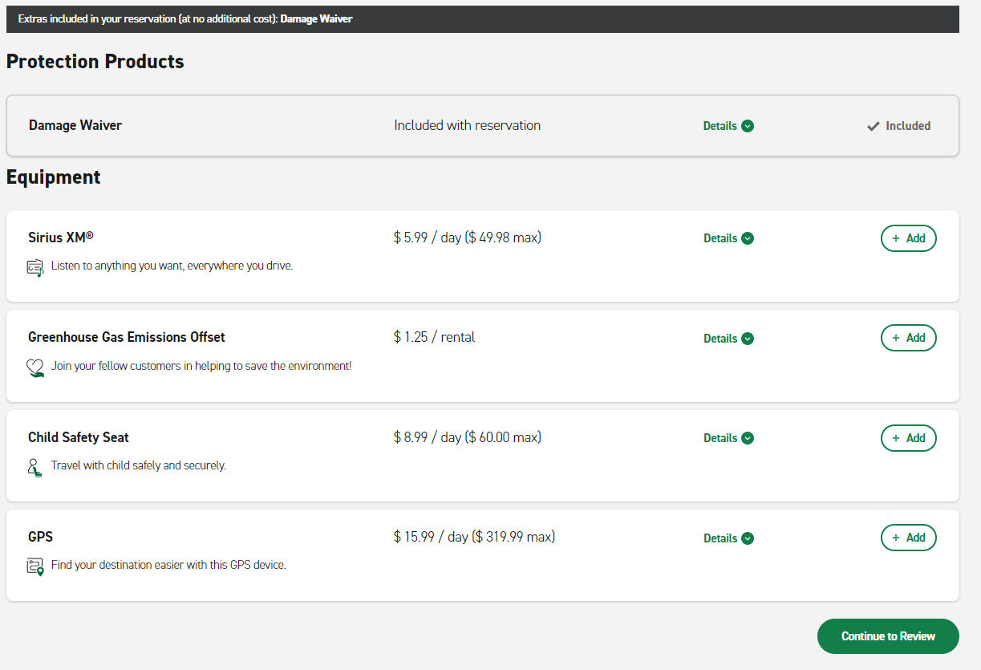
5. Enter contact details as required.
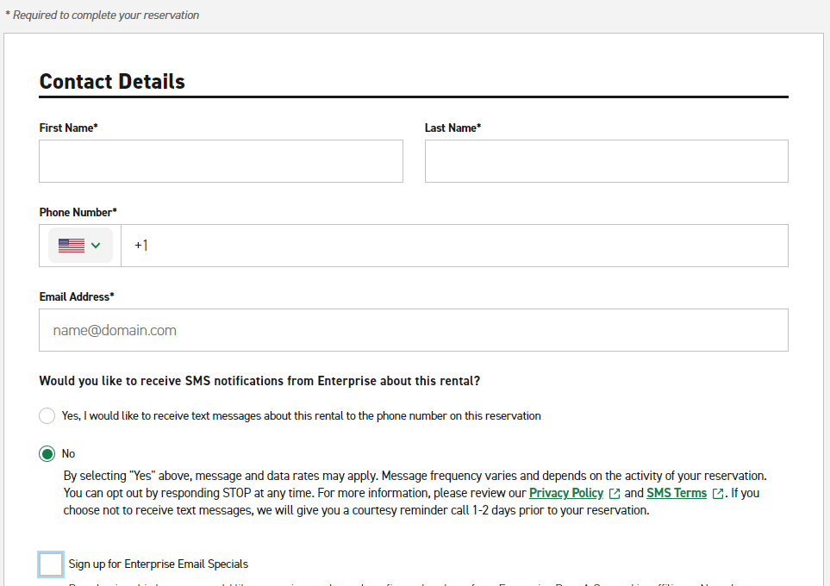
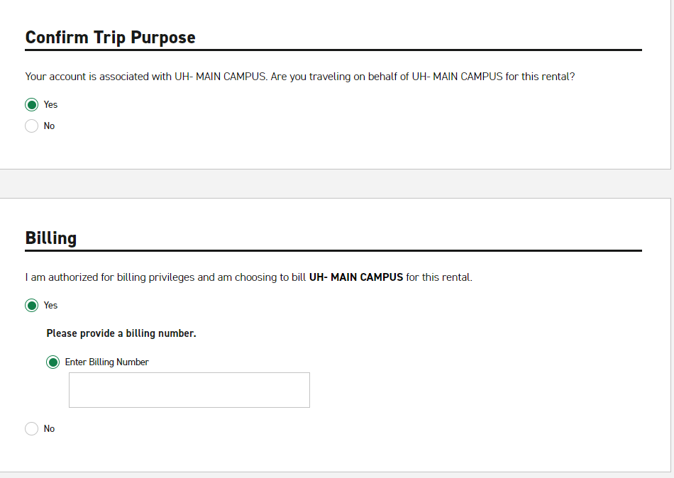
For “Billing,” you can choose either “Yes” or “No.” If you select “Yes,” please contact AP Travel Group to obtain the Billing Number. The invoice will be sent to AP Travel Group and forwarded to the department for payment; If you select “No,” you need to make payment when the vehicle is picked up;
After reviewing all the information, click “Reserve Now.”
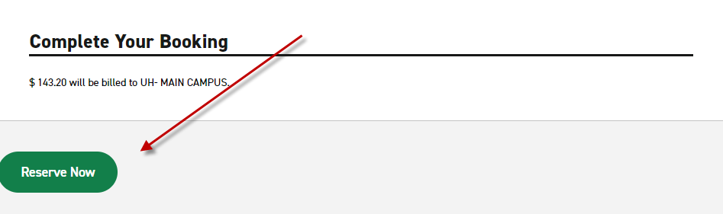
Avis
https://www.avis.com/
- Go to the Avis website, click “Discount Codes,” enter Contract Rate Code on the AWD# box (please contact AP Travel Group for this information), enter the pick-up and drop-off time and location, then “Select My Car.”
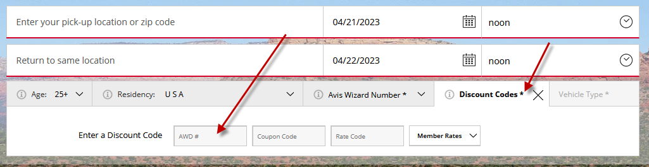
- Select the car. (Please make sure you are following UH policy.)
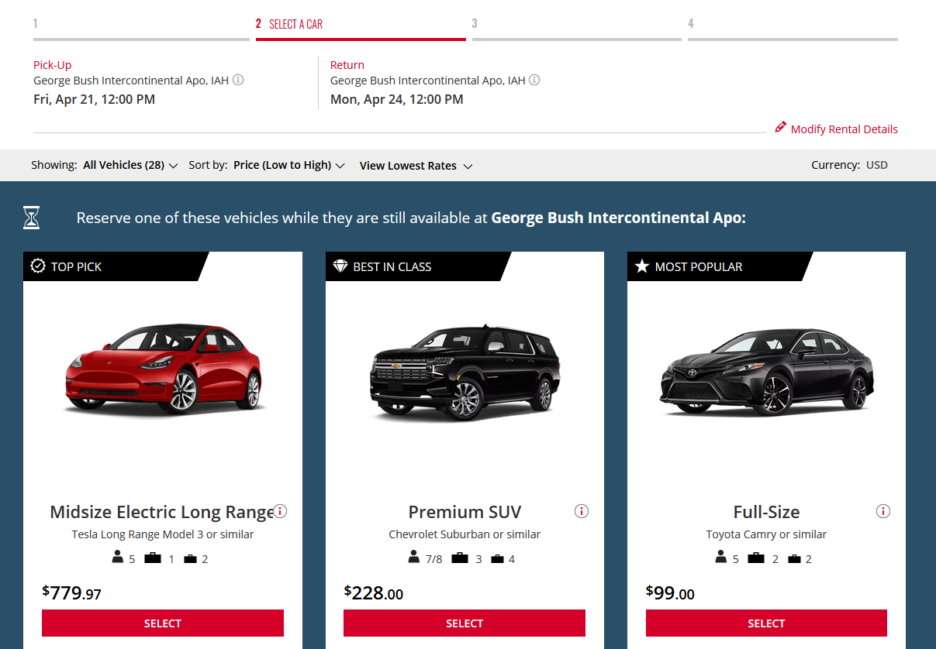
- Skip “Protections & Coverages,” “ Equipment,” and “Services,” and click “Proceed to Checkout.”
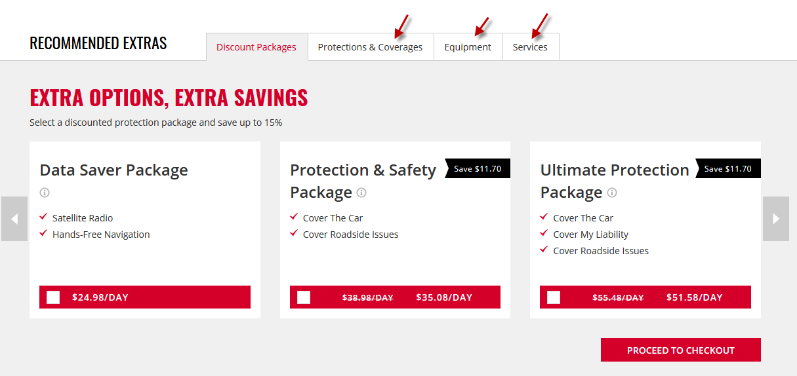
- Enter traveler’s information and “Reserve.”
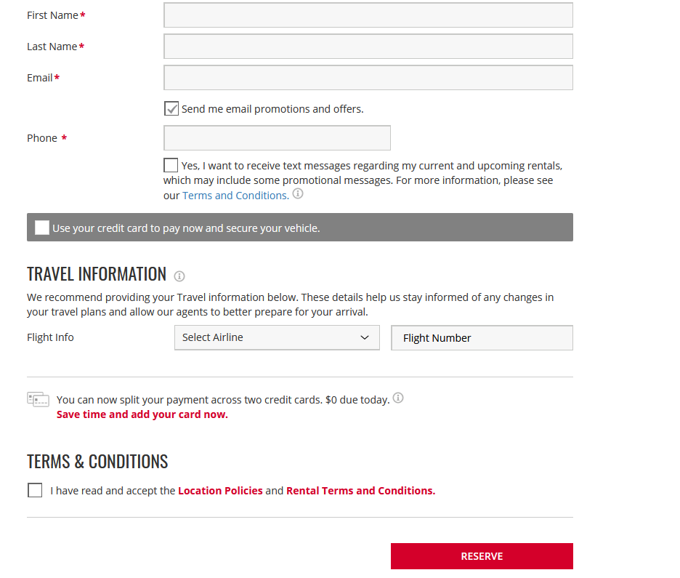

Hertz
https://www.hertz.com/
Go to the Hertz website, click “ Add a discount code.”
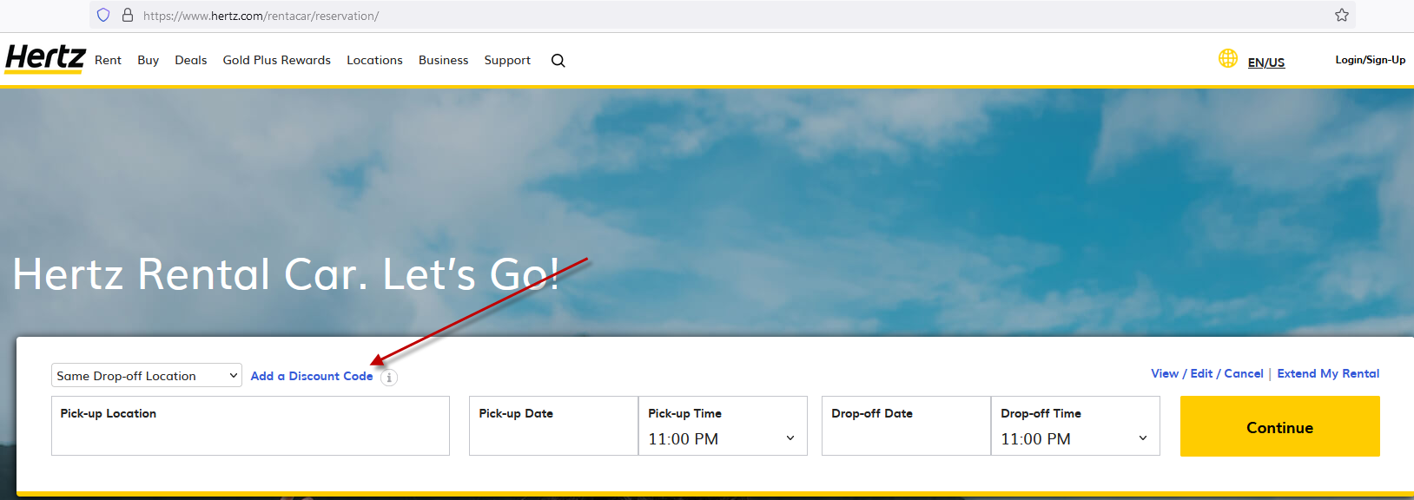

- Enter the verification code in “Discount. CDP/Club Code:”( Please contact AP Travel Group for this information.) Select business under “I am booking this trip for business” and Yes, under “Quote me the program my company has negotiated .” Then click “Apply.”
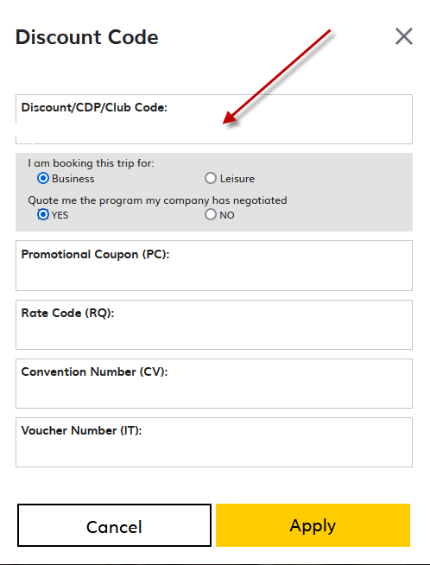

- Select the pick-up location and time and Drop-off location and time and click “Continue.”

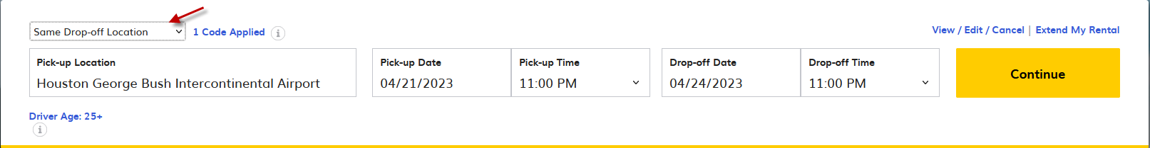
- Select the car. (Please make sure you are following UH policy.)
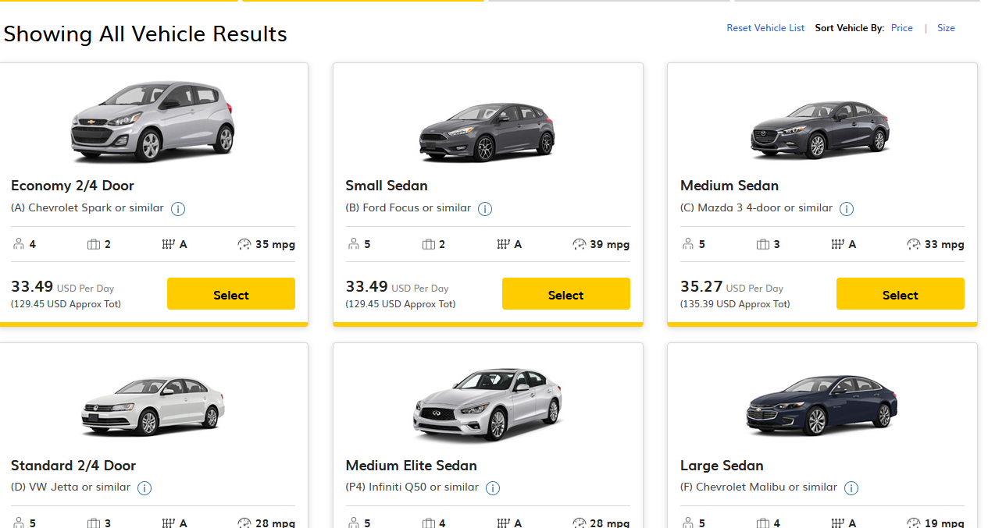

- DO NOT select any equipment on this page ( LDW is pre-selected). Click “Continue.”
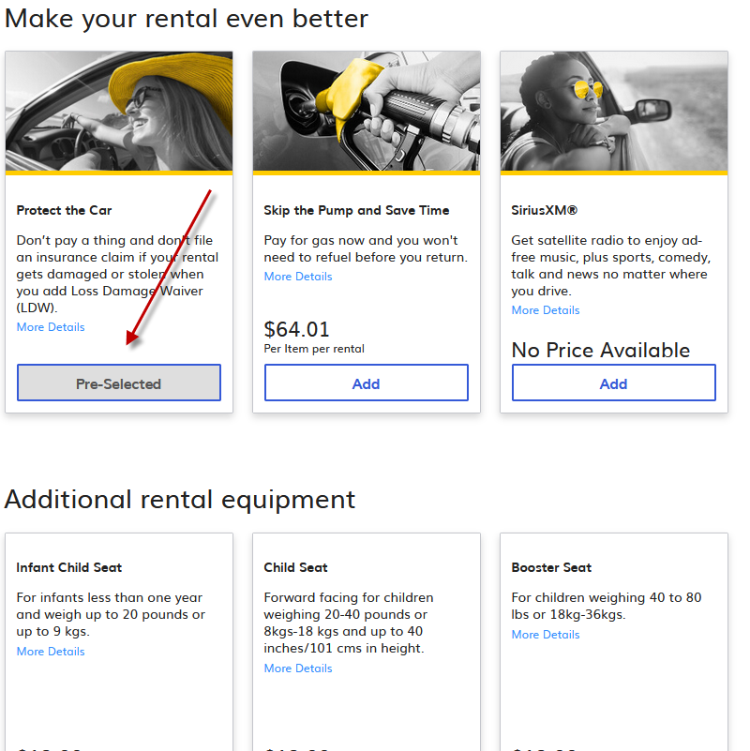
- Enter Driver information and then “Submit.”
