Step 1: In your Concur main page, click on “Requests”. It will list your Travel Requests. Click on the “Expense” hyperlink for the Travel Request for which you will be creating an Expense Report.
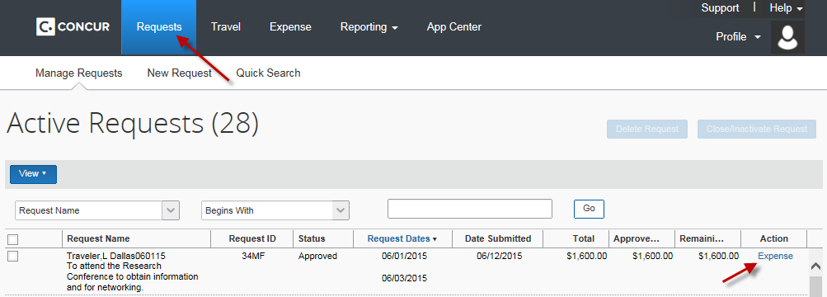
Step 2: The system will take you to the expense report header. Select an answer for the following questions and click on “Next”.
- Traveler is BOTH a non-employee and a foreign national
- All receipts submitted within 60 days after trip or moving expense
- Is this for Department Travel Card charges? -> if yes, you must complete the next two fields.
The information for the remaining fields is automatically copied from the corresponding Travel Request.
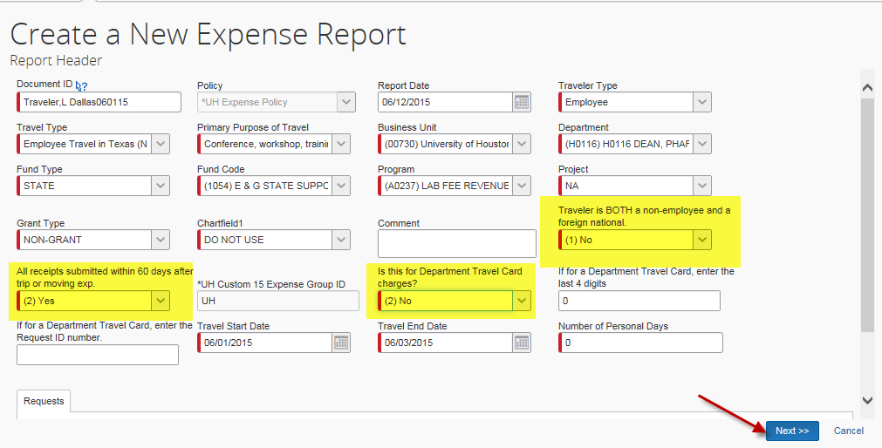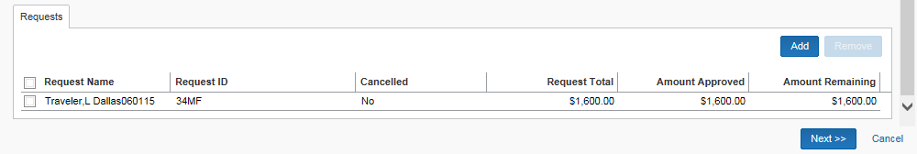
Step 3: The system will display the “Travel Allowances for Receipt” screen.
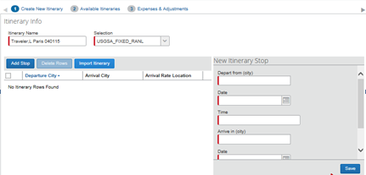
For state fund travel, enter the required information and save. The information is used to compare the actual meals and lodging expenses to the GSA federal per diem rates.
You must complete itinerary for each leg of the trip (travel to destination and return) and save.
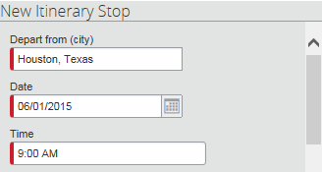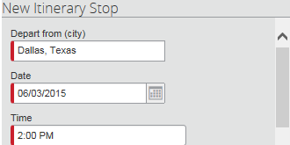
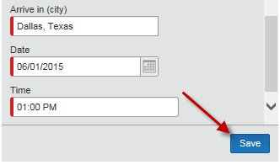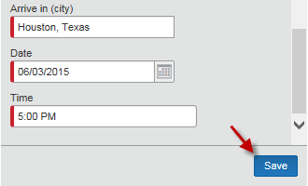
Click on “Next”.
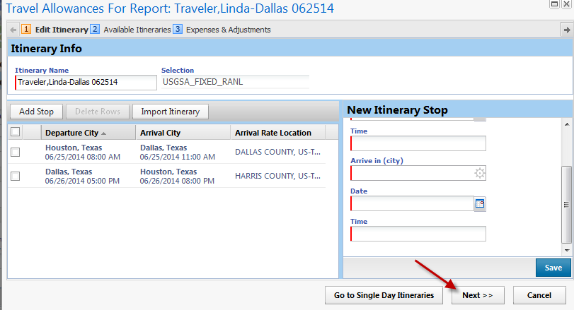
The system will display the summary of your schedule. Click on “Next”.
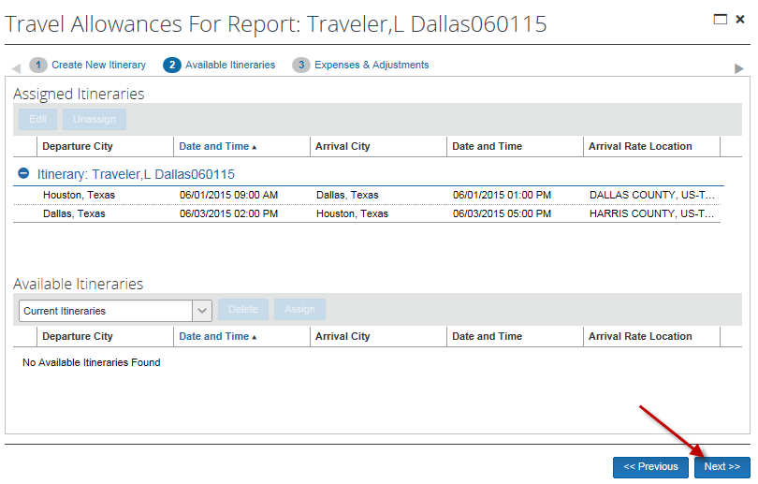
If the traveler did not pay for meals (e.g., meals provided by conference/seminar), indicate such in this screen by placing a check mark for particular meals. Then click on “Create Expense”.
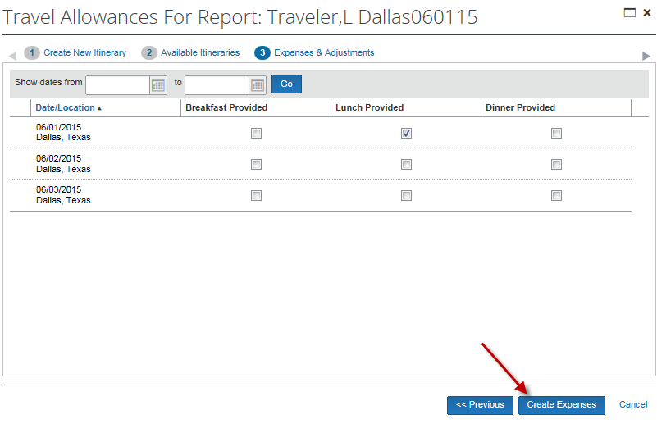

Step 4: Now you are ready to record each expense.
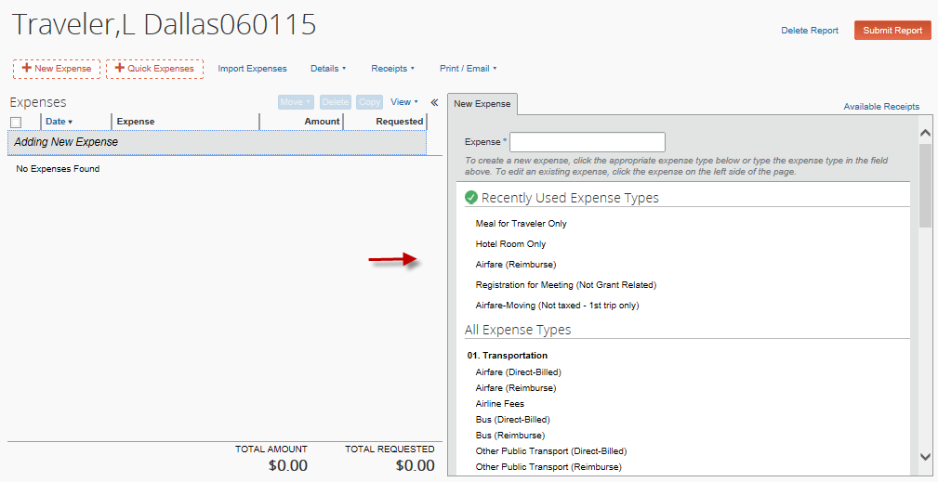
The right panel lists expense types. Click on the applicable expense type and enter the required information for each expense.

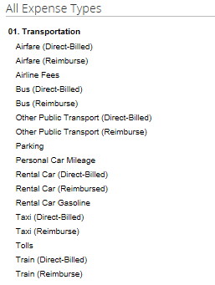
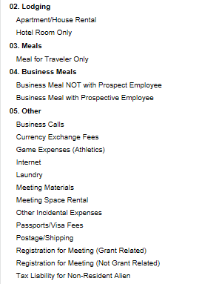
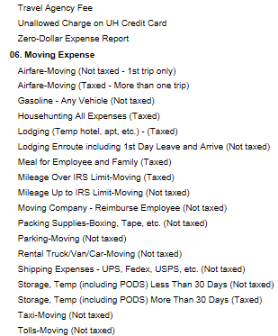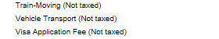
Example: Airfare (Reimburse)
Click on Airfre (Reimburse).

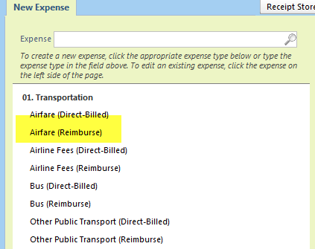
Complete the required information and click on “Save”.
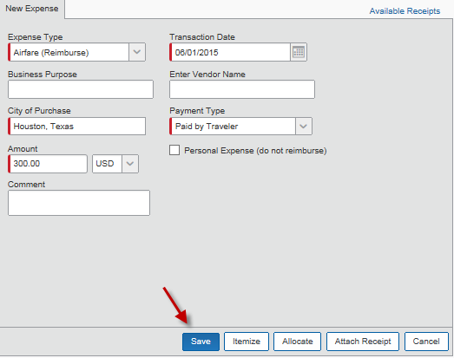

Example: Hotel Room Only
Click on Hotel Room Only.
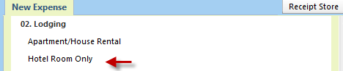

Complete the required information, place a checkmark for “Travel Allowance” and click “Itemize”.
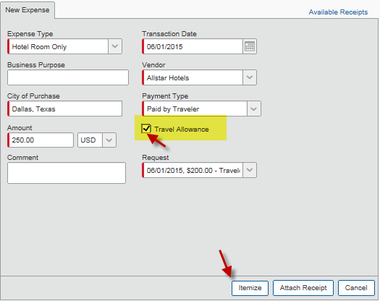
Complete the itimization information and indicate room rate and tax separately. Click on “Save Itemizations”.
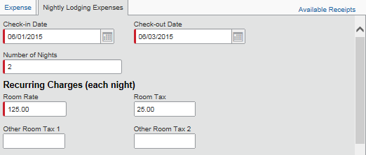
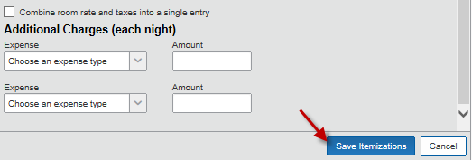

Example: Meal for Traveler Only
Click on Meal for Traveler Only.
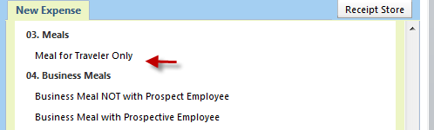

Enter the required information for each day and place a checkmark for “Travel Allowance”. Alcohol is not allowed on state funds, so there is no need itemize the meal. Click on “Save”.
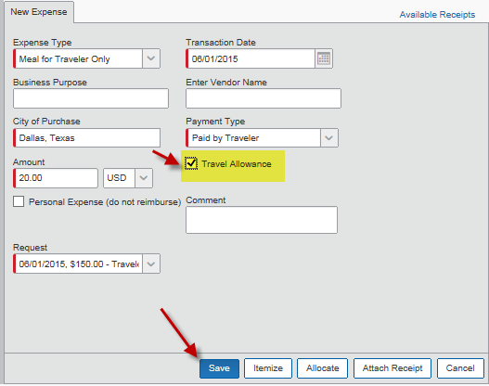

Step 5: Review the comparison of the actual meals/lodging expenses and the GSA per diem rate.

The “Amount” column indicates actual expenses. The “Requested” column indicates the GSA per diem amount allowed for payments/reimbursements.

For the example below, the traveler’s actual meal/lodging expense total was $400 ($700-300 airfare), but he/she is only reimbused for $391 ($691-300 airfare).
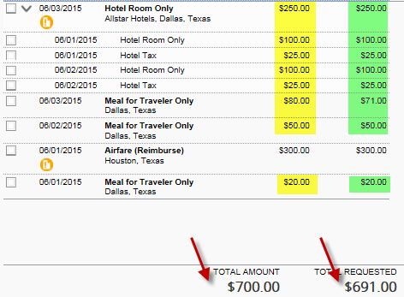

Step 6: Attach a receipt, if required. Concur will tell you if a receipt is required for each expense type.

Go to “Receipts” and select “Attach Receipt Images”.
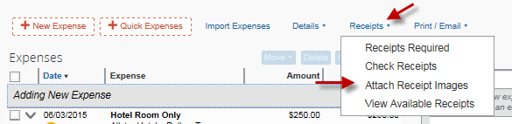

Select an applicable expense. Then clik on “Browse”.
.
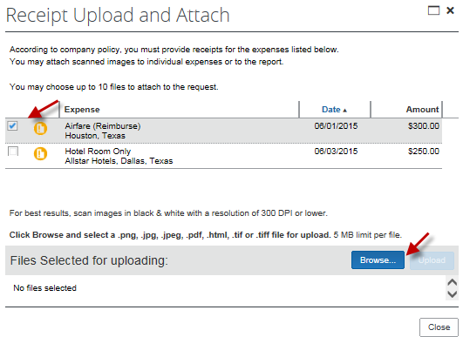

Select an appropriate file and “Upload”.

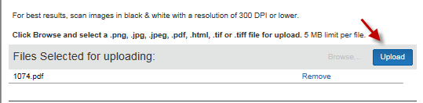

Note: If you want to upload documents at the Expense Report Header level (not for individual expenses), then do not select expense. Just click on “Browse”.

Examples of documents you would upload to the Expense Report Header include:
- Post-trip travel report
- Taxable Payments or Reimbusements to Employees form, if applicable
- Fly America Act Waiver Checklist if it was necessary to use a non-US carrier for international travel on federal funds (should not apply to state fund travel, unless federal pass-through funds)
- Moving expense worksheet (not allowed on state funds)

Step 7: Click on “Submit Report” to submit the Expense Report into workflow.

