Travel Advance requires the approval from the appropriate Certifying Signatory. In the Concur system, Travel Advance is indicated as “Cash Advance”.
Travel Advance is attached to Travel Request (TR). The Certifying Signatory must approve TR first. For instructions on how to approve TR, see Concur Instruction “Approving a Travel Request”. After TR is approved by all required approvers, the appropriate College/Division Administrator will see the travel advance request in his/her approval queue. These instructions show how the College/Division Administrator approves a Travel Advance.
Step 1: In the header menu, click on “Required Approvals”. Concur will display the documents that require your approval. Click on “Cash Advances” and select a particular Cash Advance to approve.

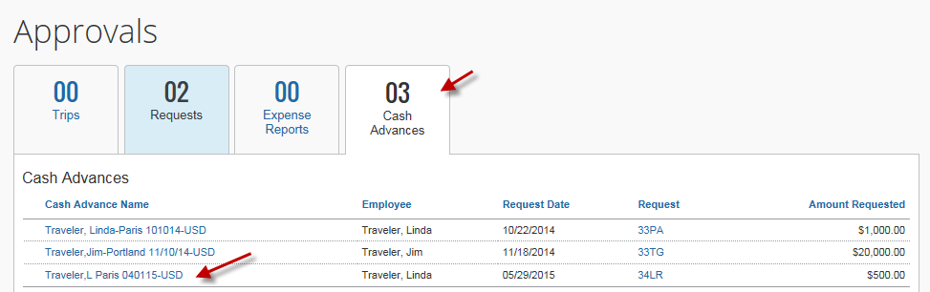
OR
You can simply select a particular Travel Request under the “My Tasks” section.
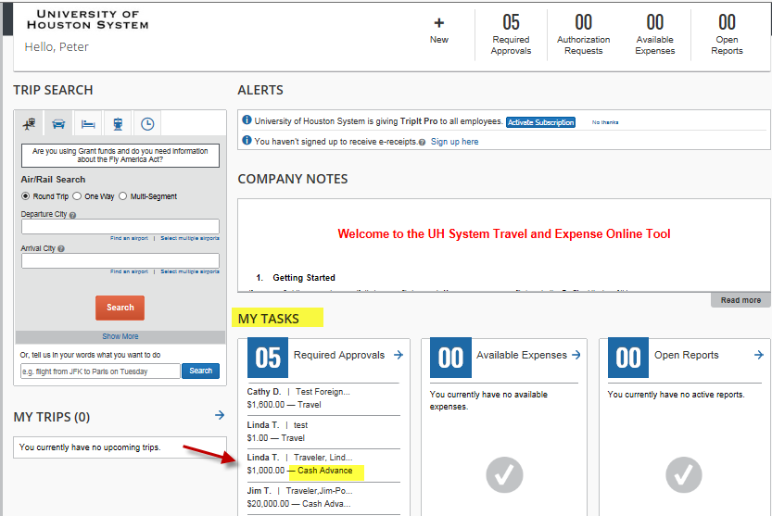
Step 2: Verify the information.
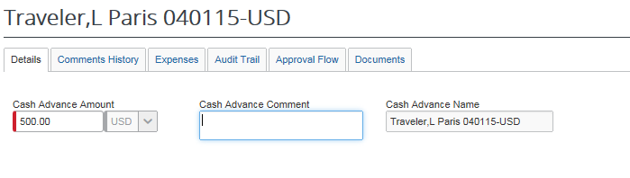

Step 3: To view the corresponding Travel Request, close out (X) the Cash Advance Details panel. The system will display “Cash Advance Approval List”. Click on the request number.
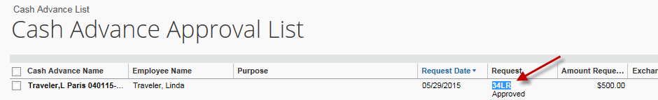
The system will display TR summary in a report format (UH Request Printed Report).

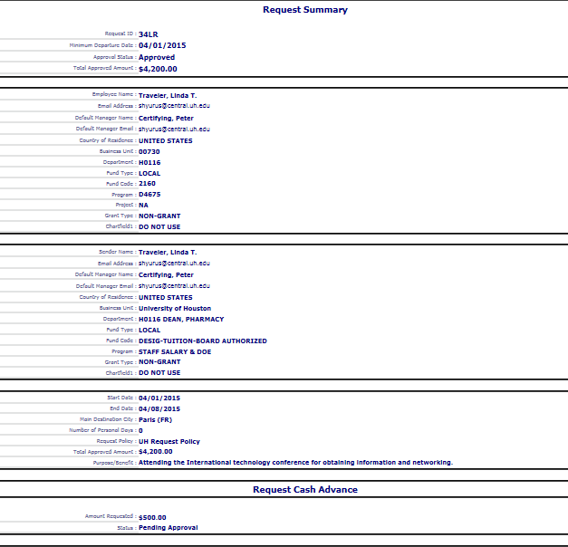
Step 4: Click on “Approve” or “Send Back to Employee”. 

