Reallocating P/T Card Expense from Local to State Cost Center

- Before you create a reallocation voucher, you would need to find out if the P/T Card merchant is setup as a vendor in the finance system. You can verify the vendor by its Tax ID or name/address.

Verify by Tax ID
To get the merchant’s Tax ID, log into GCMS, and go to the Transaction Summary Page (under Finance tab). Enter the date range or billing cycle to look for the purchase that requires a reallocation.
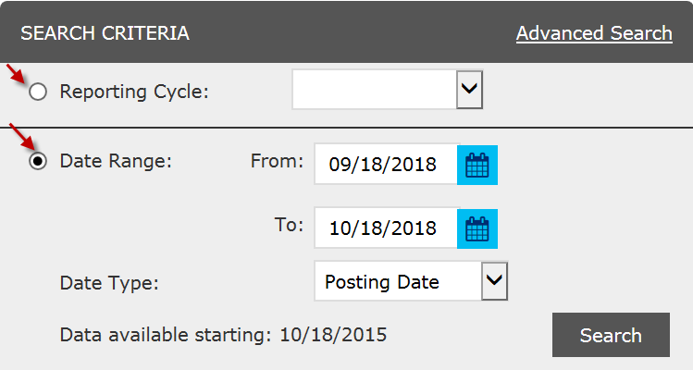

Click on the merchant name.
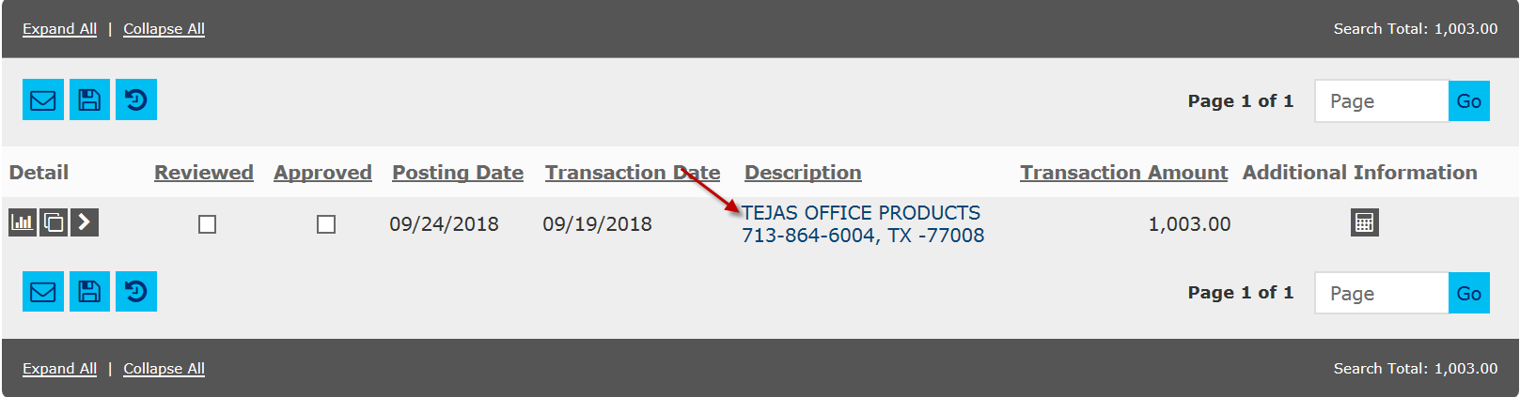

Obtain the Merchant Tax ID.
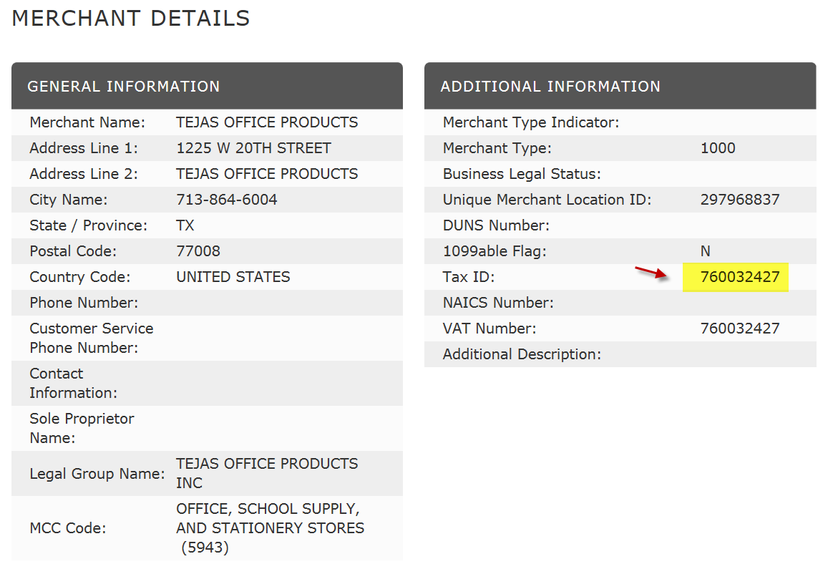

Run a query (UHS_AP_SEARCH_FOR_VENDOR). Enter the merchant’s Tax ID in the FID/SSN field with %%, and enter % in the other fields. Then, click on the View Results button to see if the merchant is setup as a vendor.

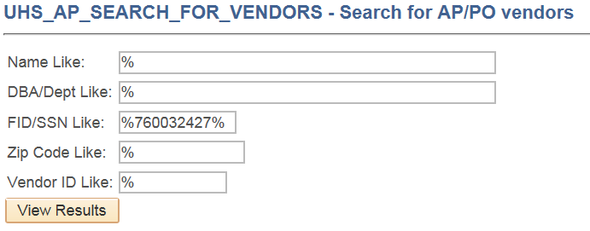

Verify by Name and Address
You can go to the Vendor page, and enter a part of the vendor name into the Short vendor Name to see if the vendor is listed. You can also verify the address.
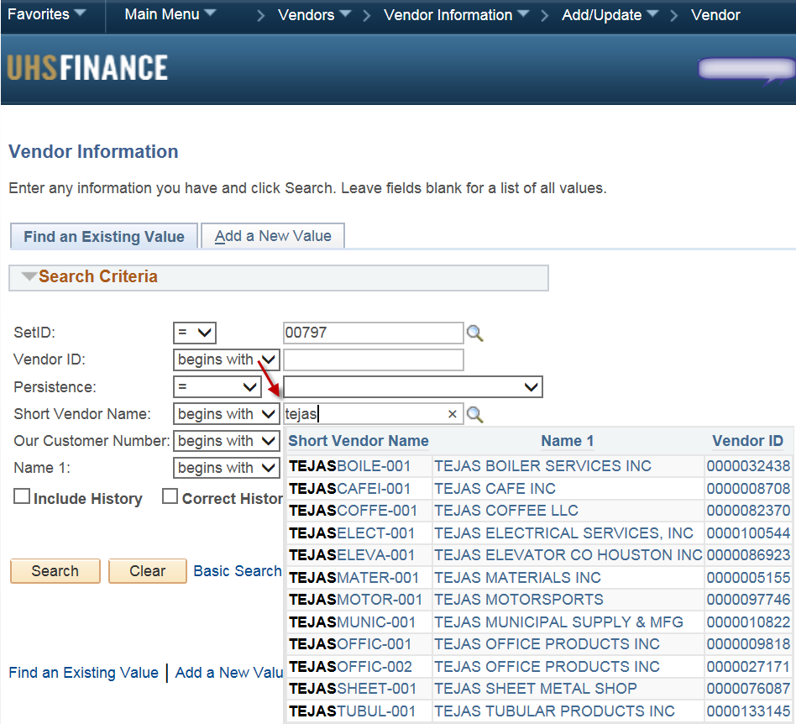

Or you can run a query (UHS_AP_SEARCH_FOR_VENDOR), enter a part of the vendor name with %, and see if the vendor is listed. You can also verify the address.
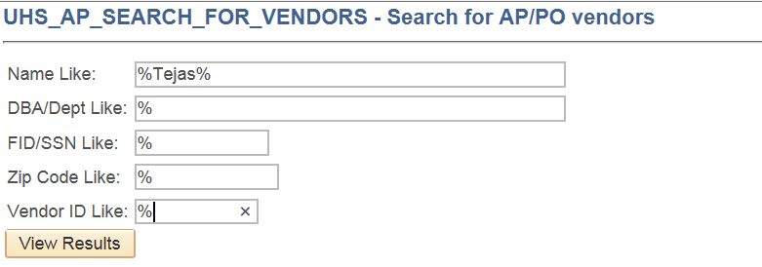

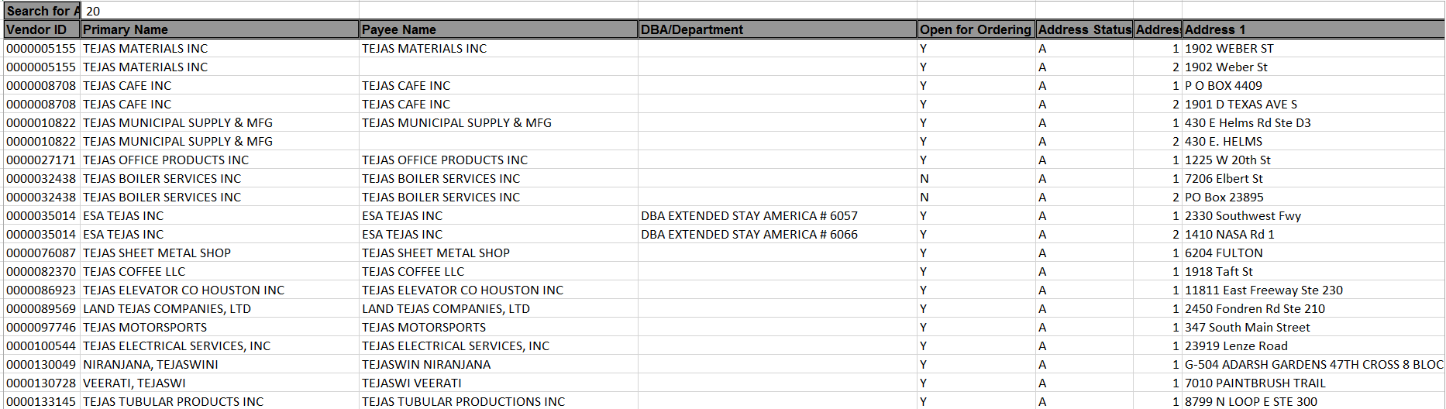

- If the vendor is not setup as a vendor in the finance system, you would need to have the vendor complete a Vendor Coversheet, W-9, and Direct Deposit Authorization Form (see http://www.uh.edu/administration-finance/vendor/vendor-setup-requirements/). Submit these forms to Vendor ID via fax 713-743-0521.

- Create a voucher to reallocate the expense from Local to State Cost Center.

Note: Expenses can be reallocated from Local to State Cost Centers only if the purchases are allowed with State Funds.
Step 1: Go to Voucher Regular Entry, enter the following information, and click on the Add button:

Vendor ID: 0000026780 (Univ of Houston)
Invoice Number: Reallocation_PCARD0123_OCT2018**(see below)
Invoice Date: Date of reallocation
Gross Invoice Amount: Amount to be reallocated

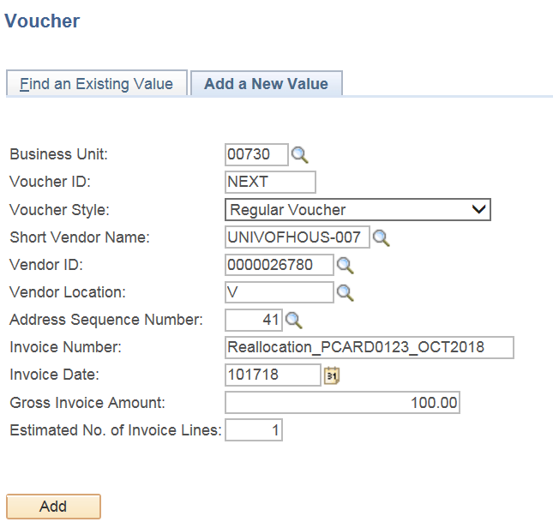

**Note: Invoice Number should show Reallocation, P or T card and last 4 digits, and Billing Cycle/Year. The above example is a reallocation of a transaction for P-Card 0123 in the July 2018 billing cycle.

Step 2: In the Invoice Information page, click on the Comments link and enter the appropriate comment describing the reallocation.

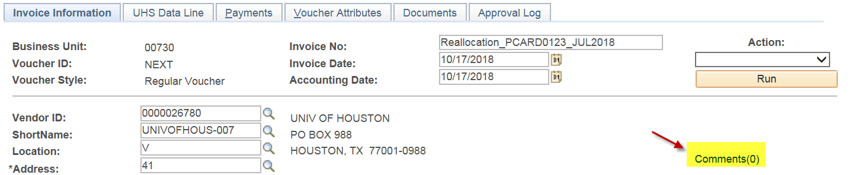
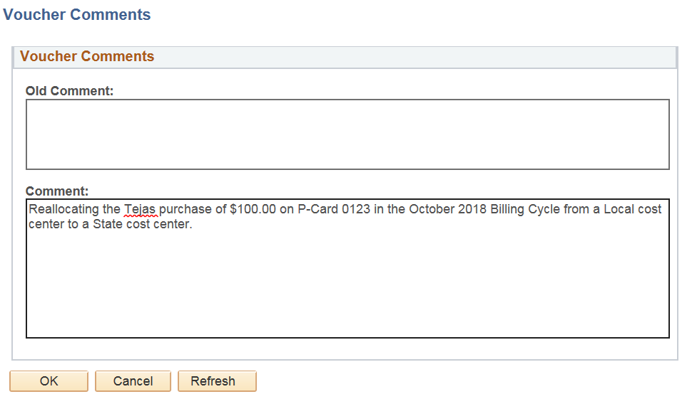

Step 3: In the Invoice Information page, click on the Calc Basis Date link, and enter the dates. The date of reallocation should be entered into the four date fields. After entering the dates, click on the calculate button, and then click on the Back to Invoice link.

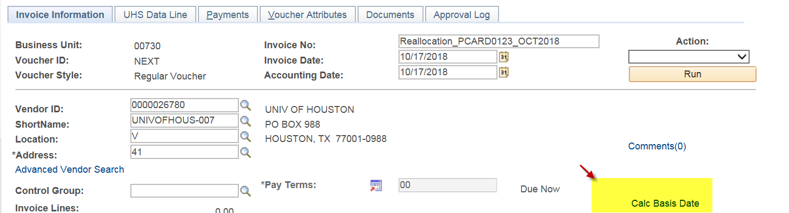

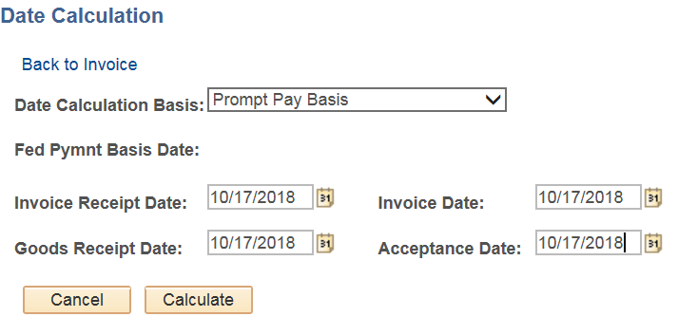

Step 4: In the Invoice Information Page, Enter the account that was used for the original purchase, and enter a state cost center to which you want to move the expense.

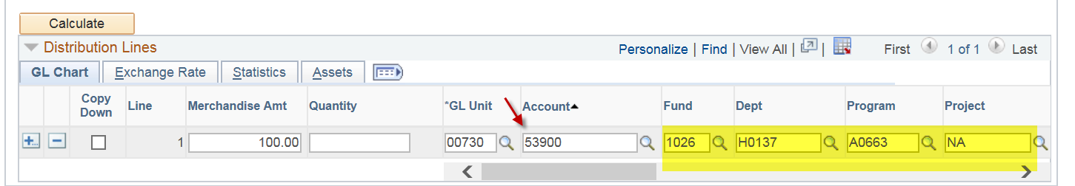

Step 5: Go to the UHS Date Line, and enter 8 in the UHS PCC field. Then, enter the vendor from which you originally purchased the items with your P or T card in the 3rd party Vendor Info section.

Note: In order to reallocate the expense, the vendor must be already setup in the finance system as a vendor and has a valid vendor ID. 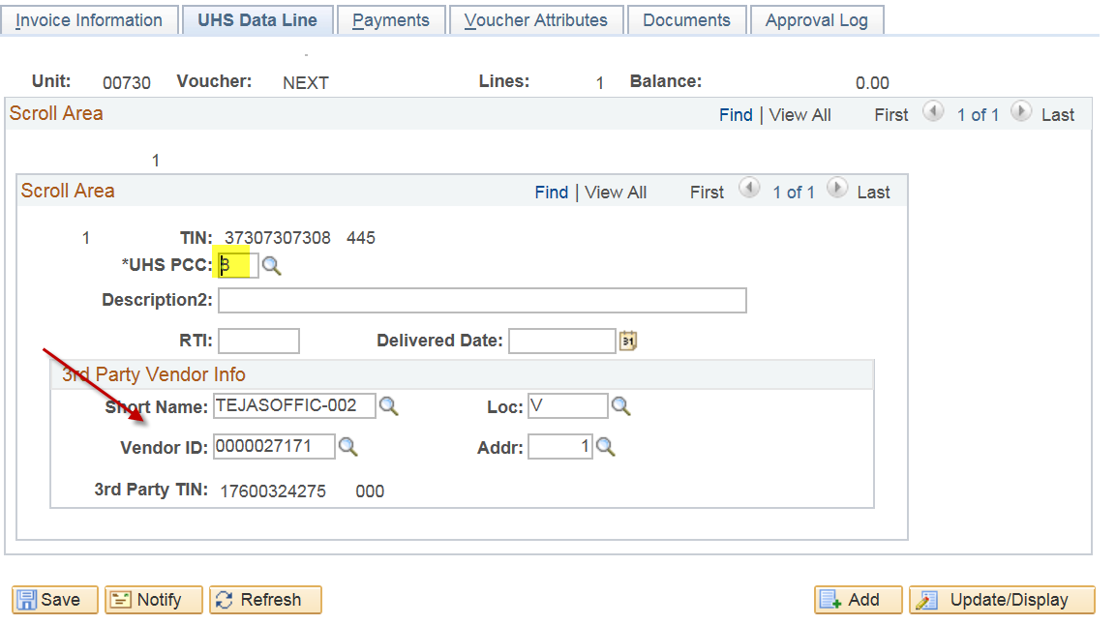

Step 6: In the Payment Page, Change the bank to STATE.

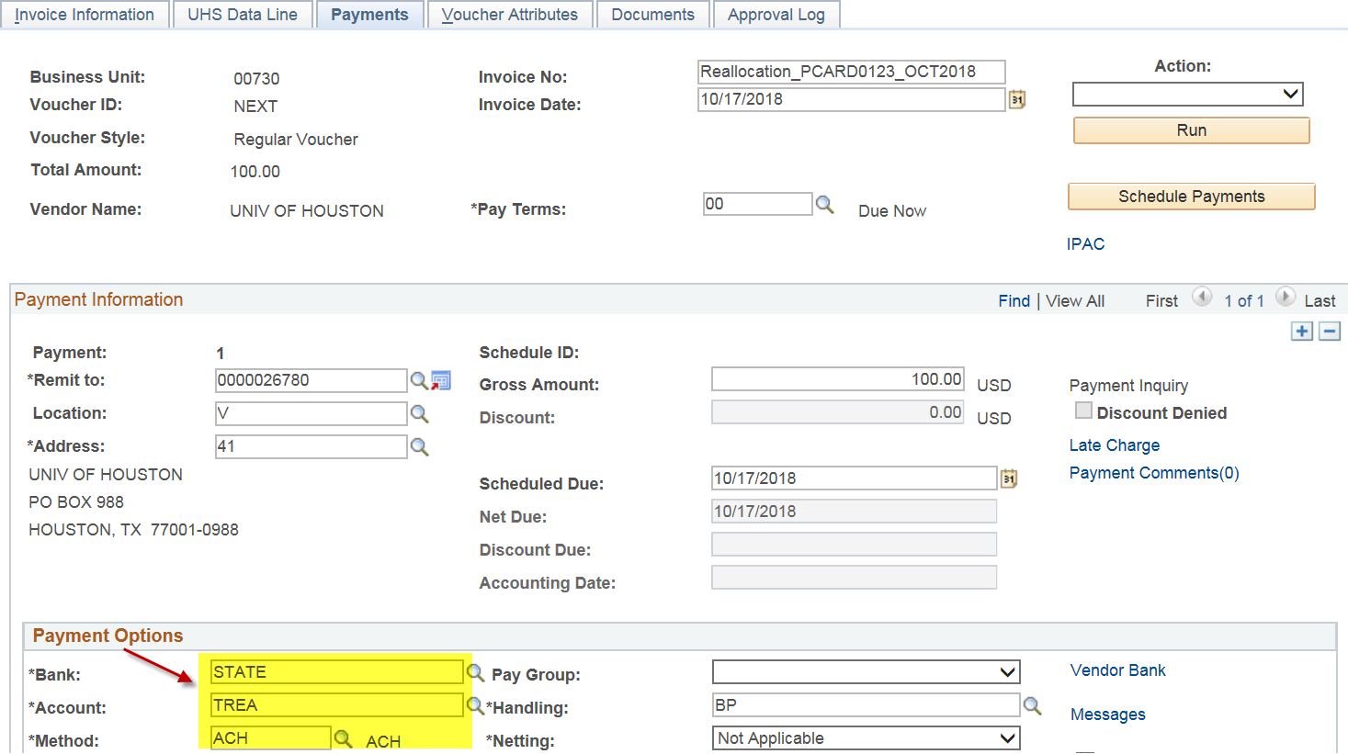

Step 7: In the Payment Page, click on the Payment Comments link, and enter the account and the local cost center you originally used to pay for the P or T card charge.

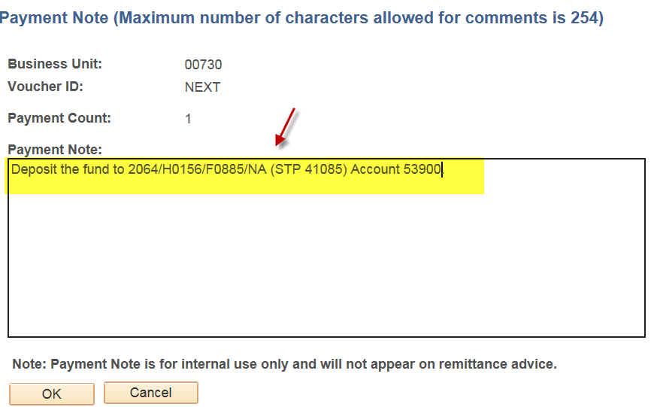

Step 8: Upload the supporting documents to the voucher:

P-Card: GCMS Expense Report, Itemized Receipt, and the 1074 report for the original transaction.

Travel Card: Concur Expense Report, Itemized Receipt, and the 1074 report for the original transaction.

Step 9: Save and budget check the voucher. Then submit it into workflow.

