**How to run reports for outstanding Travel Requests and Expense Reports**

Note: Only a limited number of people have access to run these reports. At least one person in each college/division has been given access.

1. From the Concur home page under **Reporting**, click on **Intelligence**

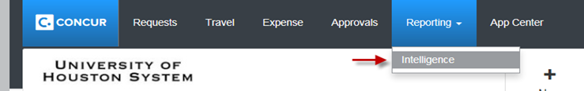

1. Click on **Team Content**,then click on **University of Houston System**

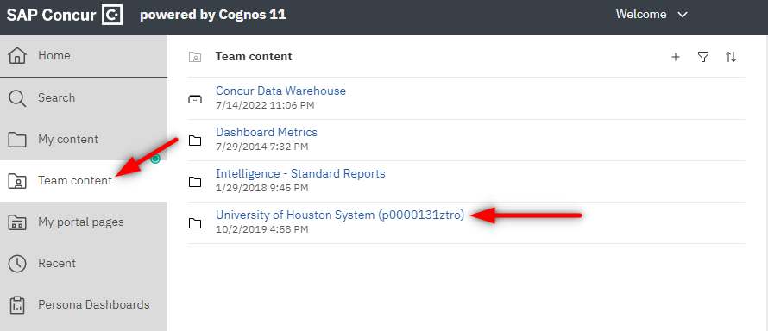

1. Open folder **User Reports**

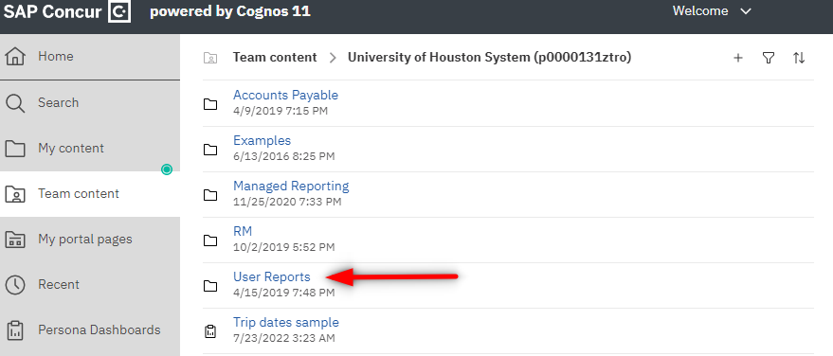

1. You can choose either Outstanding Expense Reports or Outstanding Travel Requests.

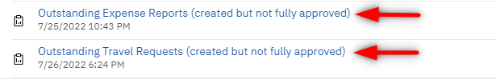

1. From the report, click on the **Run as ** icon, then click on **Run Excel** in order to run the report in Excel

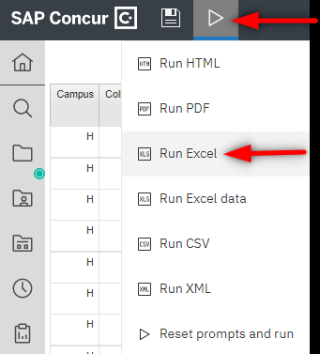

Note: Concur Reports pulls the information as of the previous day. Therefore, if you run the above reports today, you will see the results listed as of yesterday.