**How to run reports for Cash/Travel Advances**

Note: Only a limited number of people have access to run these reports. At least one person in each college/division has been given access.

You can run the following Concur Reports to obtain a list of all Cash/Travel Advances (with corresponding TRs and Expense Reports if applicable) or to identify outstanding Cash/Travel Advances with remaining balances that need to be cleared:

**Cash/Travel Advances – List of all Cash /Travel Advances**

This report will generate a list of all Cash/Travel Advances with corresponding TRs and Expense Reports, if applicable.

**Outstanding Cash/Travel Advances (with remaining Cash/Travel Advances to be cleared)**

This report will generate a list of outstanding Cash/Travel Advances with remaining balances that need to be cleared.

1. From the Concur home page under **Reporting**, click on **Intelligence**

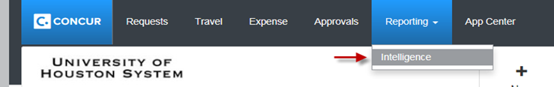

1. Click on **Team Content >** then click on **University of Houston System**

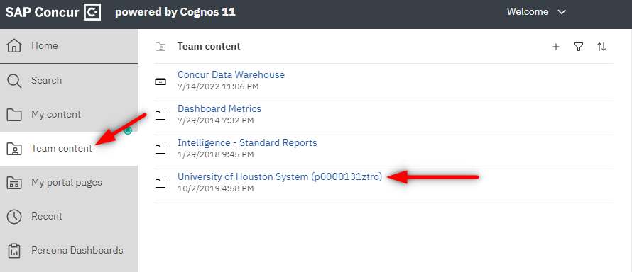

1. Open folder **User Reports**

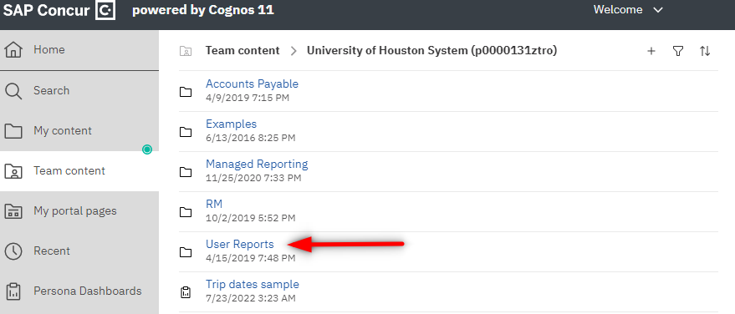

1. Click on the report that you want to run.





1. From the report, click on the **Run as ** icon, then click on **Run Excel** in order to run the report in Excel

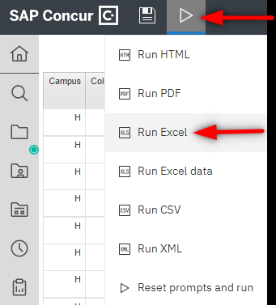

Note: Concur Reports pulls the information as of the previous day. Therefore, if you run the above reports today, you will see the results listed as of yesterday.