**How to run reports for Approved Expense Detail Report**

Note: Only a limited number of people have access to run Concur Reports. At least one person in each college/division has been given access.

The following Concur Report will list your department Expense Reports (approved) with expense types and the corresponding amounts.

**Approved Expense Detail Report**

1. From the Concur home page under **Reporting**, click on **Intelligence**

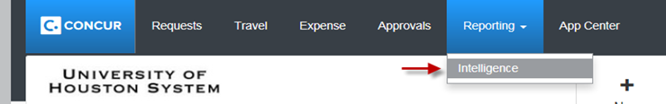

1. Click on **Team Content >** then click on **University of Houston System**

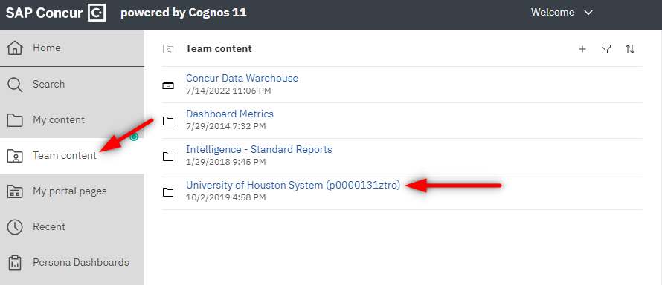

1. Open folder **User Reports**

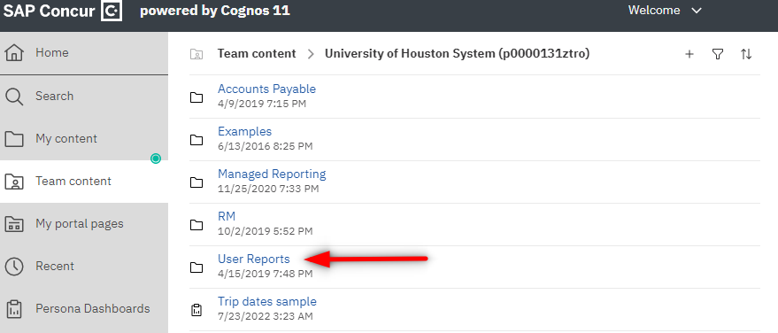

1. Click on the **Expenses: Approved Expense Detail Report**



1. Select your department(s), then click on “**Finish**”

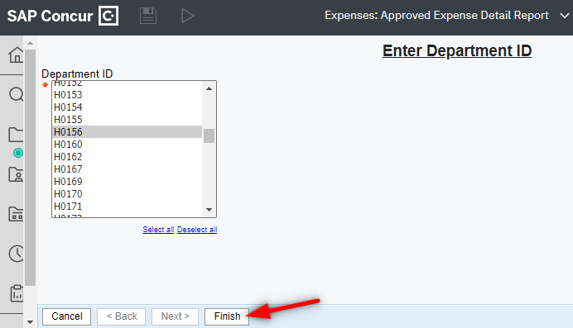

1. From the report, click on the **Run as ** icon, then click on **Run Excel** in order to run the report in Excel

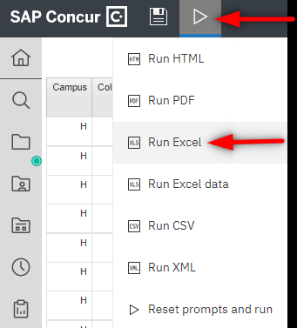

Note: Concur Reports pulls the information as of the previous day. Therefore, if you run the above reports today, you will see the results listed as of yesterday.