How to Copy a Journal

- Search for existing journal
- Go to Lines tab
- Under *Process – Select Copy Journal
- Click Process
Journal Entry Copy page will populate
- Change Journal ID “NEXT” to same as the existing journal being copied
- *If this is a Reversal journal, then “Reverse Signs” box can be checked
- Click Ok
A copy of original journal will be created. Be sure to review all information for accuracy & upload backup before submitting to workflow.

2
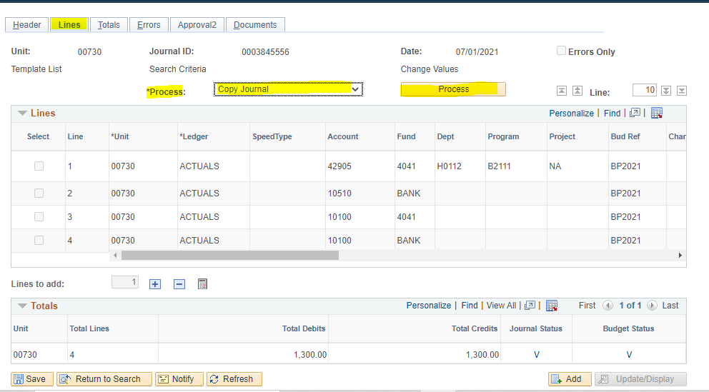
4
3

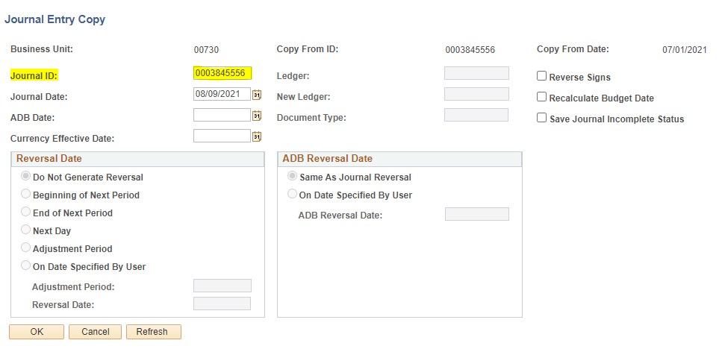
6. If Reversing
7
5

