**Credit Card Journals**

Departments which accept credit cards are assigned a Bank of America Merchant ID number from Treasury. This merchant ID number is provided to process credit card transactions and to identify credit card deposits to the bank.

Currently, the bank line description on credit card deposit journals lists the last six digits of the Bank of America Merchant ID and the credit card settlement date. Ex: 159999 08/31/2015.

Effective September 1, 2015, the bank line description for the credit card bank will be changing from recording the last six digits of the Bank of America Merchant ID and settlement date to all twelve digits of the Bank of America Merchant ID and the settlement date. Ex: 345732159999 09/01/2015.

This change is occurring because Bank of America issued new Merchant ID numbers and several of the new numbers have the same last six digits. The six digit duplication prevents efficient identification of department’s credit card deposits.

The Bank of America Merchant ID list is located on the Finance website, <http://www.uh.edu/finance/pages/GA_Bank_Recon.htm>.

**Credit Card Deposit Journal Instructions**

Credit card sales occurring on or after 9/1/2015 will be recorded as follows:

1. One credit card bank line for each batch settlement (POS machines) or each day’s sales report (Web Interface with automatic settlement).
2. Credit card bank lines will not be separated by card type; the same line will be used for all cards transmitted in the same batch.
3. Credit card bank line description will list all twelve digits of the Bank of America Merchant ID and the date of the batch settlement in the following format: 345732159999 09/01/2015.
4. Credit card transactions are recorded to the 10512 bank.
5. Documentation required for credit card deposit journals is the daily settlement or sales report.

**Sample Journal Entry - Record One Credit Card Batch**

If you are recording one batch (one printout from your swipe machine or one days’ sales from a web-interface with automatic settlement), you would record one journal line for all sales.

If your department’s batch report showed the following ($616 Visa, $7 Amex, $440 MasterCard, $11 Discover, totaling $1,074):



The twelve digit Bank of America Merchant ID number is 345799999999, your journal would look like this:

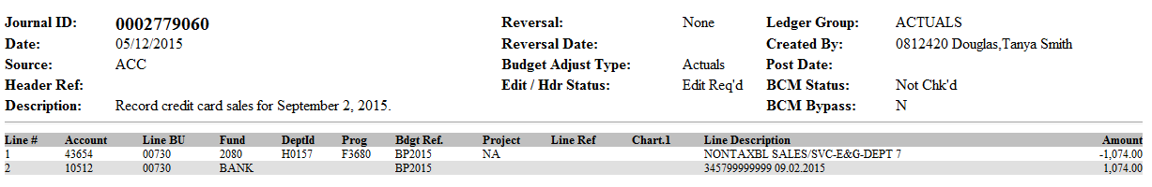

**Sample Journal Entry – Record Multiple Credit Card Batches**

If you are recording multiple batch reports (printouts from multiple swipe machines that share the same merchant ID, or more than one day’s sales reports from a web-interface with automatic settlement over the weekend), you will record one journal line for each batch:

If you have two batch reports with the following sales – Batch 1 ($616 Visa, $7 Amex, $440 MasterCard, $11 Discover, totaling $1,074), and Batch 2 ($96 Visa, $782 Amex, $23 MasterCard, totaling $901):

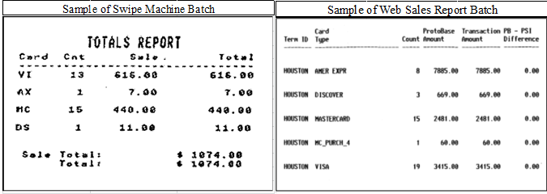

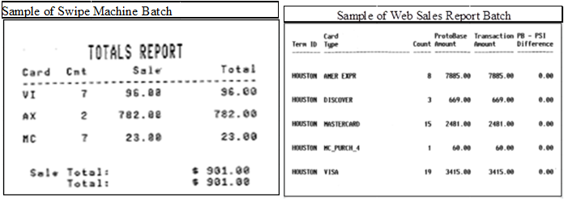

And the twelve digits of your Bank of America MasterCard/Visa Merchant ID number is 345799999999, your journal would look like this:

