This sample thesis illustrates the Kathrine G. McGovern College of the Arts formatting standards. Use this sample to help organize or format your document, essay, or thesis. (In the interest of clarity, the document, essay, or thesis will be collectively referred to as “thesis” throughout this document.)

{Replace text in “< >” with your text; remove all blue text before finalizing}

<Title of Work, Centered, Capitalize Each Word>

by
<First Name Middle Name Last Name>

A <thesis/dissertation> submitted to the <Moores School of Music/School of Theatre and Dance/School of Art>, Kathrine G. McGovern College of the Arts
in partial fulfillment of the requirements for the degree of

<Degree >
{MASTER OF ARTS, MASTER OF SCIENCES, DOCTOR OF PHILOSOPHY, DOCTOR OF EDUCATION, etc}

in <Major>

Chair of Committee: <Name>

Co-Chair of Committee: <Name> (Optional)
Committee Member: <Name>

Committee Member: <Name>

Committee Member: <Name>

Committee Member: <Name>

University of Houston
<Month Year>
------------------------------------------- Page Break -------------------------------------------

Copyright <Year>, First Name Middle Name Last Name
(Optional)

DEDICATION/EPIGRAPH
Students may optionally include a dedication or epigraph and if included, each should be denoted with a separate page.
(Optional)

ACKNOWLEDGMENTS
The purpose of this page is to recognize scholarly and professional assistance, support and advice; the inclusion of references to persons who provided clerical help, help with field studies, financial assistance, and permission to use copyrighted materials is also acceptable. Acknowledgments should be brief, in a professional style, and should not exceed two pages.
(Optional)

(Abstract Page– assigned page number v. Master’s theses & doctoral essays may not exceed 150 words, doctoral dissertations not more than 350 words.)
ABSTRACT
The abstract should be a concise description of your thesis/dissertation. Typically, the abstract should be no more than 350 words in length. The text of the abstract should be double-spaced. Your abstract should not contain any tables, figures, or musical examples, or any references/citations.

(Table of Contents Page– assigned page numbers with lower case roman numerals)
TABLE OF CONTENTS
DEDICATION/EPIGRAPHS iii
ACKNOWLEDGMENTS iv
ABSTRACT v
LIST OF TABLES (HEADING 1) vii
LIST OF FIGURES (HEADING 1) viii
LIST OF MUSICAL EXAMPLES (HEADING 1) ix
I. CHAPTER TITLE (HEADING 1) 1
Second-level subheading (Heading 2) 4
Third-level subheading (Heading 3) 8
II. CHAPTER TITLE (HEADING 1) 10
Second-level subheading (Heading 2) 15
Third-level subheading (Heading 3) 17
III. CHAPTER TITLE (HEADING 1) 20
Second-level subheading (Heading 2) 25
Third-level subheading (Heading 3) 27
<Continue similar format for your document’s chapters>
REFERENCES [page no.]
APPENDICES
A. APPENDIX TITLE [page no.]
B. APPENDIX TITLE [page no.]

(List of Tables Page – assigned page numbers with lower case roman numerals)
LIST OF TABLES
2.1 This is the Title for the First Table. 20
2.2 This is the Title for the Second Table 21
2.3 This is the Title for the Third Table 23
3.1 This is the Title for the Forth Table 29
4.1 This is the Title for the Fifth Table 35

(List of Figures Page – assigned page numbers with lower case roman numerals)
LIST OF FIGURES
1.1 This is the Title for the First Figure. 50
3.1 This is the Title for the Second Figure 51
4.1 This is the Title for the Third Figure 52

(If applicable: List of Musical Examples Page – assigned page numbers with lower case roman numerals)
LIST OF MUSICAL EXAMPLES
1.1 This is the Title of the First Musical Example 5
2.3 This is the Title of the 3rd Musical Example in the 2nd Chapter 20
3.5 This is the Title of the 5th Musical Example in the 5th Chapter 47

:::::::::::::::::::::::::::::::::: Section Break (Next Page) ::::::::::::::::::::::::::::::::::

(Text / Chapters Page – assigned page numbers with Arabic numerals.)

[Chapter or Section Title]
Lorem ipsum dolor sit amet, consectetur adipiscing elit. Fusce tortor massa, mattis sed lobortis ac, posuere a nulla. Mauris odio leo, lacinia at iaculis et, aliquam quis velit. Maecenas gravida sem est, in facilisis tortor. Lorem ipsum dolor sit amet, consectetur adipiscing elit. Cum sociis natoque penatibus et magnis dis parturient montes, nascetur ridiculus mus. Fusce vel lacus vel odio molestie sagittis. Sed tincidunt auctor lobortis. Aliquam id convallis ipsum. Pellentesque habitant morbi tristique senectus et netus et malesuada fames ac turpis egestas.
Vivamus vehicula iaculis bibendum. Nulla interdum, urna vel sollicitudin euismod, ligula sapien placerat erat, vel vehicula ipsum metus quis tortor. Sed sit amet erat in enim auctor dictum eget vel justo. Integer quis erat nec orci molestie sagittis nec quis dui. Cras cursus faucibus tortor eget adipiscing. Vivamus et nibh orci, pellentesque dictum nisi. Curabitur condimentum ante a purus imperdiet ac ornare velit tristique. Sed ut nunc augue.

[Subsection Heading]
Pellentesque sollicitudin vestibulum nibh ut placerat. Donec eu felis dolor, at pulvinar ante. Vestibulum vel quam est, in vulputate arcu. Aliquam eleifend congue tellus eget vulputate. Cras vehicula suscipit arcu, sit amet consequat nulla sodales eget. Proin vitae ornare justo. Pellentesque quis mauris quis ipsum eleifend rutrum eu eget nisl. Nam imperdiet libero id odio placerat sit amet porta diam rhoncus. Cum sociis natoque penatibus et magnis dis parturient montes, nascetur ridiculus mus. Nulla velit libero, pellentesque non sagittis rutrum, tincidunt nec odio. Sed ac tincidunt magna. Etiam sed metus ante. Fusce fermentum volutpat auctor.

Table 1: Title and/or description of table goes here.
Stubhead | Column head | Column head
Row 1 | 123 | 234
Row 2 | 456 | 567
Note. Lorem ipsum dolor sit amet, consectetur adipiscing elit.

Suspendisse nibh orci, cursus eget molestie et, lacinia et odio. Etiam egestas tortor erat, id facilisis nibh. Donec neque lacus, congue a pellentesque quis, tristique a tellus. In ipsum ante, tincidunt non malesuada quis, pellentesque in tortor. Praesent porttitor pellentesque quam, et consequat quam placerat sed. Suspendisse mattis, odio at ornare pretium, arcu sem suscipit nibh, sagittis feugiat turpis urna eget nulla. Aenean at lobortis mauris. Donec congue mauris eu ipsum elementum ultricies. In enim leo, tempor eu commodo vitae, pellentesque vitae nunc. Donec tincidunt bibendum neque, vel eleifend orci cursus eu. Integer ac tortor turpis. Curabitur porttitor felis vitae leo fermentum vitae semper magna vehicula. Morbi vitae purus nunc. Pellentesque quis purus leo, eget venenatis eros. Aliquam tortor nunc, tempor ut iaculis nec, venenatis ut tortor. Mauris dapibus, risus at malesuada dapibus, mauris enim suscipit lorem, id dignissim massa leo nec risus. Sed eget lorem non felis mollis posuere eu ac elit. In ante lorem, egestas sed mattis eget, luctus eu urna. Aenean viverra aliquet pharetra. Fusce ipsum dolor, luctus convallis consectetur id, molestie quis ligula. Vestibulum laoreet blandit nisi sit amet placerat. Morbi scelerisque semper nunc, non condimentum nisl faucibus sit amet. Praesent lacinia rhoncus ipsum, nec ultrices neque iaculis rutrum.

Figure 1: Title and/or description of figure goes here.

Vivamus quis dolor lectus. Pellentesque a orci porttitor nulla auctor viverra. Vestibulum rhoncus tellus eget nisi commodo convallis. Nullam feugiat lobortis semper. Nunc sit amet volutpat metus. Ut urna turpis, malesuada tempor scelerisque in, dictum eget libero. Phasellus blandit sapien a ligula tincidunt nec pulvinar velit ullamcorper. Suspendisse aliquet vulputate justo at placerat. Sed eget lorem non felis mollis posuere eu ac elit. In ante lorem, egestas sed mattis eget, luctus eu urna. Aenean viverra aliquet pharetra. Fusce ipsum dolor, luctus convallis consectetur id, molestie quis ligula. Vestibulum laoreet blandit nisi sit amet placerat. Morbi scelerisque semper nunc, non condimentum nisl faucibus sit amet. Praesent lacinia rhoncus ipsum, nec ultrices neque iaculis rutrum.

[Subsection Heading]
Lorem ipsum dolor sit amet, consectetur adipiscing elit. Nulla tempor tempor diam, convallis feugiat turpis mattis vitae. Phasellus non scelerisque nunc. Vivamus luctus tellus eget tellus aliquet venenatis et lacinia risus. Maecenas hendrerit rutrum scelerisque. Fusce vitae massa lorem. Nam et ipsum sed turpis dapibus varius. In ac metus massa, eget dapibus mauris. Quisque turpis velit, blandit in tempus sed, consequat vel mauris.

Example 1: Title and/or description of figure goes here.
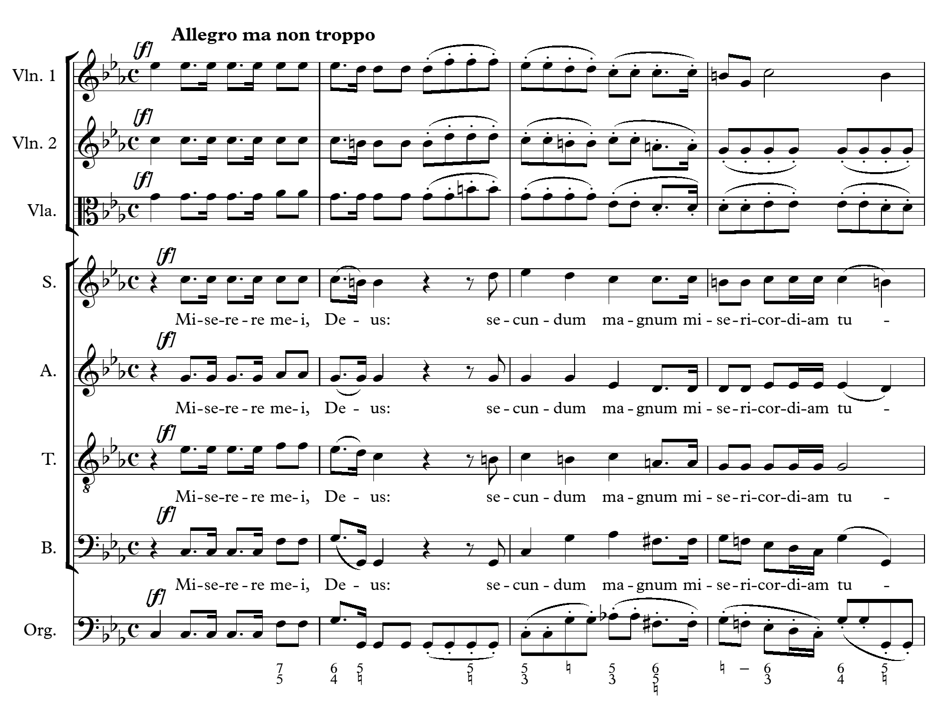
Sed augue ligula, egestas nec rutrum feugiat, vulputate non ligula. Ut sit amet nulla eu enim feugiat ultrices ac vitae leo. Donec commodo viverra nibh a luctus. Nam elementum accumsan purus ut auctor. Maecenas nec felis justo, a gravida lorem. Aenean adipiscing ligula sit amet lectus pulvinar fringilla. Donec eleifend, elit at sollicitudin tristique, nisl massa euismod ligula, id lobortis velit ligula ut sapien. Proin erat sapien, venenatis in volutpat non, dignissim id sem. Nam sed enim arcu. Sed id velit eros.

Example 2: The first phrase of of the chorale “Wir gläuben all’ an einen Gott” as it appears in the Neu Leipziger Gesangbuch (1682) and as Hiller simplified it in 1790.

Luther:
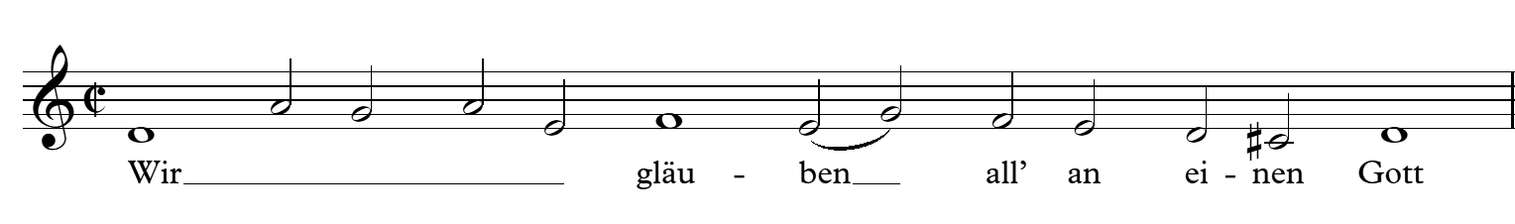

Hiller:
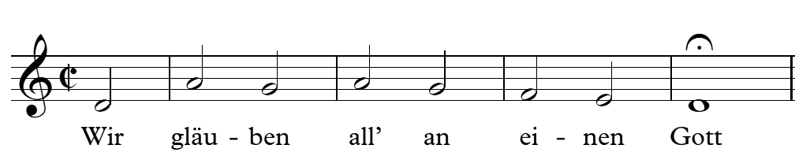

Sub-Subsection heading title. Suspendisse nibh orci, cursus eget molestie et, lacinia et odio. Etiam egestas tortor erat, id facilisis nibh. Donec neque lacus, congue a pellentesque quis, tristique a tellus. In ipsum ante, tincidunt non malesuada quis, pellentesque in tortor.

REFERENCES

Beachy, Robert. The Soul of Commerce: Credit, Property, and Politics in Leipzig, 1750-1840. Leiden: Brill, 2005.
Becker, Carl Ferdinand. “Nekrolog.” Neue Zeitschrift für Musik 18, no. 24 (23 Mar. 1843): 98.
Böhm, Claudius. “Ohne Universität kein Gewandhausorchester.” In 600 Jahre Musik an der Universität Leipzig: Studien anlässlich des Jubiläums, edited by Eszter Fontana, 197-202. Wettin: Janos Stekovics, 2010.
Bonds, Mark Evan. After Beethoven: Imperatives of Originality in the Symphony. Cambridge, MA: Harvard University Press, 1996.
Bonds, Mark Evan. “Idealism and the Aesthetics of Instrumental Music at the Turn of the Nineteenth Century.” Journal of the American Musicological Society 50, no. 2-3 (Summer-Autumn 1997): 387-420.
Brecht, Martin. “Philipp Jakob Spener, sein Programm und dessen Auswirkungen.” In Geschichte des Pietismus, edited by Martin Brecht, 281-389. Göttingen: Vandenhoeck & Ruprecht, 1993.
Brodbeck, David. “A Winter of Discontent: Mendelssohn and the Berliner Domchor.” In Mendelssohn Studies, edited by R. Larry Todd, 1-32. Cambridge: Cambridge University Press, 1992.
Brown, Clive. A Portrait of Mendelssohn. New Haven: Yale University Press, 2003.

(Our thanks to Velvette Laurence and the UH College of Education for allowing us to build upon their sample thesis model in creating this document.)

Footnote numbers and text should be in the same font as the body text. They may either be the same size and line spacing as the body text, or smaller (10 point) and single spaced as appears here. Footnotes should be flush left, with the number superscripted and with space between the number and the text (as is done here). All citations should be in the format associated with your discipline (usually Chicago Manual of Style/Turabian).
A note about “Ibid.”: it always has a period after it, even when it’s followed by a page number (Ibid., 35.).
Gottfried Vopelius, Neu Leipziger Gesangbuch: Von den schönsten und besten Liedern verfasset (Leipzig: Gallus Niemann, 1682), 501; Johann Adam Hiller, Drey Melodien zu Wir gläuben all' an einen Gott: zwo neue, und die alte verbessert (Leipzig: Adam Friedrich Böhme, 1790), 6.

