How to consent to receive your Form 1095-C electronically:
Step 1: Login to PASS
- On Home Screen select Benefit Summary Tile
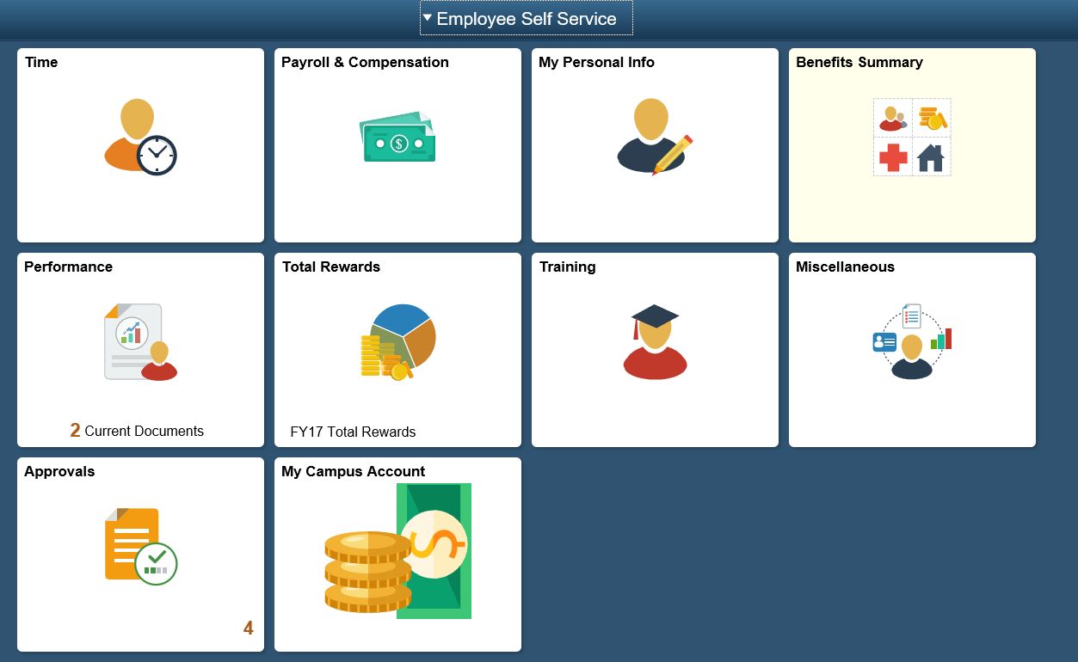
Step 2: Form 1095-C Consent
- Scroll down, on the left side select Form 1095-C Consent
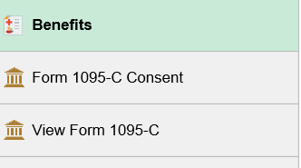
- Select and read the Form 1095-C Consent
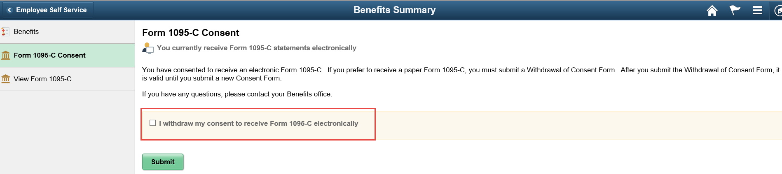
- Check box (I consent to receive Form 1095-C electronically)
- Click Submit Button, after you submit you will be asked for User Validation
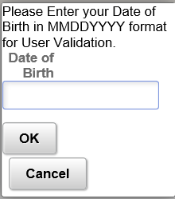
- Enter your Date of Birth is the specified format (MMDDYYYY)
- Click ok, and you will receive your online confirmation
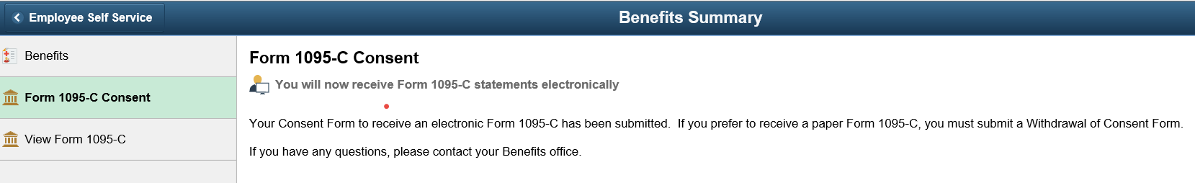
- In addition to the online confirmation an email confirmation will be sent to your email address on file.
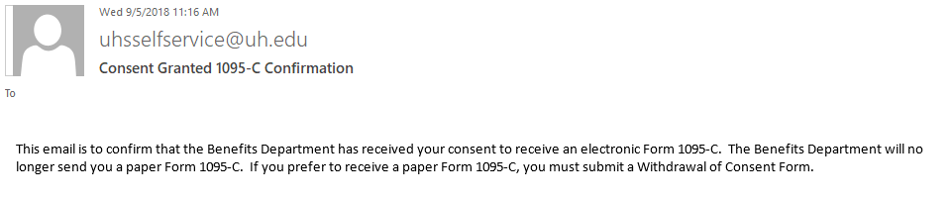

How to view and print your Form 1095-C:
Step 1: View W-2/W-2c Forms
- In your Payroll & Compensation Tile – select View Form 1095-C
- Select 1095-C Original hyperlink to open and print the 1095-C Form in pdf format.
