Mars Habitation

DAY 1 - INTRODUCTION TO MARS HABITATION

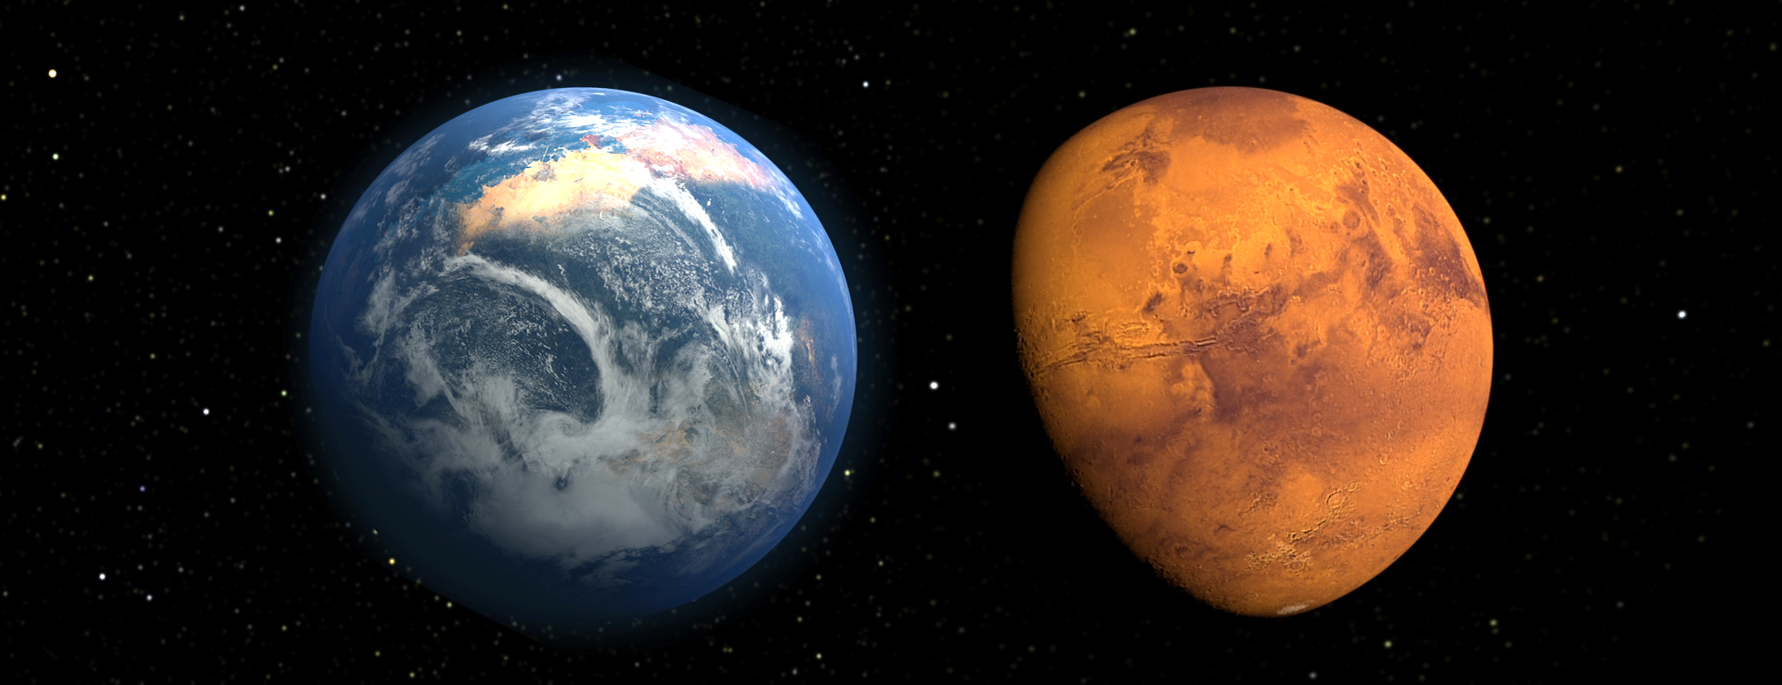

Objectives:

- Students read and understand NASA challenge
- Students have opportunity to ask questions
- Students identify prior knowledge and curiosities about Mars
- Students get a taste of what Mars is like
- Students feel committed to project and part of a team

Time: 1.5 - 2 hours

Materials:

- Mission team agreement
- Poster board
- Markers
- Writing Journals
- 3-2-1 Model for Learning
- Pens/pencils

Activity (step by step):

STEP 1: Review Letter

- Tell students that they have received official correspondence from NASA and have been presented with a challenge.
- Present each student with his or her own official NASA letter.
- Have students open their documents together and have a student read contents out loud.

STEP 2: Clarify Challenge

- Talk to students about NASA’s challenge.
  - Explain that they will be competing with other housing authorities across the country
  - Explain that they will present their final projects to their community/families and then compete at the University of Houston’s Mars Rover Celebration.
- Explain that NASA wants mission experts who are committed to the mission.
  - Ask students to think about whether they are willing to be a part of the team, to come to all of the mission planning sessions, and to give 100% of themselves.
  - Tell students that when they are sure they are ready to join the team they should sign the mission team agreement and they will then choose their group for the rest of the project.

STEP 3: Open Mars Discussion

- Begin brief discussion about Mars and the possibility of humans living there.
  - There are no right answers here. This is to get students thinking, feeling confident and a part of the group. Acknowledge all responses.
  - Guiding questions:
    - Humans have never been to Mars, when do you think the first human will actually step on Mars?
    - Why would we want to go to Mars anyway?
    - Would YOU go to Mars if you had the chance? Why? Why not?
    - What do you think it would be like to live on Mars?

STEP 4: Begin Activity

- Draw a line down the middle of a large piece of poster board. At the top of one column write “things we know about Mars.” At the top of the other column write, “Questions that we have about Mars.”
  - Explain to students that they are all explorers and that all of their questions are very important to the whole team.
  - Explain that they need to become experts and to do that, all questions need to be asked.
- Give each student a small stack of sticky notes. Give students 5-10 minutes to fill out as many as they can for each side of the poster board. Have students put sticky notes on the board as they finish them.
- Once students are finished, read the completed lists.
  - At this point make no comments. Even if information in the “things I know” is incorrect – the objective is for students to discover it on their own, or through the process.
  - If student asks directly, advise them that you will have to figure it out together as you all learn more about Mars.
- Explain that as the team works on this mission together they will be adding to both sides of the board – they will be learning more about Mars, but also having more questions.
  - Encourage students to continue to put up sticky notes on the board as they learn more.
  - Keep board posted in the room for each meeting.

STEP 5: Writing activity

- Writing to Learn
  - Use the 3-2-1 Model (See Template) to reflect on today’s activities and the Guiding Questions to write about how you are feeling.
3-2-1 Model for Learning
Write down 3 new things you learned.

Write down 2 things that surprised you.

Write 1 question you want to ask.

Imagine this Mission is REAL! For 10 minutes, write about how you are feeling. What are you thinking about? Are you scared of the dangers? Excited to be going somewhere no one has been? Sad to leave your family?

OFFICIAL NASA community Proposal
NASA Jet Propulsion Laboratory
4800 Oak Grove Drive
Pasadena, CA 91001

Date:
Students in the Your Place on Mars Program

Dear Students in the Mars Habitation Program:
NASA is planning for its first community on the planet Mars. We need your help. Your creativity and out-of-the-box thinking is what will make this a successful NASA mission.

Your team is competing to design the best community on Mars for the first inhabitants. You will work together to plan the world of the future. Remember to follow the directions, and be creative.

When your proposal is complete, scientists, engineers and experts will review it – along with other students’ work – and choose a proposal for their first mission to Mars.

The proposal you submit to NASA must include the following:

- Your proposal must describe what characteristics are important for members of community to have and what type of jobs/job skills will your community members need on Mars.

- Your proposal must include a mission statement describing how your community will work together and what their core values will be.

- Your proposal must explain where the community is located, how it will be protected and how you will provide food water and air.

- Your proposal must include a replica of you community built from found items.

- Your proposal must include a short book from each team member about their community.

Best of Luck,
NASA SELECTION COMMITTEE CHAIR

MISSION TEAM AGREEMENT I ____________________________________________ understand that by signing this document I am becoming a part of the NASA mission planning team, designing a plan for the first martian community. I promise I will attend all mission design meetings and will give my best effort at each session. If I cannot attend a meeting, I will let my team leader know ahead of time. I will support my team and use my talents to make our community the best it can be.

Signed: ______________________________________

Date: _______________________________________

