SECTION 28 10 00 ACCESS CONTROL SYSTEM

GUIDE SPECIFICATION
The following guide specification is intended to be modified and included in the Contract Documents. Items to be modified should be done in consultation with the University Project Manager, Campus Engineering and EAC Manager.

PART 1 - GENERAL
1.01 SECTION CONTENTS
A. Building access control system including intelligent field panels, input modules, output modules, power supplies, communications devices, and related equipment.
B. Card readers, detection devices, request-to-exit devices, and related equipment.
1.02 RELATED SECTIONS
- Division 01 – General Requirements.
- Division 08 -- Openings (including hardware)
- Division 14 – Conveying Equipment
- Division 26 – Electrical.
1.03 RELATED WORK PROVIDED IN OTHER SPECIFICATION SECTIONS
A. Unless noted otherwise, the following work is to be provided under other specification sections:
1. Electric door lock hardware.
2. Automatic door openers, including actuator buttons.
3. Door position switches on pedestrian doors.
4. Conduits, raceways, and electrical back boxes.
5. 120 VAC power wiring to power supplies.
1.04 BASIC DESCRIPTION OF SYSTEM
A. The University of Houston has an existing campus-wide access control system. This system is known as the “Electronic Access Control System” (EAC). Principal components of EAC are manufactured by Lenel, a unit of United Technologies Corporation.
B. In the interest of standardization and to permit centralized management and support, all new access control systems installed at the main University of Houston campus shall utilize equipment compatible with EAC and be connected as an extension to the existing access control system. The use of other types or brands of access control systems shall not be permitted at University of Houston facilities.
C. The access control system at each building shall consist of one or more “intelligent controllers” installed locally at the building. These intelligent controllers shall be installed at backboards located in designated closets within the building. Intelligent controllers shall be connected to existing EAC host computer via the University’s TCP/IP network. Local host or server computers for EAC shall not be installed at individual building.
D. All card readers, detection devices, signaling devices, lock hardware and other such devices at building are to be wired to the nearest EAC backboard in the building. The maximum cable distance between device and backboard shall not exceed 500’.
E. Control and management of the building’s access control system to be accomplished using a web-browser interface connected to the central EAC host computer via the University’s TCP/IP network. Remote or off-campus access shall be permitted by UH owned laptops or computers only, and approved by the Electronic Access Control Department.
1.05 CONTRACTOR
A. The University of Houston has an exclusive purchase agreement with a security system contractor for all work related to the EAC. This contractor was selected using an open competitive bidding process which resulted in the award of an exclusive purchase agreement for the current contract period. The Contractor performing the work of this section shall be the security contractor who currently has the exclusive agreement with University of Houston.
B. For the current University of Houston EAC contractor, contact The Electronic Access Control Department.
1.06 SUBMITTALS
A. Provide submittals in accordance with Division 1.
B. Shop drawings
1. Provide shop drawings showing equipment locations and routing of cables and wiring in conduits, raceways, and cable trays.
2. Shop drawings shall indicate cable types and sizes, routing, splice and connection points, equipment locations, point numbers, and equipment addresses, and other such information.
3. Shop drawing floor plans shall be prepared using a standard architectural scale. Preferable scale of floor plans for shop drawings shall be 1/8" = 1'. Smallest scale allowable for shop drawings shall be 1/16" = 1'.
4. Approved shop drawings shall be used as plan for system installation.
C. Point-to-point wiring diagrams
1. Provide point-to-point wiring diagrams; indicating terminal-to-terminal connections between system components, type of connections, and other information necessary to make final terminations.
2. Point-to-point wiring diagrams may be included within shop drawings instead of as a separate submittal.
D. Product data
1. Provide product data submittals on all products proposed for use under this section.
1.07 FINAL ACCEPTANCE
A. After work is completed, and prior to requesting the Acceptance Test, Contractor shall conduct a final inspection and pre-test all equipment and system features. Contractor shall correct any deficiencies discovered as the result of the inspection and pre-test.
B. Contractor shall submit a request for the Acceptance Test in writing to the UH EAC Manager using an approved "Request for EAC Acceptance Test" form, a copy of which is provided on the second page following.
1. This request shall be submitted to UH EAC Manager no less than 5 business days prior to the requested test date.
2. The request for Acceptance Test shall constitute a certification from Contractor that all work is complete and in compliance with the Contract Documents, all systems have been tested, and all corrections have been made.
C. Acceptance Test shall be scheduled during a period when the building is unoccupied and a complete system test can be accomplished.
D. Contractor shall provide the services of no fewer than 2 technicians to perform the Acceptance Test.
1. Technicians performing the Acceptance Test shall have been involved in the installation of this project and shall be thoroughly familiar with all aspects of the work.
2. Technicians shall be equipped with portable two-way radios for use during the test.
E. Contractor shall provide all ladders, tools, test equipment, and other facilities needed to accomplish the Acceptance Test.
F. During the Acceptance Test, Contractor shall demonstrate all equipment and system features to UH EAC Manager.
1. Contractor shall fully cooperate with the UH EAC Manager and provide assistance with the inspection and test.
2. Contractor shall remove and reinstall covers, open and restore wiring connections, operate equipment, and perform other reasonable work as requested by the UH EAC Manager.
3. The Acceptance Test shall be documented using an approved EAC Acceptance Test Checklist. An example is provided on the second page following. Contractor may use alternative types of checklists and/or documentation methods as approved by the UH EAC Manager.
G. Any portions of the work found to be deficient or not in compliance with the Contract Documents will be rejected.
1. UH EAC Manager will prepare a list of any deficiencies observed during the Acceptance Test.
2. A copy of this list will be provided to the Contractor, who will promptly correct all deficiencies.
UNIVERSITY OF HOUSTON
REQUEST FOR EAC ACCEPTANCE TEST

Building: ____________________________________________
Contractor:___________________________________________
I hereby certify that:
1. The EAC installation at the above mentioned building is complete and has been provided in accordance with the Contract Documents.
2. That all systems and devices have been thoroughly pre-tested, and that all necessary corrections have been made.
3. That all project documentation, including Project Record Drawings, System Documentation, Panel Program Sheets and other such information, has been submitted in accordance with the Contract Documents.
4. That all systems have received final inspection and acceptance by the regulatory bodies having jurisdiction at the project location, and that copies of "signed-off" permits have been submitted in accordance with the Contract Documents.
I request that a EAC Acceptance Test be conducted

on the_______________day of ______________________, 20______.

By:_______________________________________________________

Title:______________________________________________________

Company:__________________________________________________

Date:______________________________________________________

Figure 1- Example of Acceptance Test Checklist
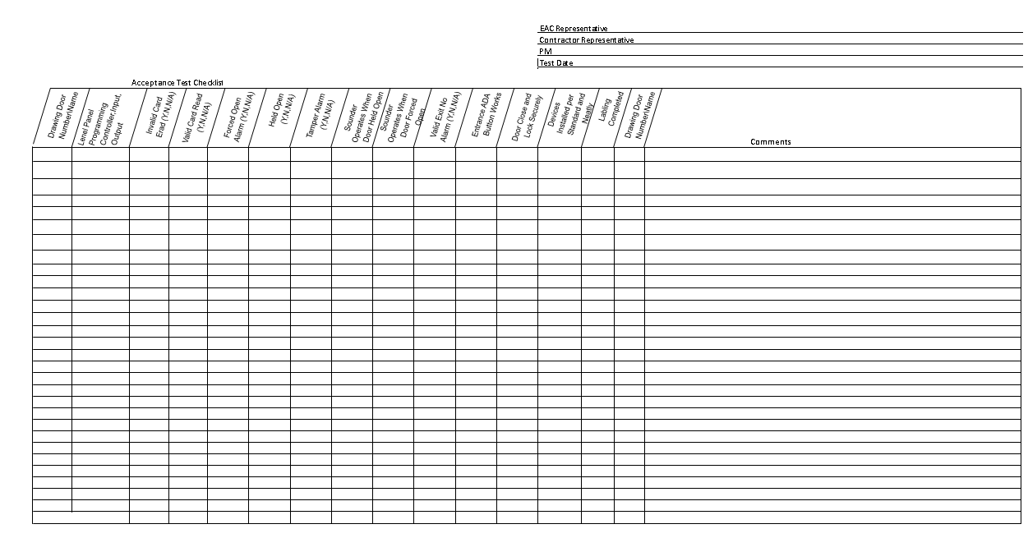
1.08 PROJECT RECORD DRAWINGS
A. Submit project record drawings in accordance with Division 1.
B. The purpose of project record drawings is to provide factual information regarding all aspects of the access control system to allow for future service, modifications, and additions.
C. Project record drawings shall include documentation of all work, including the documentation of equipment, wiring, conduits, cable trays, and raceways that are related to the work but are provided under other sections.
1. Contractor shall maintain the working set of project record drawings at the project site throughout the course of the work.
2. The working set shall be updated on a daily basis as the work progresses.
D. Project record drawings shall accurately show the physical placement of the following:
1. Equipment and devices
2. Wire and cable runs
3. Conduits, cable trays, and raceways
4. Junction and pull box locations
5. End-of-line resistor locations
6. Interfaces to external equipment
7. Connections to power and data circuits
E. Project record drawings shall show the physical placement of each device or conduit centerline, to be accurate to within 3 inches on scaled drawings.
1. Show dimensions from finished walls or floors if location cannot be accurately portrayed by scale.
2. Show, by symbol or note, the vertical location of the item ("under slab," "in ceiling space," "exposed," etc.)
F. Project record drawings shall show wire and cable runs, point and door numbers, tamper circuit configuration, panel/circuit breaker numbers from which equipment is powered, and splice points.
1. Such information may be shown on the floor plans, or may be documented on separate Riser Diagrams that will supplement the floor plans.

PART 2 - PRODUCTS
2.01 MANUFACTURERS
A. Access control intelligent controllers, input modules, output modules and card readers shall be branded by Lenel and use Lenel part numbers. No substitutions are acceptable.
B Other equipment shall be produced by the manufacturer or manufacturers indicated herein. No substitutions are acceptable.
2.02 INTELLIGENT SYSTEM CONTROLLER
A. Microprocessor-based intelligent controller provides complete local processing of access control transactions. Stores up to 500,000 cardholders in non-volatile flash memory. Supports up to 64 card reader controlled doors through use of card reader interface modules. On-board high-speed Ethernet 10/100Base-T upstream port for connection to central EAC server computer. 15 MB of available on-board, non-volatile flash memory.
B. Intelligent controller shall provide local processing for up to 16 different card formats, up to 32,000 access level permissions, 255 holidays, 255 time zones, and provide elevator control support for up to 128 floors.
C. Provide Lenel Model #LNL-0000. No substitutions are acceptable.
2.03 SINGLE-READER INTERFACE MODULE
A. Card reader interface module allows monitoring and control of one card reader controlled door. Provides one (1) card reader input, one (1) SPDT (Form C) output rated at 5 amperes, one SPDT (Form C) output rated at 1 ampere, two (2) general purpose supervised inputs, and (1) tamper input. Connects to intelligent controller using RS-485 data connection.
C. Provide Lenel Model #LNL-1300. No substitutions are acceptable.
2.04 DUAL-READER INTERFACE MODULE
A. Card reader interface module allows monitoring and control of two card reader controlled door. Provides two (2) card reader inputs, six (6) SPDT (Form C) outputs rated at 5 amperes, eight (8) general purpose supervised inputs, one (1) power status input, and (1) tamper input. Connects to intelligent controller using RS-485 data connection.
B. Provide Lenel Model #LNL-1320. No substitutions are acceptable.
2.05 INPUT CONTROL MODULE
A. Input control module provides sixteen (16) general purpose inputs, one (1) power status input, and (1) tamper input. General purpose inputs programmable as supervised or unsupervised. Two (2) SPDT (Form C) outputs rated at 5 amperes. Connects to intelligent controller using RS-485 data connection.
B. Provide Lenel Model #LNL-1100. No substitutions are acceptable.
2.06 OUTPUT CONTROL MODULE
A. Output control module provides sixteen (16) SPDT (Form C) outputs rated at 5 amperes. One (1) power status input, and (1) tamper input. Connects to intelligent controller using RS-485 data connection.
B. Provide Lenel Model #LNL-1200. No substitutions are acceptable.
2.07 EQUIPMENT ENCLOSURE - LARGE
A. Large equipment enclosure for EAC equipment, 36"H x 30"W x 4.5"D. 16 Gauge steel construction with top and bottom cabinet locks. Removable back plate with mounting provisions for Lenel modules, power supplies and other equipment.
B. Enclosure shall provide space for up to six (6) Lenel modules, two (2) power supplies, accessory modules and standby batteries
C. Provide Life Safety Power Model #E8M. No substitutions are acceptable.
2.08 EQUIPMENT ENCLOSURE - SMALL
A. Small equipment enclosure for EAC equipment, 24H x 20W x 4.5D.16 Gauge steel construction with cabinet lock. Removable back plate with mounting provisions for Lenel modules and other equipment.
B. Enclosure shall provide space for up to six (6) Lenel modules.
C Provide Life Safety Power Model #E4M. No substitutions are acceptable.
2.09 POWER SUPPLY
A. Power supply for use in powering all EAC equipment including electric lock hardware. User-selectable for 12 VDC at 20 amperes, or 24 VDC at 10 amperes. Microprocessor controlled charging process provides proper charging current for the battery and the fastest charge time. Maximum output ripple of 120 Millivolt peak-to-peak. Line Regulation ± 0.1%, Load Regulation ± 2%. Provides integral processor that allows monitoring, programming and reporting of power supply through network interface.
B. Independent charging circuit with programmable charging current settings at .25 amperes, .5 amperes, 1 amperes, and 5 amperes. 80 ampere-hour battery charge capacity.
C. Provide Life Safety Power Model #FPO250. No substitutions are acceptable.
2.10 POWER DISTRIBUTION MODULE
A. Power distribution module provides eight (8) individually protected Class II power outputs rated at 2.5 amperes per output. Uses solid-state circuit breakers. Provides visual indicator for each power output.
B. Provide Life Safety Power Model #D8P. No substitutions are acceptable.
2.11 LOCK CONTROLLER MODULE
A. Lock controller module provides eight (8) relay-controlled lock outputs. Each output may be programmed for the following modes:
1) Voltage output from power supply one.
2) Voltage output from power supply two.
3) Fail-safe.
4) Fail-secure.
5) Normally open dry contact.
6) Normally closed dry contact.
7) Fire alarm interface for egress lock control.
B. Provide Life Safety Power Model #C8P. No substitutions are acceptable.
2.12 NETWORK INTERFACE MODULE
A. Four-port network communication interface allows remote power monitoring, reporting and control of up to four (4) power supplies and accessories. Connects to remote power manager software over TCP/IP network connection.
B. Provide Life Safety Power Model #NL4. No substitutions are acceptable.
2.13 BATTERIES
A. Rechargeable sealed lead-acid battery to provide back-up power to EAC power supplies.12 volts, 12 ampere hour. Rugged impact resistant ABS case. Valve regulated spill-proof construction. F2 quick-disconnect tabs for power connections.
B. Batteries shall be sized to provide a minimum of four hours of operation of all system components, including control equipment, card readers, request-to-exit devices, and electric lock hardware.
C. Provide Powersonic Model #PS-12120.
2.14 MULTI-TECHNOLOGY CARD READER
A. Multi-technology access card reader that features ability to simultaneously read multiple card formats including:
1) UTC ProxLiteTM and ISO ProxLite.
2) HID 125 kHz ProxCard II, ISOProx II, ProxKey II, and ProxCard and Corporate 1000 formats.
3) MIFARE ISO 14443A Card Serial Number (CSN).
4) MIFARE/DESFire CSN.
5) Vicinity ISO 15693 CSN.
6) HID iCLASS CSN.
B. Operates at 6 to 16 VDC and supports both Wiegand and F/2F compatible communications formats. Tri-color status indicator and audible sounder
C. Provide UTC Fire & Security Model #T-520SW. No substitutions are acceptable.
2.15 MULTI-TECHNOLOGY CARD READER WITH KEYPAD
A. Multi-technology access card reader with integral PIN keypad. Reader features ability to simultaneously read multiple card formats including:
1) UTC ProxLiteTM and ISO ProxLite.
2) HID 125 kHz ProxCard II, ISOProx II, ProxKey II, and ProxCard and Corporate 1000 formats.
3) MIFARE ISO 14443A Card Serial Number (CSN).
4) MIFARE/DESFire CSN.
5) Vicinity ISO 15693 CSN.
6) HID iCLASS CSN.
B. Operates at 6 to 16 VDC and supports both Wiegand and F/2F compatible communications formats. Tri-color status indicator and audible sounder. Includes integral twelve-button numeric keypad.
C. Provide UTC Fire & Security Model #T-500SW. No substitutions are acceptable.
2.16 MULTI-TECHNOLOGY CARD READER – MULLION MOUNT
A. Multi-technology access card reader that features ability to simultaneously read multiple card formats including:
1) UTC ProxLiteTM and ISO ProxLite.
2) HID 125 kHz ProxCard II, ISOProx II, ProxKey II, and ProxCard and Corporate 1000 formats.
3) MIFARE ISO 14443A Card Serial Number (CSN).
4) MIFARE/DESFire CSN.
5) Vicinity ISO 15693 CSN.
6) HID iCLASS CSN.
B. Reader shall be designed to mount on standard 1.75” and 2” wide mullions. Dimensions of reader shall not exceed 1.73” wide x 5.83” high x 1.18” deep.
C Operates at 6 to 16 VDC and supports both Wiegand and F/2F compatible communications formats. Tri-color status indicator and audible sounder
D. Provide UTC Fire & Security Model #T-520SW. No substitutions are acceptable.
2.17 REQUEST-TO-EXIT (REX) MOTION DETECTOR
A. Passive infrared (PIR) motion detector specifically designed for use as request-to-exit (REX) detector for access control systems. Curtain type Fresnel lens with adjustable coverage pattern. Red and green indicator light. Adjustable timer. SPDT relay output contacts rated at one ampere. Operates and 12 to 28 VDC. Built-in audible sounder.
B. Provide Kantech Systems Model #T.REX-XL. No substitutions are acceptable.
C Provide with mounting plate to enable mounting to standard single-gang electrical box. Kantech Systems Model #T.REX-PLATE.
D. REX motion detectors shall not be required at doors whose lock hardware includes a built-in request-to exit switch.
2.18 AUDIBLE SOUNDERS USED AT DOORS
A. Piezo electronic sounder mounted to single-gang stainless steel plate. 12 VDC operation.
B Sounder shall provide audible output of not less than 85 db when measured at three feet.
2.19 EOL RESISTOR PACK
A. End-of-line (EOL) resistor pack with 1000 ohm supervisory resistor.
B. Provide George Risk Industries Model #6644. No substitutions are acceptable.
2.20 WIRE AND CABLE
A. Provide cabling between all EAC equipment in accordance with manufacturer’s requirements. All cabling shall be shielded unless otherwise specified by manufacturer.
B. Wire and cable shall be sized to provide minimum resistance and minimum voltage drop to the devices being supplied. Voltages delivered to all devices shall be within the tolerance specified by the device manufacturer.
C. No conductor shall be smaller than #22 AWG gauge.
D. Wire to electric lock hardware shall be no smaller than #16 AWG gauge unless otherwise noted.
E. All wire and cable installed within ceiling plenums, air handling spaces, and cable trays shall be UL listed for such use.
F. Comply with equipment manufacturer’s recommendations for wire and cable.
G. Comply with all applicable code requirements.
2.21 COMPOSITE CABLE
A. Plenum-rated composite cable for use between EAC backboard and access controlled
doors. Consists of the following elements:
1) Element 1: 22 AWG 3 Pairs Shielded.
2) Element 2: 16 AWG 2 Conductor Shielded.
3) Element 3: 22 AWG 6 Conductor Shielded.
4) Element 4: 22 AWG 2 Conductor Shielded.
2.22 WIRELESS LOCKSETS
A. Wireless locksets may be used on interior doors on a case-by-case basis as approved by the EAC Manager. In no case shall wireless locksets be used on building exterior doors.
B. Wireless locksets shall be self-contained lockset units that provide stand-alone access control capability at the door. Wireless locksets shall include card reader, electric lock, door position switch, and request-to-exit device. Wireless locksets shall have the following capabilities at a minimum:
1. Self-contained processor that stores cardholder locally and provide processing of access requests at the doors.
2. Battery-powered using standard AA batteries.
3. Available in cylindrical lock, mortise lock, and exit device configurations.
4. Provides wireless communications with wireless portal gateway using 2.4 GHz spread spectrum wireless signal with AES 128 bit encryption.
C. Wireless portal gateways shall serve as interface between EAC and wireless locksets. Wireless portal gateways shall be provided in locations as needed to reliably communicate with wireless locksets. Wireless gateway portals shall have the following capabilities at a minimum:
1. Communicates to wireless locksets using 2.4 GHz spread spectrum wireless signal with AES 128 bit encryption.
2. Capable of supporting from 1 to 64 wireless locksets.
2. Uses 802.15.4 protocol with clear channels above 802.11 to allow interoperability with Wi-Fi.
3. Connects to EAC VLAN using 10/100/1000 Base-T bit Ethernet.
4. Appears as Intelligent Controller to Lenel OnGuard software.
D. Approved Manufacturer/Model Numbers (verify currently approved products with EAC Manager prior to submitting bid):
1. Wireless Locksets, Mortise Locks: Stanley Security Solutions/Best Access 45 HQ Series. Coordinate lock function, lever and trim style, finish and handing with architectural door and hardware schedule.
2. Wireless Locksets, Cylindrical Locks: Stanley Security Solutions/Best Access 9KQ3, 9KQ4, and 9KQ5 Series. Coordinate lock function, lever and trim style, finish and handing with architectural door and hardware schedule.
3. Wireless Locksets, Exit Device Trim: Stanley Security Solutions/Best Access EXQ Series. Coordinate lock function, lever and trim style, finish and handing with architectural door and hardware schedule.
4. Wireless Portal Gateways: Stanley Security Solutions/Best Access WQX Series. Provide with enclosure and antenna type as required to meet requirements of application. Locations and quantities of wireless portal gateways to be determined by Contractor based on engineering studies that consider quantities and locations of locksets, signal propagation through building materials, and availability of suitable mounting locations.
PART 3 - EXECUTION
3.01 GENERAL
A. Provide all labor, tools, supplies, materials, and equipment required for the design, installation, configuration, programming, and testing of a complete and operational building access control system.
B. Install all equipment in accordance with manufacturer’s instructions and approved shop drawings.
3.02 INTELLIGENT CONTROLLER PANEL INSTALLATION
A. Install each panel at EAC backboards in equipment closet locations as indicated.
B. Install each panel at a location and height to facilitate ease of service.
C. Identify the software and hardware address of each panel with a permanent metal marking label installed on the exterior of the cabinet.
D. Neatly dress and tie all wiring within panel. Do not obstruct access to terminal strips and configuration jumpers with wiring.
E. Provide terminating resistor on all unused input connections.
F. Label all inputs and outputs with a permanent marking label.
G. Ground all shielded cables in accordance with manufacturer’s instructions.
H. Trim and wrap all unused shield wires to prevent shorting or inadvertent grounding.
3.03 CONNECTIONS TO CAMPUS NETWORK
A. University will provide two data outlets at each EAC backboard location, and will provide network cabling from outlets to the nearest network switch. Data outlets shall be assigned to the EAC virtual LAN (VLAN) and used for no other purpose.
B. Contractor shall provide connections between data outlets and Intelligent Controller and power supply network interface module.
C. Other types of security systems (video surveillance systems, intrusion alarm systems, etc.) shall not be connected to the EAC VLAN.
3.04 POWER SUPPLY INSTALLATION
A. Install all system power supplies at Intelligent Controller panel backboard locations as indicated. Do not install power supplies at other locations.
B. Provide adequate clearance around all power supplies to permit dissipation of heat.
C. Install wiring harness between batteries and power supplies.
D. Connect power fault output from each power supply to input point on Intelligent Controller.
E. Power all electric lock hardware from 24 VDC lock power supply located at equipment backboard.
F. All system accessories, such as REX motion detectors, card readers, door alarm horns, piezo-sounders and the like shall be powered from 12 VDC power supply located at equipment backboard.
G. Install label on all power supply batteries indicating the date that they were placed into service.
H. 120 VAC input connections to power supplies to be provided under other sections.
3.05 CARD READER INSTALLATION
A. Securely mount all card readers using tamper-resistant fasteners.
B. Card readers shall completely cover any electrical back box. Provide trim plates at locations where required.
C. Completely seal openings in exterior walls for outdoor mounted card readers to make weather-tight.
3.06 CONNECTION TO ELECTRIC LOCK HARDWARE
A. Provide wiring and final connection to electric strikes, electric locks, transfer hinges, electric exit devices, and other such devices furnished under other specification sections.
B. Verify operating voltage and current requirements of each piece of hardware provided. Thoroughly test all electric lock hardware for proper operation.
C. Install pilot relay to control lock hardware where current requirements of hardware exceeds relay contact rating of Intelligent Controller or where electrical isolation is required.
3.07 CONNECTION TO MAGNETIC CONTACT SWITCHES
A. Provide cabling and connection to magnetic contact switches (door position switches) furnished under other sections.
B. Install end-of-line resistor pack at each contact switch. Resistor pack shall not be installed at locations away from device.
C. Test all contact switches for proper operation.
3.08 CONNECTION TO AUTOMATIC DOOR OPENERS
A. EAC shall be used to sequence the operation of card reader controlled doors that are equipped with automatic door openers. Door opener actuator buttons shall be connected as inputs to a EAC input control module, and the door operator activation signal shall be connected to an output on a EAC output control module.
B. Provide cabling and connections between electric lock hardware, automatic door openers, and door actuator buttons as indicated.
C. Configure EAC software as needed to establish desired sequence of operation including timing.
D. Coordinate work with installer of automatic door openers.
3.09 CONNECTION TO ELEVATORS
A. Coordinate installation of access control system for elevator with elevator installer.
B. Coordinate requirements for conductors in elevator traveling cables with elevator installer. Verify that conductor quantities and types are suitable for use with card reader.
C. Provide card readers to elevator installer for installation in elevator. Provide information on how to properly install and connect reader.
D. Provide interface cabling between access control system and elevator control equipment. Route cabling in elevator machine room to locations designated by elevator installer.
E. With cooperation and assistance of elevator installer, fully test all elevator control functions. Provide assistance to elevator installer as required to troubleshoot any elevator control related problems.
3.10 DEVICE WIRING, GENERAL
A. Comply with manufacturer recommendations concerning the installation of wiring and cable. Observe cable distance limitations as outlined by manufacturers.
B. The distance of cabling used for card readers shall not exceed the Wiegand protocol distance limitation of 500’.
C. Use standard and consistent wire conductor color-coding for device wiring. Use the same colors for each function throughout the project; for example, red and black-colored wires are always used for power; green and yellow-colored wires for detection circuit, etc.
D. Install end-of-line resistor pack at detection device. Resistor pack shall not be installed at locations away from device.
E. Provide separate conduits and raceways for EAC cabling. Do not mix EAC cabling with power wiring or with the cabling of other systems that may cause electrical interference.
3.11 INSTALLATION OF REX MOTION DETECTORS
A. Install detector to provide positive detection of person approaching door to exit. Direct detector to minimize unwanted detection in halls, corridors, rooms, etc. Carefully adjust to provide trouble-free REX operation.
3.12 PROGRAMMING AND CONFIGURATION
A. Contractor shall provide initial programming and configuration of the access control system. This shall include configuration of existing host computer software as necessary to accommodate addition of this building to the campus system.
B. Programming shall include defining doors, door groups, inputs, input groups, outputs, output groups, maps, map groups, alarms, alarm groups, and other such system parameters. Input of all program data shall be by Contractor. Contractor shall consult with University EAC Manager to determine operating parameters and regarding UH Programming Standards.

END OF GUIDE SPECIFICATION SECTION
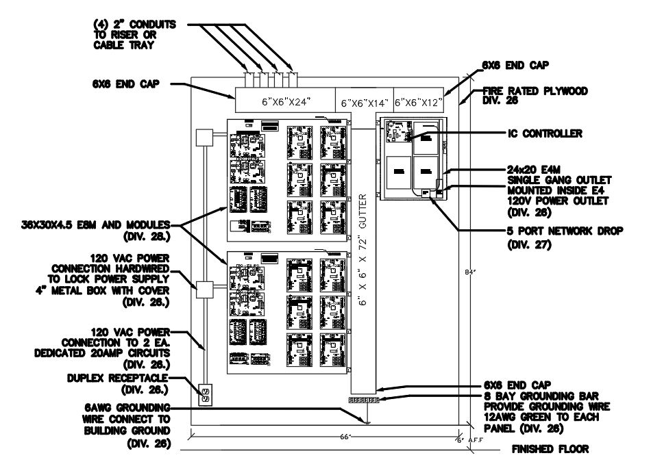
Figure 2 - Example of Typical EAC Backboard

