**SECTION 26 29 13**

**ENCLOSED MOTOR CONTROLLERS**

**PART 1 - GENERAL**

# RELATED DOCUMENTS:

#### The Conditions of the Contract and applicable requirements of Divisions 0 and 1 and Section 26 00 01, “Electrical General Provisions”, govern this Section.

# DESCRIPTION OF WORK:

#### Work Included: The extent of motor starter work is as shown and scheduled, as indicated by the requirements of this Section, and as specified elsewhere in these Specifications.

#### Types: The types of motor starters required for the project include, but are not limited to, the following:

##### Individual motor starters.

##### Combination motor starters.

##### Manual motor starters.

# STANDARDS:

#### Products shall be designed, manufactured, tested, and installed in compliance with the following standards:

##### NEMA ICS 2 Industrial Control Devices, Controllers, and Assemblies.

##### NEMA KS 1 Enclosed Switches.

# QUALITY ASSURANCE:

#### Manufacturers: Provide products complying with these specifications and produced by one of the following:

##### Allen-Bradley.

##### Cutler-Hammer, Inc.

##### General Electric Company.

##### Square D Company.

##### Siemens.

#### UL Listing: Motor starters shall conform to all applicable UL Standards and shall be UL‑listed.

# SUBMITTALS:

#### Shop drawing submittals shall include, but not be limited to, the following:

##### Cut sheets of individual and combination motor starters with construction, ratings, voltage, poles, and all associated accessories clearly indicated.

##### Cut sheets of manual motor starters with ratings, voltage, poles, and all associated accessories clearly indicated.

##### Cut sheets of manual motor disconnect switches with ratings, voltage, poles, and all associated accessories clearly indicated.

##### Additional information as required in Section 26 00 01, “Electrical General Provisions”.

# PRODUCT DELIVERY, STORAGE AND HANDLING:

#### Store motor starters in a clean, dry space. Maintain factory-wrapping or provide an additional heavy canvas or heavy plastic cover to protect units from dirt, water, construction debris, and traffic.

#### Handle motor starters carefully to avoid damage to material components, enclosure and finish.

**PART 2 - PRODUCTS**

## INDIVIDUAL MOTOR STARTERS:

#### General: Individual motor starters shall consist of an integrally mounted, magnetic, full-voltage, non-reversing (FVNR), 2‑speed - 1‑winding (2S-1W), or 2‑speed - 2‑winding (2S‑2W) starter in a heavy-duty type, dead front, sheet steel enclosure and shall be surface-mounted. Size and number of poles shall be as shown and required by equipment served. All starters shall be constructed and tested in accordance with the latest NEMA standards and shall be NEMA standard sizes. IEC sizes are not acceptable. All starters shall contain 480V – 120V control transformer.

#### Contacts: Magnetic starter contacts shall be solid silver cadmium oxide alloy and shall not require any filing, dressing or cleaning throughout the life of the starter.

#### Operating Coils: Operating coils shall be 120 volts and shall be pressure molded and designed so that accidental exposure to excessive voltage up to 480 volts will not damage the coil. The starter design shall also be such that when a coil fails due to an overvoltage condition, the starter shall definitely open and shall not freeze in the closed position.

**[SELECT WHICH ONE]**

#### Overload Relays: **[All starters shall have user selectable class 10/20/30 solid state overload relays. Overload relays shall have visual trip indication, be ambient insensitive within an operating temperature range to minus 20 and to plus 70 degrees Celsius. They shall provide built in thermal memory to prevent hot motor restarts. Relays shall provide protection against phase current loss, and phase current unbalance, adjustable from 20 to 50 percent for all 3 phases. Relay shall have adjustable full load current dial. They shall have a reset mechanism that resets on the upstroke only. OR They shall have remote reset capability.]**

#### Pilot Lights: Provide red RUNNING pilot lights for all motor starters. Furnish additional pilot lights for motor starters as shown. Provide amber FAST and green SLOW pilot lights for all two speed starters. Pilot lights shall be mounted in the starter enclosure cover. Pilot lights shall be operated from an interlock on the motor starter and shall not be wired across the operating coil. **Pilot lights shall be LED type.**

#### Controls: Provide starters with HAND-OFF-AUTOMATIC switches, or START-STOP pushbuttons as shown or required. Provide for FAST-SLOW speed selection from HVAC control system in the automatic position for all two speed starters. Provide two-speed starters with FAST-SLOW selector switches for manual speed selection in the HAND position. All two speed starters shall have deceleration relays between fast and slow speeds. Coordinate motor starter controls with the requirements of Division 15 **[and 17]**.. Motor starter controls shall be mounted in the starter enclosure cover.

#### Control Power: A single-phase control power transformer shall be included integrally with each starter for 120 volt control power. The primary shall be connected to the line side of the motor starter and shall have both legs fused; the secondary shall have one leg fused and one leg grounded. Arrange transformer terminals so that wiring to terminals will not be located above the transformer.

#### Auxiliary Contacts: Each starter shall have a minimum of one normally open and one normally closed convertible auxiliary contact in addition to the number of contacts required for the "holding interlock". Provide additional contacts if required for control, interlock, and monitoring. In addition, it shall be possible to field-install one or more additional auxiliary contacts without removing existing wiring or removing the starter from its enclosure.

#### Unit Wiring: Unit shall be completely prewired to terminals to eliminate any interior field wiring except for:

##### Connection of power supply conductors to switch line side terminals.

##### Motor leads to the starter load side terminals.

##### Control conductors to holding coil terminals.

#### Power Monitor: Provide a Square D Type MPS, Taylor Phase Guard, Diversified Electronics, or Agastat Electronics phase failure/phase reversal relay for each 3‑phase motor starter serving a motor of **[____ hp] [1 hp]** or greater. Monitor relay shall drop out upon loss of any phase, undervoltage on any or all phases, or phase reversal from A‑B‑C sequence. Relay shall be adjustable for trip range and shall automatically reset upon correction of trouble. Starters with integral phase failure protection are acceptable**.[delete this paragraph if solid state relay selected]**

#### Enclosures: All motor starter enclosures shall be NEMA 1, general purpose enclosures, unless shown otherwise.

## COMBINATION MOTOR STARTERS:

#### General: Combination motor starters shall consist of an integrally mounted magnetic starter and a breaker type disconnect switch in a heavy-duty type, dead front, sheet steel NEMA 1 enclosure, surface-mounted. Size and number of poles shall be as shown and required by equipment served. Combination motor starters shall be as specified for individual motor starters in Paragraph 2.1, except as modified herein.

#### Disconnect Switch: Disconnect switches shall be as specified in Section 16170, "Safety and Disconnect Switches".

#### Unit Wiring: Unit shall be completely prewired to terminals to eliminate any interior field wiring except for:

##### Connection of power supply conductors to switch line side terminals.

##### Motor leads to the starter load side terminals.

##### Control conductors to holding coil terminals.

#### Enclosures: All combination motor starter enclosures shall be NEMA 1, general purpose enclosures, unless shown otherwise.

## MANUAL MOTOR STARTERS:

#### General: Manual motor starters shall consist of an integral starter and overload protection in a common enclosure, surface-mounted. Size and number of poles shall be as shown and required by equipment served. Furnish pilot light as indicated.

#### Manual Motor Starter: Manual motor starter with overload protection, one horsepower maximum, 115 or 230 volts; Square D Class 2510 FG‑1‑(1) Pole, FG‑2‑(2) Pole; Square D Class 2510 FG‑1P‑(1) Pole with pilot light, and FG‑2P‑(2) Pole with pilot light.

#### Enclosures: All manual motor starter enclosures shall be NEMA 1, general purpose enclosures, unless shown otherwise.

#### Switch: For self-protected motors where a single pole toggle motor control switch is allowed, the switch shall be as specified for toggle switches in Section 26 27 26, "Wiring Devices".

**PART 3 ‑ EXECUTION**

### INSTALLATION OF MOTOR STARTERS:

#### General: Install motor starters where shown, in accordance with the manufacturer's written instructions, the applicable requirements of the NEC and the NECA's "Standard of Installation", and recognized industry practices to ensure that products serve the intended function. Major equipment motor starters located in mechanical rooms that are a part of the main building service shall be located so as to be accessible “within arm’s reach” without resort to a ladder.

**[SELECT WHICH ONE]**

#### **[Overloads: provide solid state adjustable overload relays in each motor starter. Ratings shall be set based on actual motor nameplate full load amps.]**

#### Coordination: Motor starters shall be provided to properly coordinate with motors as furnished by Divisions 23 and 25. Motor starter controls shall be provided to properly coordinate with controls specified in Divisions 23 and 25.

#### Supports: Provide all individual and combination motor starters with galvanized angle or other suitable supports where mounting on wall or other rigid surface is impractical. Starters shall not be supported by conduit alone. Where motor starters are mounted on equipment served, the switch shall not inhibit removal of any service panels or interfere with any required access areas. All motor starters shall be installed plumb and aligned in the plane of the wall in/on which they are installed.

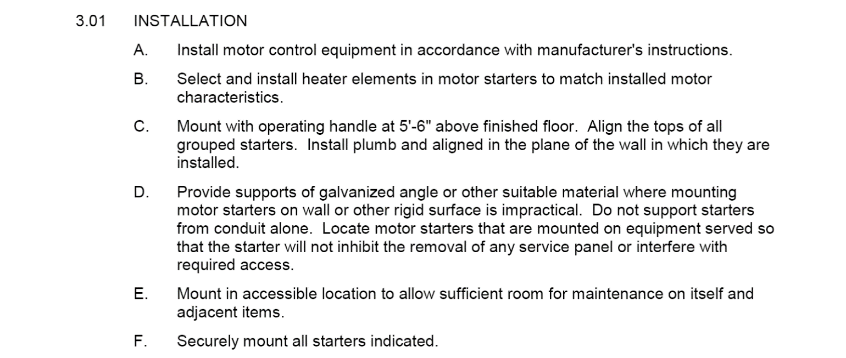

### TESTING:

#### Pre‑energization Check: Check motor starters for continuity of circuits, short circuits, presents of foreign material, and remedy prior to energizing.

#### Post Hookup Test: Subsequent to wire and cable hook‑ups, energize motor starter and demonstrate satisfactory functioning.

#### Motor-starter Coordination Documentation: Provide motor-starter coordination documents including, but not limited to, the following information in the operation and maintenance manuals.

##### Motor size in horsepower.

##### Motor full load amps.

##### Motor efficiency.

##### Motor service factor.

##### Size and manufacturer's catalog number of starter and thermal overloads.

#### Motor Rotation: Verify that motor rotation is correct as connected. Where rotation must be changed, reconnect phase conductors to motor leads at motor junction box.

### IDENTIFICATION:

#### Refer to Section 26 05 53, “Identification for Electrical Systems”, for painting and nameplate requirements for all motor starters.

#### Every starter shall have an internal wiring diagram on the inside of the starter cover and shall be labeled inside the cover to indicate the type and ampacity of thermal overloads installed.

**END OF SECTION 26 29 13**