Reviewing Submittals
Overview: Submittals submitted by vendors require review prior response. Specification section requiring UH review will automatically be routed to the appropriate UH reviewer for comment.
Reference: N/A

- Click on FORMS  2  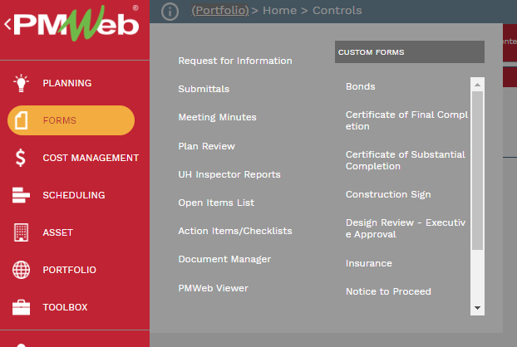  1 | - Click on Submittals
- OR, click on the link provided in the PM Web notification e-mail.
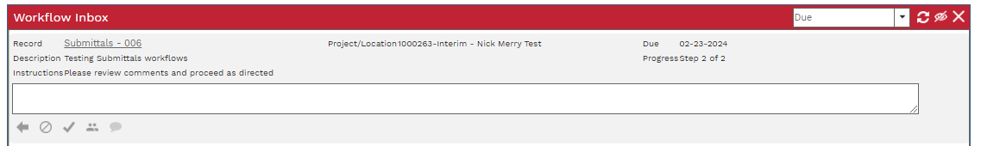
- OR, select from the Workflow Inbox in your PM Web home screen
Design Team Reviewer
- Select the ATTACMENTS tab and review the submittal documents.
- Download submittal cover sheet.
- If submittal requires UH review, add draft comments to submittal cover sheet and attach in the ATTACHMENTS tab.
- Under the WORKFLOW tab, select the SUBMIT button.
- Select REVIEW COMPLETED from the ACTIONs list, then click on SAVE.
- Proceed to Step 26 or 32.
- If submittal does NOT require UH review, add final comments to submittal cover sheet and attach in the ATTACHMENTS tab.
- Under the WORKFLOW tab, select the SUBMIT button.
- Select the appropriate action from the ACTION list (RESUBMIT, RETURN, FINAL APPROVE), then click on SAVE.

UH Reviewer
- Review the submittal and draft Design Team comments.
- UHS Reviewers are not required to submit comments. If choosing to comment, select the ‘Details’ tab at the bottom.
- Click on the Layouts button to verify the ‘Submittals’ layout is selected.
- Click on the ‘+Add’ button.
- In the ‘Sub #’ column, enter the submittal number or set number if applicable.
- In the ‘UH Reviewer’ column, enter your name
- Enter comments in the ‘UHS Reviewer Comments’ column.
- Click the Save icon in the bottom header bar.
- To add additional comments, repeat the above steps.
- Optional, when review is complete, select the ‘WORKFLOW’ tab at the bottom.
- Select the button next to ‘COMPLETE REVIEW’ in the ‘ACTIONS’ box.
- Click the Save button.
Additional TEAM Input
- To forward the submittal for input from additional team members with PM Web accounts, under the WORKFLOW tab, select the TEAM INPUT button
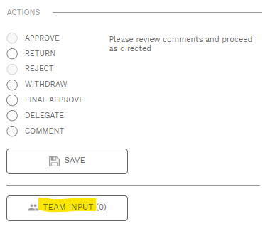
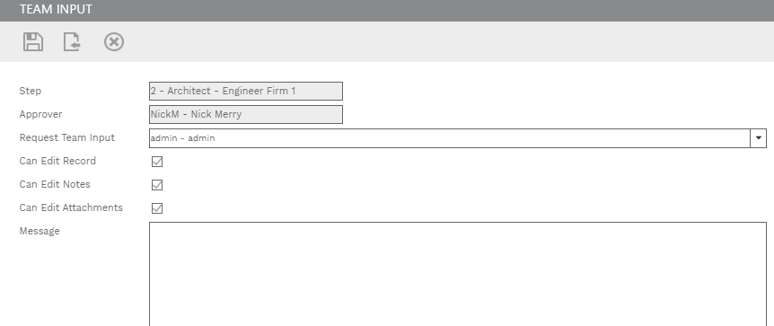
30
27
28

29
- In the popup window, select team members to receive edit rights for the record. You can start typing a name to refine the list.
- Check boxes for edit rights to be given.
- Enter any comments in the Message box
- Click on the Save & Exit button.
- IMPORTANT, you MUST then click on the SAVE button under ACTIONS for the TEAM INPUT to be sent.
Design Team Reviewer
- Select the ‘MAIN’ tab at the top.
- Review any comments provided by UH Reviewers
- Select all rows to review and click on the Edit button in the bottom header bar.
- In the ‘Design Team Response’ column, provide comments.
- In the ‘Action Taken’ column, select the appropriate action taken.
- Click the Update Records icon in the bottom header bar.
- When all UHS Reviewer comments have been reviewed, update comments on the submittal set cover sheet and include as an attachment labeled as ‘Final Design Team Comments’.
- Select the ‘Workflow’ tab at the bottom.
- Select the appropriate action from the ACTION list (RESUBMIT, RETURN, FINAL APPROVE), then click on SAVE.
- Process complete.

