UH Guideline for Nanomaterials

Table of Contents
1.0 Introduction 3
2.0 Purpose and Scope 3
3.0 Overview of Nanomaterials 4
4.0 Planning your research 6
4.1. Gather Information 6
4.2. Determine Potential Risks 6
4.3. Develop a Laboratory-specific Standard Operating Procedure (SOP) 6
4.4. Obtain Training and Consultation/Approval 6
5.0 Conducting your research 7
5.1 Minimize Exposures 7
5.1.1 Engineering Controls 7
5.1.2 Administrative Controls 8
5.1.3 Personal Protective Equipment (PPE) 9
5.2. Respond to Exposures and Spills 10
5.3. Waste Management 11
6.0 Quick Guide for Risk Levels and Control Measures for Nanomaterial 13
7.0 Reference 17
8.0 Standard Operating Procedures Template for Nanomaterials 18

1.0 Introduction

The increasing use of nanomaterials in research and development laboratories along with applications in industry are providing breakthroughs for many technologies and solutions for addressing major problems in our society. However, as with all new technologies, the potential health effects of engineered nanomaterials (ENMs) remain uncertain. The aim of this project is to provide practical guidance as to how ENMs must be handled safely in the research laboratory setting in the face of such uncertainty over possible toxic effects.

Currently many government agencies, academic institutions, and industries have issued detailed guidance documents as to how NMs can be monitored, controlled, and handled in different work settings. Only a portion of these practices have been validated by scientific research or reference to peer reviewed literature. Most guidance documents and exposure studies to date have focused primarily on industrial settings, but academic research settings present their own challenges that also need to be addressed. Much of the initial research and development in nanotechnology is still performed in academic research laboratories. In academic laboratories, the quantity of materials used tends to be less than those used in industry, but the variety of nanomaterials used tends to be more diverse. As a result, the potential hazards are also more diverse and exposure monitoring is more challenging. Furthermore, academic practices tend to be less standardized and to vary more from lab to lab and from day to day than typical industrial processes. This means that engineering controls which are commonly used in industry may not be practical to apply in academic laboratory research settings.

The nature of research and training in academic institutions dictates that new students and employees with various backgrounds and levels of training are regularly being introduced into the many diverse laboratory settings. Undergraduate student researchers, graduate students and other laboratory personnel often have minimal formal safety training or are lacking the latest hazard information about such new technological developments. All of these factors make a simple adoption or application of standardized industrial best practices for working with NMs in laboratories difficult.

2.0 Purpose and Scope

This guideline presents information on common laboratory operations involving engineered nanomaterials according to their potential risk of exposure to personnel, which is based on the state of the material and the conditions of use. Controls are provided in the table to minimize exposures. This guide is intended to be used in conjunction with the UH laboratory safety practices (UH Chemical Hygiene Plan, UH General Laboratory Safety Manual or other established guidelines (e.g., Prudent Practices by The National Research Council). All UH Laboratory Personnel who work in labs containing nanomaterials must familiarize themselves with this policy. Laboratory-specific Standard Operating Procedures for nanomaterials must be provided by Principle Investigator (PI) and used to train all the nanomaterial users in his/her laboratory. A copy of the signature page, the last page of this document, must be kept by the PI and Designee acknowledging nanomaterial users have read this document and are aware of the unique dangers and precautions that must be taken when handling the nanomaterials.

3.0 Overview of Nanomaterials

Definitions of Nanomaterial: Material or particle with any external dimension in the nanoscale (range 1 nm to 100 nm) or having internal structure or surface structure in the nanoscale.^{1,2}
Naturally Occurring Nanomaterial: Particles on the nanoscale occur naturally in the environment. They can also be manufactured and have a variety of commercial applications.
Engineered Nanomaterials (ENMs): An Engineered Nanomaterial is any intentionally produced material with any external dimension in the nanoscale. It is noted that neither 1 nm nor 100 nm is a “bright line” and some materials are considered engineered nanomaterials that fall outside this range. For example, Buckyballs are also included even though they have a size <1 nm. Excluded are materials that are on the nanoscale, but do not have properties that differ from their bulk counterpart and micelles and single polymers.³
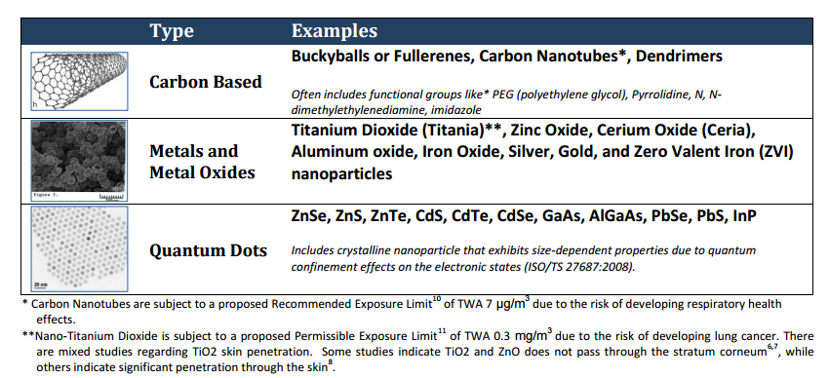
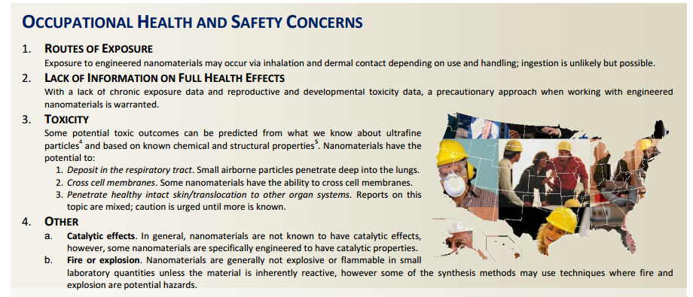
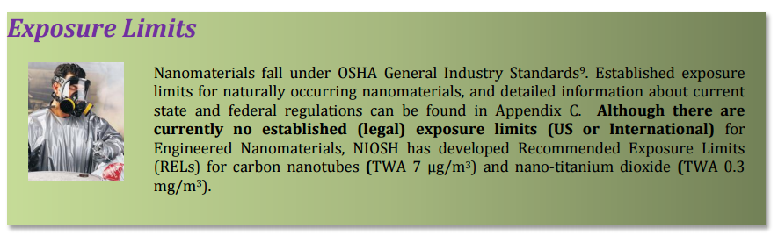

4.0 Planning your research

4.1. Gather Information

Select less-hazardous forms.
Whenever possible, select engineered nanomaterials bound in a substrate or matrix or in water-based liquid suspensions or gels.

Review Safety Data Sheet (SDS), if available.
NOTE: Information contained in some SDSs may not be fully accurate and/or may be more relevant to the properties of the bulk material rather than the nano-size particles. The toxicity of the nanomaterials may be greater than the parent compound.

Review UH Chemical Hygiene Plan for general laboratory safety guidance.

4.2. Determine Potential Risks

Common laboratory operations involving ENMs may be categorized as posing a low, moderate, or high potential exposure risk to researchers depending on the state of the material and the conditions of use. Refer to the Quick Guide for Risk Levels and Control Measures for Nanomaterials. Follow the instructions in this matrix to identify the potential risk of exposure and recommended control measures. Special consideration shall be given to the high reactivity of some nanopowders with regard to potential fire and explosion, particularly if scaling up the process. Consider the hazards of the precursor materials in evaluating the process.

4.3. Develop a Laboratory-specific Standard Operating Procedure (SOP)

A laboratory-specific standard operating procedure (SOP) is a set of written instructions that describes in detail how to perform a laboratory process or experiment safely and effectively. Employing the hierarchy of controls described in Quick Guide for Risk Levels and Control Measures for Nanomaterials, establish an SOP for operations involving nanomaterials.

4.4. Obtain Training and Consultation/Approval

Training. Principal Investigators or Designee must ensure that researchers have both general laboratory safety training and lab-specific training relevant to the nanomaterials and associated hazardous chemicals used in the process/experiment. Laboratory-specific training can include a review of this policy, the relevant Safety Data Sheets (if available), and the lab’s Standard Operating Procedure (SOP) for the experiment.
Consultation/Approval. Consult with and seek prior approval of the Principal Investigator prior to procuring or working with nanomaterials.
Notification. If dosing animals with the nanomaterial, follow institution’s hazard communication processes for advanced notification of animal facility and cage labeling/management requirements.

5.0 Conducting your research
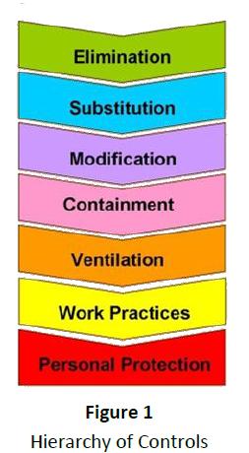
Controlling potential exposures to nanomaterials involves elimination of highly hazardous materials through substitution, engineering controls, administrative or work practices, and personal protective equipment. The hierarchy of controls are shown in Figure 1. If the nanomaterial cannot be substituted with a less hazardous substance, then engineering controls must be installed to control exposure.

5.1 Minimize Exposures

5.1.1 Engineering Controls

CONTROL EXPOSURE WITH EQUIPMENT

Minimize airborne release of ENMs by utilizing one of the following devices:

- Fume Hoods When using a fume hood to contain dust or aerosols of nanomaterials, follow good fume hood use practices such as working 6” back from sash, working with sash below 18”, removing arms slowly from hoods to prevent dragging out contaminants, and not blocking the lower back slot with equipment.
- Biosafety Cabinets Only Class II type A2, B1 or B2 biosafety cabinets which are exhausted into the building ventilation system may be used for nanomaterials work. BSCs that recirculate into the room may not be used. There is recirculation of air inside type A2 and B1 cabinets, so care must be taken not to perform extremely dusty processes in these cabinets as the internal fans of the BSC are not explosion proof. The air in the type B2 cabinet is 100% exhausted and standard amounts of nanomaterials and solvents may be used in this type of enclosure. EHS shall be consulted when considering a biosafety cabinet for control of nanomaterials.
- Ventilation for furnaces and reactors must be provided to exhaust gases generated by this equipment. Unless unfeasible, exhaust gases must be run through a liquid filled bubbler to catch particulate before it enters the building ventilation system. Parts removed from reactors or furnaces for cleaning that may be contaminated with nanomaterial residue shall be repaired or cleaned in a fume hood or other type of exhausted enclosure.
- Use a glove box or fully-enclosed system. Where it is not possible to prevent airborne release, such as in grinding operations or in gas phase, use equipment that fully encloses the process. This includes a glove box.
- Use local capture exhaust hoods. Do not exhaust aerosols containing engineered nanoparticles into the interior of buildings. Use High-Efficiency Particulate Air (HEPA) filtered local exhaust ventilation (LEV). HEPA-filtered LEV must be located as close to the possible source of nanoparticles as possible and the installation must be properly engineered to maintain adequate ventilation capture. Use HEPA-filtered local capture exhaust hoods to capture any nanoparticles from tube furnaces, or chemical reaction vessels or during filter replacements.

ENSURE PERFORMANCE AND MAINTENANCE

Laboratory equipment and exhaust systems used with nanoscale materials shall be wet wiped and HEPA vacuumed prior to repair, disposal, or reuse. Make sure fume hoods and any LEV achieves and maintains adequate control of exposure at all times. These systems require regular maintenance and periodic monitoring to ensure controls are working and thorough examination and testing at least once a year.

5.1.2 Administrative Controls

USE SOLUTIONS OR SUBSTRATES

To minimize airborne release of engineered nanomaterials to the environment, nanomaterials are to be handled in solutions, or attached to substrates so that dry material is not released.

LOCATE SAFETY EQUIPMENT

Know the location and proper use of emergency equipment, such as emergency eyewash/safety showers, fire extinguishers, fire alarms, and spill clean-up kits.

USE SIGNS AND LABELS

Restrict access and post signs in area indicating ENM work. When leaving operations unattended, use cautious judgment: 1) Post signs to communicate appropriate warnings and precautions, 2) Anticipate potential equipment and facility failures, and 3) Provide appropriate containment for accidental release of hazardous chemicals.

CLEAN AND MAINTAIN

Line work area with absorbent pad. When working with powders, use antistatic paper and floor sticky mats. Wet wipe and/or HEPA-vacuum work surfaces potentially contaminated with nanoparticles (e.g., benches, glassware, apparatus) at the end of each operation.

MAINTAIN PERSONAL HYGIENE

To avoid potential nanoparticle or chemical exposure via ingestion in area where ENMs are used or stored, do not: consume or store food and beverages, apply cosmetics, or use mouth suction for pipetting or siphoning. Remove gloves when leaving the laboratory in order to prevent contamination of doorknobs or other common use objects such as phones, multiuser computers, etc. Wash hands frequently to minimize potential chemical or nanoparticle exposure through ingestion and dermal contact.

STORE AND LABEL PROPERLY

Store nanomaterials in a well-sealed container. Label all chemical containers with the identity of the contents (do not use abbreviations/ acronyms); include term “nano” in descriptor (e.g., “nano-zinc oxide particles” rather than just “zinc oxide.” Include hazard warning and chemical concentration information, if known.

TRANSPORT IN SECONDARY CONTAINMENT

Nanomaterials removed from furnaces, reactors, or other enclosures shall be put in sealed containers with secondary containment for transport to other locations on UH campus. If nanomaterial product from a reactor is bound or adhered to a substrate, the substrate may be removed and put in a transport container. If the nanomaterials product is unbound and easily dispersible (such as in CNT synthesis using aerosolized catalyst), the removal from a reactor shall be done with supplementary exhaust ventilation or a glove bag connected to a HEPA vacuum.

TRANSPORTATION OF NANOMATERIALS OFF-SITE

Transportation of nanomaterials to offsite locations and other universities or laboratories outside of UH may be covered by DOT regulations. Improper packaging and/or transportation could lead to regulatory action and fines. Contact EHS for procedures to follow for shipping or transporting materials.

5.1.3 Personal Protective Equipment (PPE)

KNOW THE APPLICATIONS AND LIMITS

Many occupational safety and health issues associated with ENM’s are not fully understood (i.e., ENM toxicity, exposure metrics, fate and transport, etc.). The same uncertainty exists with how to select the myriad of available types of PPE and effectively use them to minimize the potential hazards associated with employee exposure to ENM hazards.

There is a growing body of evidence resulting from on-going research which indicates that commonly available PPE does have efficacy against specific sizes and types of ENMs. The PPE described within the Quick Guide was selected as a result of a comprehensive review of available guidance and published research available at the time the Guide was developed.

USE THE QUICK GUIDE

The user of this guideline directed to the Quick Guide for a description of the recommended PPE. Note that the referenced PPE increases for each Category consistent with the increasing exposure potential. The basic PPE ensemble described under Category 1 is to be augmented by the specific PPE in Category 2 and Category 3. The user is reminded of the following important issues associated with the safe and effective use of PPE:

Respiratory Protection. Mandatory use of respirators will require full adherence to the requirements of UH respiratory protection program. It is imperative that you consult with EHS prior to utilizing respiratory protection, even if that use is voluntary.

Gloves and Clothing. Glove material, fabrication process and thickness are significant issues which impact the permeation of ENM’s. Consequently, two layers of gloves may be needed for personal protection to be considered adequate. For more information, refer to Table 1.

The selection of dermal PPE for protection against ENM’s must also take into account other chemicals which may be part of the ENM matrix or use conditions (i.e., solvents, surfactants, carrier gases, etc.). Dermal PPE manufacturers provide permeation/penetration tables which allow the end user to select dermal PPE based upon performance criteria to specific chemical threats. The technique used to remove gloves (and all PPE) is very important so that any material contaminating the outer surfaces of the PPE does not impact the wearer. Change gloves routinely when using nanomaterials or if contamination is suspected. Keep contaminated gloves in plastic bags or sealed containers with proper label (include term “nano” in descriptor). Wash hands and forearms thoroughly after handling nanomaterials. If contamination of clothing is a concern, use disposable lab coats and dispose of through hazardous waste pickup.

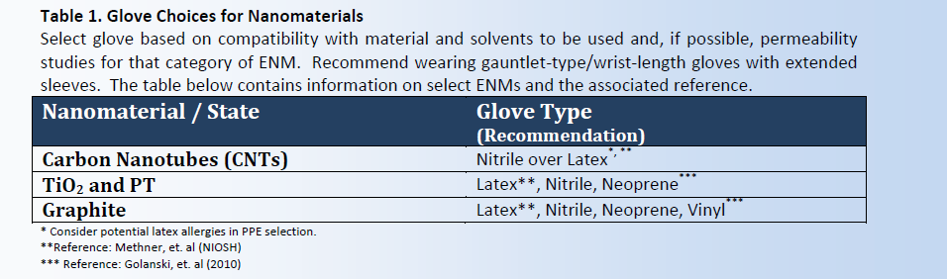

5.2. Respond to Exposures and Spills

Depending upon the quantity, physical properties, and storage media of nanomaterials in use in the lab, each shall procure the following items as applicable in a nanoparticle spill kit: barricade tape, nitrile gloves, disposable P100 respirators, adsorbent material, wipes, sealable plastic bags, walk-off mat (e.g. Tacki-MatTM). Minor spills or small quantities of nanomaterial can be wiped up using wet wiping for solid material and absorbent wipes for suspensions. Larger spills can be cleaned using a vacuum cleaner specially fitted with a HEPA filter on the exhaust to prevent dispersion into lab air. A log of HEPA vacuum use must be maintained so that incompatible materials are not collected on the HEPA filter. HEPA filter change-out shall be done in a fume hood. Contact the EHS for cleanup of major nanomaterial spills.
Actions to be taken in the event of a personnel exposure or a spill exposure are also listed as part of “Standard Operating Procedure (SOP) template for Nanomaterials.

5.3. Waste Management

There are no specific EPA regulations that apply to nanomaterial waste. University of Houston are taking a cautious approach and handling nanomaterial waste as hazardous. The following waste management guidance applies to nanomaterial-bearing waste streams consisting of:
- Pure nanomaterials (e.g., carbon nanotubes)
- Items contaminated with nanomaterials (e.g., wipes/PPE)
- Liquid suspensions containing nanomaterials
- Solid matrixes with nanomaterials that are friable or have a nanostructure loosely attached to the surface such that they can reasonably be expected to break free or leach out when in contact with air or water, or when subjected to reasonably foreseeable mechanical forces.

The guidance does not apply to nanomaterials embedded in a solid matrix that cannot reasonably be expected to break free or leach out when they contact air or water, but would apply to dusts and fines generated when cutting or milling such materials.
Nanomaterial – bearing waste streams shall not be placed into the regular trash or down the drain. If there are questions, the EHS shall be called for a waste determination.

Specific waste management guidance is as follows;
Paper, wipes, PPE and other items with loose contamination are collected in a plastic bag or other sealable container stored in a laboratory hood. When the bag is full, close it, and place it into a second plastic bag or other sealable container. Label the outer bag with the hazardous waste tag. The content section of the label must indicate that it contains nano sized particles and indicate what they are.

Characterize the other hazards of the waste: currently the disposal requirements for the base materials are considered first when characterizing these materials. If the base material is toxic, such as silver or cadmium, or the carrier is a hazardous waste, such as a flammable solvent or acid, they shall be identified on the red tag. Many nanoparticles may also be joined with toxic metals or chemicals. Bulk carbon is considered a flammable solid, so even carbon based nanomaterials shall be collected for determination as hazardous waste characteristics.

Manage waste streams containing ENMs according to the hazardous waste program requirements on UH Waste Manual. Until more information is available, assume ENM containing wastes to be hazardous waste unless they are known to be non-hazardous. Recommended management methods for typical research waste streams containing nanomaterials are described in Table 2.

Table 2. Recommended Nanomaterial waste management methods by stream.
Waste Stream | Management Method
Solid  - Dry ENM product  - Filter media containing ENMs  - Debris / dust from ENMs bound in matrix | - Manage according to UH Hazardous Waste Program.  - Label nanomaterial waste containers at all times. Specify the nanomaterial and its hazard characteristic (or the hazard characteristic of the parent material) on container labels; label information to contain the word “nano” as a descriptor.  - Keep containers closed at all times when not in use.  - Maintain containers in good condition and free of exterior contamination.  - Collect waste in rigid container with tight fitting lid.
Liquid  - Suspensions containing ENMs | - Manage according to UH Hazardous Waste Program.  - Label nanomaterial waste containers at all times. Specify the nanomaterial and its hazard characteristic (or the hazard characteristic of the parent material) on container labels; label information to contain the word “nano” as a descriptor.  - Keep containers closed at all times when not in use.  - Maintain containers in good condition and free of exterior contamination.  - Indicate both the chemical constituents of the solution and their hazard characteristics, and the identity and approximate percentage of ENMs on container labels.  - Use leak proof containers that are compatible with all contents.  - Place liquid waste containers in secondary containment and segregate from incompatible chemicals during storage.
Laboratory trash with trace nanomaterials  - PPE  - Sticky mats  - Spill clean-up materials | - Manage according to UH Hazardous Waste Program.  - Label nanomaterial waste containers at all times. Specify the nanomaterial and its hazard characteristic (or the hazard characteristic of the parent material) on container labels; label information to contain the word “nano” as a descriptor.  - Keep containers closed at all times when not in use.  - Maintain containers in good condition and free of exterior contamination.  - Dispose of in double clear plastic bags, folded over and taped at the neck.  - Avoid rupturing the bags during storage and transport.
Solid Matrix embedded with nanomaterials (intact and in good condition) | - Consult with your EHS, as these materials may be non-hazardous.

6.0 Quick Guide for Risk Levels and Control Measures for Nanomaterial

Purpose

This Quick Guide categorizes common laboratory operations involving engineered nanomaterials according to their potential risk of exposure to personnel, which is based on the state of the material and the conditions of use. Controls are provided in the table to minimize exposures. This guide is intended to be used in conjunction with the UH laboratory safety practices or other established guidelines.

Instructions
Follow these steps to create a Standard Operating Procedure:
- Step 1. Determine your risk level
- Step 2. Identify the controls needed
- Step 3. Develop a Standard Operating Procedure
Below are tables to assist you in completing each step. If your research falls in between two risk categories, consider employing the higher level control.

Step 1. Determine your risk level
Risk Level | Material State or Type of Use | Examples
Category 1  Lower Exposure Potential | Material State  No potential for airborne release (when handling)  - Solid: Bound in a substrate or matrix  - Liquid: Water-based liquid suspensions or gels  - Gas: No potential for release into air (when handling)  Type of Use  - No thermal or mechanical stress | - Non- destructive handling of solid engineered nanoparticle composites or nanoparticles permanently bonded to a substrate | 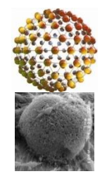
Category 2  Moderate Exposure Potential | Material State  Moderate potential for airborne release (when handling)  - Solid: Powders or Pellets  - Liquid: Solvent-based liquid suspensions or gels  - Air: Potential for release into air (when handling)  Type of Use  - Thermal or mechanical stress induced | - Pouring, heating ,or mixing liquid suspensions (e.g., stirring or pipetting), or operations with high degree of agitation involved (e.g., sonication)  - Weighing or transferring powders or pellets  - Changing bedding out of laboratory animal cages | 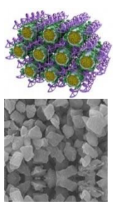
Category 3  Higher Exposure Potential | Material State  High potential for airborne release (when handling)  - Solid: Powders or Pellets with extreme potential for release into air  - Gas: Suspended in gas | - Generating or manipulating nanomaterials in gas phase or in aerosol form  - Furnace operations  - Cleaning reactors  - Changing filter elements  - Cleaning dust collection systems used to capture nanomaterials  - High speed abrading / grinding nanocomposite materials | 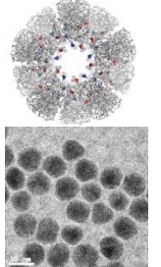
Step 2. Identify the controls needed
Use the table below to identify the controls needed to work with the risk level of your nanomaterial (Category 1, 2, or 3).
Risk level | Controls
Category 1 Low Exposure Potential | Engineering | - Fume Hood or Biosafety Cabinet. Perform work with open containers of nanomaterials in liquid suspension or gels in a laboratory-type fume hood or biosafety cabinet, as practical.
 | Work Practices | - Storage and labeling. Store in sealed container and secondary containment with other compatible chemicals. Label chemical container with identity of content (include the term “nano” in descriptor).  - Preparation. Line workspace with absorbent materials.  - Transfer in secondary containment. Transfer between laboratories or buildings in sealed containers with secondary containment.  - Housekeeping. Clean all surfaces potentially contaminated with nanoparticles (i.e., benches, glassware, apparatus) at the end of each operation using a HEPA vacuum and/or wet wiping methods. DO NOT dry sweep or use compressed air.  - Hygiene. Wash hands frequently. Upon leaving the work area, remove any PPE and wash hands, forearms, face, and neck.  - Notification. Follow institution’s hazard communication processes for advanced notification of animal facility and cage labeling/management requirements if dosing animals with the nanomaterial
 | PPE | - Eye protection. Wear proper safety glasses with side shields (for powders or liquids with low probability for dispersion into the air)  - Face protection. Use face shield where splash potential exists.  - Gloves. Wear disposable gloves to match the hazard, including consideration of other chemicals used in conjunction with nanomaterials (refer to Table 1. Glove Choices for Nanomaterials)  - Body protection. Wear laboratory coat and long pants (no cuffs).  - Closed toe shoes.
Category 2 Moderate Exposure Potential | Engineering | - Fume Hood, Biosafety Cabinet, or Enclosed System. Perform work in a laboratory-type fume hood, biosafety cabinet* (must be ducted if used in conjunction with volatile compounds), powder handling enclosure, or enclosed system (i.e., glove box, glove bag, or sealed chamber).
 | Work Practices | - Category 1 Work Practices. Follow all work practices listed for Category 1.  - Access. Restrict access.  - Signage. Post signs in area.  - Materials. Use antistatic paper and/or sticky mats with powders.
 | PPE | - Category 1 PPE. Wear all PPE listed for Category 1.  - Eye protection. Wear proper chemical splash goggles (for liquids with powders with moderate to high probability for dispersion into the air).  - Gloves. Wear two layers of disposable, chemical-protective gloves.  - Body protection. Wear laboratory coat made of non-woven fabrics with elastic at the wrists (disposable Tyvek®-type coveralls preferred).  - Closed toe shoes. Wear disposable over-the-shoe booties to prevent tracking nanomaterials from the laboratory when working with powders and pellets.  - Respiratory Protection. If working with engineering controls is not feasible, respiratory protection may be required. Consult an EHS professional for more information (i.e., N95 respirator, or one fitted with a P-100 cartridge).
Category 3 High Exposure Potential | Engineering | - Enclosed System. Perform work in an enclosed system (i.e., glove box, glove bag, or sealed chamber).
 | Work Practices | - Category 2 Work Practices. Follow all work practices listed for Category 2.
 | PPE | - Category 2. PPE Wear all PPE listed for Category 2.  - Body protection. Wear disposable Tyvek®-type coveralls with head coverage.  - Respiratory Protection. If working with engineering controls is not feasible, respiratory protection may be required. Consult EHS for more information (i.e., N95 respirator, or one fitted with a P-100 cartridge).

Step 3. Develop a Standard Operating Procedure Complete “Standard Operating Procedures (SOP) for the Laboratory Use of Nanomaterials”.

7.0 Reference

1 Lövestam, G., Rauscher, H., et al. (2010). Considerations on a Definition of Nanomaterial for Regulatory Purpose. Joint Research Centre (JRC) Reference Reports. Luxembourg, European Union [ISO TS 80004-1]
2 Council for Science and Technology Nanosciences and Nanotechnologies. (2007). A Review of Government’s Progress on Its Policy Commitments. Nano Review (11). London.
3 Good Nano Guide. (2007, March 13). What are nanomaterials? Retrieved June 16, 2011 from http://goodnanoguide.org/tiki-index.php?page=What+are+nanomaterials; and American Chemistry Council, Nanotechnology Panel. (2007, March 13). Consideration for a Definition for Engineered Nanomaterials. Retrieved June 16, 2011 from http://www.americanchemistry.com
4 Peters, A., Ruckerl, R., et al. (2011). Lessons From Air Pollution Epidemiology for Studies of Engineered Nanomaterials. Journal of Occupational and Environmental Medicine 53 (6 Supplement): S8-S13.
5 Castranova, V. (2011). Overview of Current Toxicological Knowledge of Engineered Nanoparticles. Journal of Occupational and Environmental Medicine 53 (6 Supplement): S14-S17.
6 Nohynek, G. J., EDufour, E.K., et al. (2008). Nanotechnology, Cosmetics and the Skin: Is There a Health Risk? Skin Pharmacology and Physiology 21(3): 136-149.
7 Sadrieh, N., Wokovich, A.M., et al. (2010). Lack of Significant Dermal Penetration of Titanium Dioxide from Sunscreen Formulations Containing Nano- and Submicron-Size TiO2 Particles. Toxicological Sciences 115 (1): 156-166.
8 Wu, J., Liu, W., et al. (2009). Toxicity and penetration of TiO2 nanoparticles in hairless mice and porcine skin after subchronic dermal exposure. Toxicology Letters 191 (1): 1-8.
9 OSHA. Nanotechnology Standards. http://www.osha.gov/dsg/nanotechnology/nanotech_standards.html

University Web Sites with Guidelines for Working with Nanomaterials
MIT. Potential Risks of Nanomaterials and How to Safely Handle Materials of Uncertain Toxicity. Available at http://ehs.mit.edu/site/content/nanomaterials-toxicity

MIT. Best Practices for Handling Nanomaterials in Laboratories.
Available at https://ehs.mit.edu/site/sites/default/files/files/University_Best_Practices.pdf

California Nanosafety Consortium of Higher Education. Nanotoolkit Working Safely with Engineered Nanomaterials in Academic Research Settings. Available at http://innovation.luskin.ucla.edu/sites/default/files/nano%20toolkit%202012%200419%20updated.pdf

8.0 Standard Operating Procedures Template for Nanomaterials
Chemical Name: Nanomaterials
STANDARD OPERATING PROCEDURES
This is an SOP template and is not complete until: 1) lab specific information is entered into the box below 2) lab specific protocol/procedure is added to the protocol/procedure section and 3) SOP has been signed and dated by the PI and relevant lab personnel.

According to the Safety Data Sheet (SDS) for Nanomaterials special precautions must be taken when working with this chemical. This operating procedure briefly describes the use of the equipment and supplies maintained at the facility, procedures that must be followed, and the responsibilities of personnel when working in these facilities. Amend SOP to reflect changes in procedure, equipment, etc. Do not conduct experiments, even pilot studies, which are not described in this approved SOP. It is essential that all personnel follow the appropriate procedures outlined in this SOP. Please provide the SDS associated with this chemical.

PI Acknowledgement
Name:
Dept:
PSID:
Date:
 | 1. PI Responsibilities (Please initial before each responsibility below.)
 | The Principal Investigator is responsible for training employees using the chemical. The training must include a discussion of the known and potential hazards and an explanation of the relevant policies, techniques and procedures including the proper use of personal protective equipment and containment equipment.
 | Employees shall be trained initially and then annually thereafter. Their knowledge, competence and practices must be evaluated and documented.
 | Implement a safety program and include this information in the chemical hygiene plan.
 | Limit access to authorized users.
 | Minimize the possibility of direct skin or eye contact with the drug or inadvertent ingestion/inhalation.
 | Transportation of the chemical within the facility should be performed using a sealed non-breakable container with secondary containment.
 | Develop Standard Operating Procedures (SOP) for delivery and storage of the chemical. The SOP must have a contingency plan for broken or leaking bottles.
 | Properly label containers and any secondary containers of the chemical.
 | Provide SDS via email to ehs@uh.edu
 | 2. Chemical Information
Nanomaterials are materials having one or more external dimensions, or an internal structure of 100 nm or less, which could exhibit novel characteristics compared to the same material without nanoscale features.

Special Circumstances of Use:
(Use this section to describe the circumstances of use, including the types of nanomaterials covered by this SOP, the shape and size of particles/fibers, and chemical composition. Include the approximate total mass that will be handled at a time as well as the frequency of use, along with a description of steps (such as synthesis, weighing, etc.) Please provide a 1-2 sentence brief description of the process. Indicate if aerosols are likely to be created.

Material State and Conditions of Use (check all that apply)  Nanomaterials are handled in/as:  ☐ dry particles (powders / pellets)  ☐ suspension / gels  ☐ gaseous phase |  |  |  |  |  | Frequency (check one):  ☐ one time  ☐ daily  ☐ weekly  ☐ monthly  ☐ other: |  |  |  |  |  | Duration per experiment:  ___________ minutes;  or _________ hours
Risk Level(check one):

☐ Category 1: low potential for exposure
☐ Category 2: moderate potential for exposure
☐ Category 3: high potential for exposure
Potential Hazards. Identify potential chemical and safety hazards using the safety data sheet (SDS) for the nanomaterial or parent compound. The toxicity of the nanomaterials may be greater than the parent compound. Special consideration must be given to the high reactivity of some nanopowders with regard to potential fire and explosion, particularly if scaling up the process. Consider the hazards of any precursor materials in evaluating the process. For more information, refer to the section on “planning your research”.

 |  | 3. Engineering Controls
If aerosols may be produced, nanomaterials (and any suspensions of nanomaterials) must be handled in a chemical fume hood, exhausted biological safety cabinet with negative pressure ductwork, or other exhausted enclosure. Aerosols may be produced during any open handling of dry powder, and during open or pressurized manipulations of suspensions.
Controls beyond those described above are warranted when aerosol generation of nanomaterials will be extensive, or will involve PHS parent materials or tubular or fibrous-shaped nanomaterials. These controls might include a higher level of containment and/or HEPA-filtration or other cleaning of exhaust.

Indicate engineering device(s) to be utilized. Note: if work cannot be conducted with appropriate engineering controls, consult with an EHS professional.
☐ Fume hood (laboratory-type)
☐ Biosafety cabinet (must be ducted if used in conjunction with volatile compounds)
☐ Enclosed system (i.e., glove box, glove bag, or sealed chamber)
☐ Powder handling enclosure
☐ other:

 |  | 4. Work Practice Controls
The following controls will be implemented (check all that apply):

☐ Category 1 work practices  - STORE in sealed container with secondary containment with other compatible chemicals  - LABEL chemical container with the identity of contents and include term “nano” as descriptor  - TRANSFER in sealed container with secondary containment  - PREPARE work space by lining with absorbent materials  - CLEAN all surfaces potentially contaminated with nanoparticles (e.g., benches, glassware, apparatus) at the end of each operation using a HEPA vacuum and/or wet wiping methods.  - WASH hands frequently. Upon leaving the nanomaterial work area, remove any PPE worn and wash hands, forearms, face, and neck.  - NOTIFY in advance of animal facility and cage labeling / management requirements if dosing animals with nanomaterial |  |  |  |  |  |  | ☐ Category 2 work practices  - FOLLOW all work practices listed for Category 1.  - RESTRICT ACCESS.  - POST signs in area  - USE antistatic paper and/or sticky mats with powders. |  |  |  |  |  | ☐ Category 3 work practices  - FOLLOW all work practices listed for Category 2.
☐Approvals Required.. Identify tasks that require prior approval by the principal investigator / laboratory supervisor before performing:

☐Other. Describe any additional work practices specific to the experiment / process:

 |  | 5. Personal Protective Equipment (PPE)
PERSONAL PROTECTIVE EQUIPMENT (PPE). INDICATE THE PPE TO BE UTILIZED (check all that apply):

Body Protection: | ☐ Long pants (no cuffs)  ☐ Laboratory coat made of standard materials  ☐ Laboratory coat made of non-woven fabrics with elastics at wrists (i.e., Tyvek®)  ☐ Coveralls (disposable) with head coverage (i.e., Tyvek®)
Eye / Face Protection: | ☐ Safety glasses with side shields  ☐ Chemical splash goggles  ☐ Face shield
Hand Protection: | ☐ Latex  ☐ Nitrile  ☐ Neoprene  ☐ Vinyl  ☐ Other:
Foot Protection: | ☐ Closed toe shoes  ☐ Over-the-shoe booties
Other: | ☐ Respiratory Protection*  ☐ Other:

 |  | 6. Storage
- Nanomaterials must be in sealed shatter-resistant containers during transportation. If the container is not shatter-resistant, use a secondary container.
- Containers must be labeled with nanomaterial name (or composition) and approximate particle size, along with any known hazard warnings.
- If the material may be flammable, reactive, or explosive, keep away from heat and open flame.
Keep these powders away from any incompatible materials.

List if any specific incompatibles.

 |  | 7. Accident and Spill Procedures
Location of nearest emergency equipment:

Item: | Location
Eyewash/Safety Shower
First Aid Kit
Chemical Spill Kit
Fire Extinguisher

Personnel Exposure procedures  1. Flush contamination from eyes/skin using the nearest emergency eyewash /shower for a minimum of 15 minutes. Remove any contaminated clothing.  2. Take copy of MSDS(s) of chemical(s) when seeking medical treatment.  3. Report potential exposures to your Principal Investigator/Laboratory Supervisor.  4. File an incident report with your institution. |  |  |  |  |  |  |  |  | Spill Response procedures  1. Notify. Alert workers near spill to avoid entering the area. Post signs in area or on door of lab. Eliminate sources of ignition. Report spill to your Principal Investigator/Lab Supervisor.  2. Assess. Are you able to cleanup spill yourself?   If YES Proceed with Spill Cleanup if it is a small spill (i.e., 30 mL), you are knowledgeable about the hazards of the spill, it can be cleaned up within 15 minutes, and an appropriate spill kit is available.  If NO Obtain spill assistance. Contact EHS.  3. Cleanup Spill. Wear existing PPE (NOTE: Respiratory protection may be required if spill / release is outside the engineering control device).  For powders:  - Use a dedicated, approved HEPA vacuum whose filtration effectiveness has been verified.  - Do not sweep dry nanoparticles or use compressed air.  - Consider possible pyrophoric hazards associated with vacuuming up nanoparticles.  - Wet wipe using damp cloths with soaps or cleaning oils, or commercially available wet or electrostatic microfiber cleaning cloths. Consider possible reactivity of nanoparticles with the wipe solvent.  For liquid dispersions:  - Apply absorbent material (appropriate for the solvent in the dispersion) to liquid spill.  4. Dispose. Dispose of used cleaning materials and wastes as hazardous waste.  5. Report. File incident to EHS.
 |  | 8. Waste Disposal
Indicate the nanomaterial waste management procedures to be utilized.

 | Waste Stream | Management Method
☐ | Solid  - Dry ENM product  - Filter media containing ENMs  - Debris / dust from ENMs bound in matrix | - Manage according to UH Hazardous Waste Program.  - Label nanomaterial waste containers at all times. Specify the nanomaterial and its hazard characteristic (or the hazard characteristic of the parent material) on container labels; label information to contain the word “nano” as a descriptor.  - Keep containers closed at all times when not in use.  - Maintain containers in good condition and free of exterior contamination.  - Collect waste in rigid container with tight fitting lid.
☐ | Liquid  - Suspensions containing ENMs | - Manage according to UH Hazardous Waste Program.  - Label nanomaterial waste containers at all times. Specify the nanomaterial and its hazard characteristic (or the hazard characteristic of the parent material) on container labels; label information to contain the word “nano” as a descriptor.  - Keep containers closed at all times when not in use.  - Maintain containers in good condition and free of exterior contamination.  - Indicate both the chemical constituents of the solution and their hazard characteristics, and the identity and approximate percentage of ENMs on container labels.  - Use leak proof containers that are compatible with all contents.  - Place liquid waste containers in secondary containment and segregate from incompatible chemicals during storage.
☐ | Laboratory trash with trace nanomaterials  - PPE  - Sticky mats  - Spill clean-up materials | - Manage according to UH Hazardous Waste Program.  - Label nanomaterial waste containers at all times. Specify the nanomaterial and its hazard characteristic (or the hazard characteristic of the parent material) on container labels; label information to contain the word “nano” as a descriptor.  - Keep containers closed at all times when not in use.  - Maintain containers in good condition and free of exterior contamination.  - Dispose of in double clear plastic bags, folded over and taped at the neck.  - Avoid rupturing the bags during storage and transport.
☐ | Solid Matrix embedded with nanomaterials (intact and in good condition) | - Consult with your EHS, as these materials may be non-hazardous.

Describe Laboratory-specific waste management procedures here (if applicable):

 |  | 10. Lab-specific Protocol/Procedure (Please add lab specific Protocol/Procedure here or attach additional pages as necessary)
 |  | 11. EHS Policy Requires
EHS policy requires that all chemical hazards must be clearly identified. If you have any questions regarding risk assessment and SOP development, contact the EHS office 713-743-5858 or ehs@uh.edu

This SOP must be supplemented with the UH Chemical Hygiene Plan and must include special practices when working with nanomaterial and the SDS must be accessible. Also, all laboratory personnel must be familiar with safe handling practices (i.e., training with proof of training).

 |  | PI Acknowledgement
By signing this form the individual certifies that the information provided is true and correct to the best of their knowledge.
Name: |  |  |  |  |  |  |  |  |  | E-Mail:
Signature: |  |  |  |  |  |  |  |  |  | Date:
Office Phone: |  |  |  |  |  |  |  |  |  | Cell Phone:
 |  | Trainer Acknowledgement
“I acknowledge that I have provided below training(s) to nano material users listed in ‘Trained Laboratory Personnel’.”

(check all the apply)
☐ Review the UH Nanomaterial Guideline
☐ Review the SDS for the nanomaterial(s), if available
☐ Review the SDS for other chemicals involved in the experiment/process
☐ Review this SOP

Name: |  |  |  |  |  |  |  |  |  |  | E-Mail:
Signature: |  |  |  |  |  |  |  |  |  |  | Date:
 |  | Trained Laboratory Personnel
“I have read and understand this SOP. I agree to fully adhere to its requirements. By signing below, I also acknowledge that I have received trainings for use of nanomaterials.”
Last |  |  |  | First | PSID |  |  | Email |  |  | Signature |  |  |  | Date

*This document, including the signature page with signatures by all involved personnel shall be maintained by the Principal Investigator or Designee, and be submitted to EHS either electronically via the ehs@uh.edu or hard copy upon request.

Template Revision History
Version | Date Approved | Author | Revision Notes:
1.0 | 07/01/2019 | EHLS Chemical Safety | New Template.
1.1 | 06/10/2020 | EHS Chemical Safety | Name & logo change, and review.

