Write the History of a Non-Profit Organization!
Co-Author a Published Article!
Learn About the History of Activism in Houston!
History 6383 Topics in Public History (Organizational Histories) Fall 2014 (Wed. 2:30-5:30, AH 520)

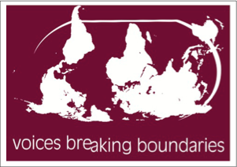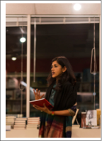

A Great Opportunity for Students (Graduate and Undergraduate*) Interested in Public History, Women’s Studies, and International/Local Activism.
Participants in this course will be trained how to produce an organizational history from start to finish. Archiving, interviewing, and researching skills will be covered, along with the methods and techniques of synthesizing data from a diverse array of sources (oral, digital, print). The final product will be posted on the VBB website and published in a future edition of the UH journal Houston History.
Come join this exciting Public History course to gain hands-on experience documenting the history of a non-profit organization. The goal of the course is to produce a history of Voices Breaking Boundaries (http://www.vbbarts.org), a multidisciplinary arts organization with a mission to cross borders, sustain dialogue and promote social justice through art. Founded in 200 by five women writers/artists: Sehba Sarwar, Marcela Descalzi, Jacsun Shah, Donna Perkins and Christine Choi, VBB has undergone a great deal of expansion and change since its inception. It is this change we will document, along with VBB’s long-term impact on Houston.

*To take part as an undergrad you must have achieved an A- average in the majority of your history classes, and get the instructors approval in advance. Please contact Dr. Klieman to discuss (kklieman@uh.edu). Note Also: this course can fulfill the capstone requirement for all History majors.

