Women & Pleasure
The Barbara Karkabi Living Archives Series
Presented by The University of Houston Friends of Women’s Studies
January 28, 2016
Panel Biographies

Sensitive topics may be addressed
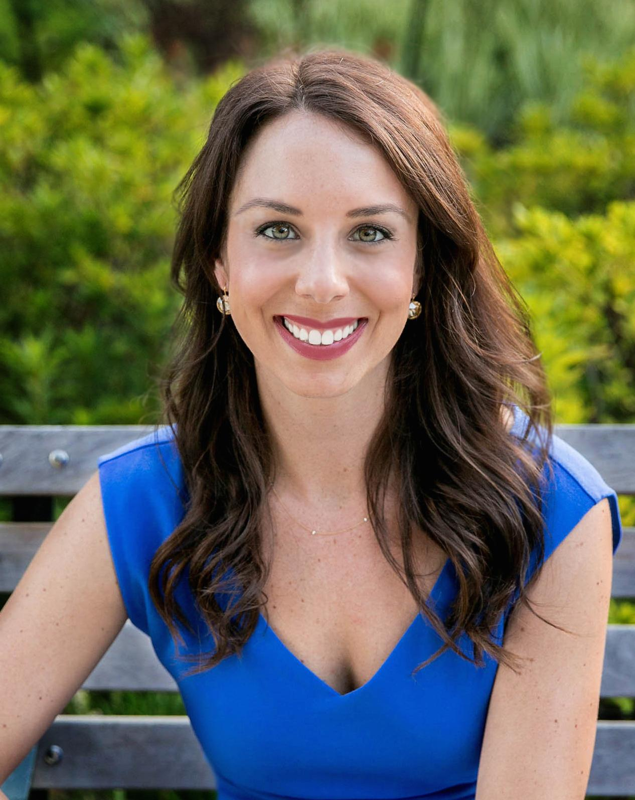
Emily deAyala completed her undergraduate work at the University of Texas at Austin, where she graduated with honors, receiving a BA in Psychology. She then completed her Master of Arts in Counseling at St. Edward’s University, with a dual emphasis in marriage and family therapy and licensed professional counseling. After her graduate program, Emily worked in both private practice and medical settings before eventually opening Houston Sex Therapy, PLLC in 2012.

Emily has given many guest lectures at Baylor College of Medicine, Rice University, MD Anderson, and at various support groups and meetings in the Houston area. She is also a regular contributor on Channel 11 Great Day Houston. Please contact Emily if you are interested in a guest lecture for your organization.

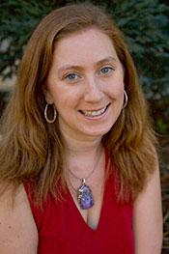
Sheila Katz, Ph.D. uses qualitative methodologies to explore women’s experiences in poverty, on welfare, accessing health and human services, in higher education, and during the Great Recession. She conducts longitudinal qualitative research with single mothers who graduated from higher education while participating in the welfare system in the San Francisco Bay Area. She interviewed the same participants three times, in 2006, 2008, 2011 with a 78% retention rate, and her research explores the needs of families who pursued higher education while on welfare, how families fared during/after the “Great Recession,” the role of grassroots advocacy organizations in their lives, and policy issues for welfare reauthorization. This project received national funding from the National Science Foundation and the National Poverty Center. She is currently writing the book manuscript based on this research: Reformed American Dreams: Welfare Mothers in Higher Education During the Great Recession.

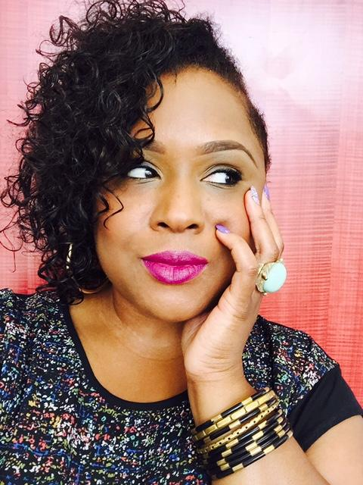
Josie Pickens also affectionately known as Jo Nubian, or simply Jo—is an activist, culture critic, scribe, educator and soldier of love. She utilizes all of her various talents and passions to uplift and translate the narratives of women and people of color through the lenses of creative writing, journalism, performance and professorship. As a columnist for Ebony Digital, Jo explores love and relationships in a manner that focuses on our humanity and self-love foremost, and specifically comments on topics associated with race and feminism. She also offers insightful and authentic cultural critique on subjects ranging from pop culture to politics for various publications including Ebony.com, The Root, The Guardian, and The Rumpus and serves as a composition instructor and mentor for students at Texas Southern University. She speaks locally and nationally in forums that discuss challenges African-Americans face in the media and particularly how current media trends affect African-American youth. She is presently working on two storytelling projects: one that seeks to chronicle African American love stories (particularly focusing on how Black music and Black love intersect,) and one that captures feminism through the stories Black matriarchs and Blues music. Jo’s recent TEDx Lubbock Women Talk entitled, “To Make Revolution Irresistible: Where Art, Activism and Story Telling Meet” focused on her work (specifically in Houston’s Third Ward community) as an educator, activist and griot. In addition to contributing to several publications, academic and otherwise, Jo blogs at www.jonubian.com. Follow Jo on twitter at @jonubian.
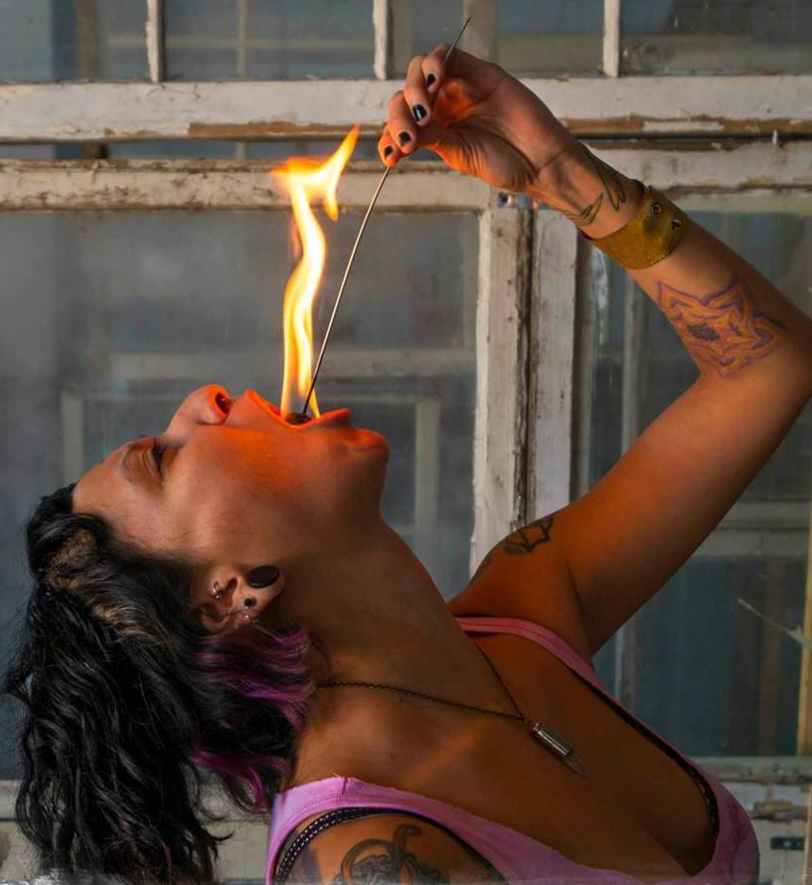
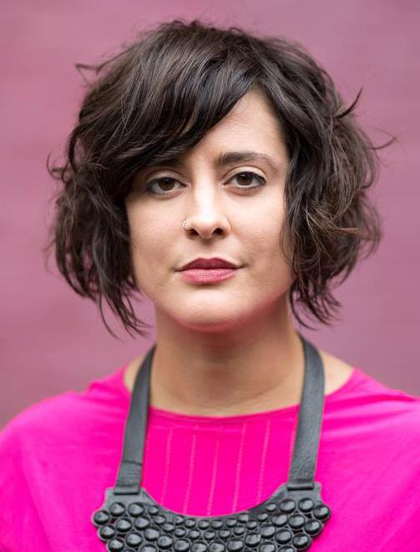
Y. E. Torres (ms. YET) is a fire bellydancer, improvisational muscle dancer (fusion bellydance), fire breather/fire eater, visual and performance artist, teacher, curator, model, and muse. Torres began her study of Oriental Dance at the age of 17 while attending Houston’s High School for the Performing and Visual Arts as a visual artist. After receiving a BFA in Drawing & Painting and a BFA in Fashion Design from the University of North Texas, Torres immediately returned to her dance and performance study. She is a Yoga instructor (200 RYT) and Bellydance/Fusion instructor. Torres is a Punk Rock Hoops certified hoopdance instructor, has completed Rachel Brice's 8 Elements™ Phase 2: Cultivation, has been Level One Certified by the Suhaila School of Bellydance, and continuously trains with a cast of present day masters of the bellydance and tribal fusion forms. Torres has exhibited her visual art and dance films at universities, museums and galleries throughout the US, in Europe, was named one of Houston's Top "100 Creatives" by the Houston Press in 2011 and was awarded Houston Press’ Best Artistic Collaboration in 2013 for her participation in the performance installation “Once There Was, Once There Wasn't: Two Tales From the Minds of Lisa Chow & Y.E. Torres”.

Sarah Luna, Ph.D. is currently a Postdoctoral Fellow in Women’s, Gender, and Sexuality Studies at the University of Houston (2014-2016). Luna earned her Ph.D. in Anthropology at the University of Chicago in 2013. Luna is currently working on her first book manuscript, Sex Workers and Missionaries Transforming Value on the U.S./Mexico Border. Luna’s book project is based upon her Fulbright-Hays funded dissertation research, which examined the projects of two kinds of migrants to a Mexican border city prostitution zone: (mostly Mexican) women who migrated to labor as sex workers and (mostly American) evangelical missionaries who migrated to build relationships with and a “modern day monastery” for sex workers. Her analysis of how these migrants created value through relations of obligation and love forges a dialogue between feminist approaches to sex work and the “rescue industry," anthropological theories of value and sovereignty, and political and cultural theories of non-sovereignty. Luna has also participated in collaborative feminist conceptual art projects and performances with artists, academics, and curators in San Diego, Oaxaca, and Mexico City, and she hopes to continue these projects in Houston.

Questions or to become a member: amccloud@uh.edu / 713.743.3773

The Barbara Karkabi Living Archives Series features panels and interviews with Houston women on diverse topics which are videotaped and collected in the Carey C. Shuart Women’s Archive at the UH library, Special Collections.

Follow us on Twitter: @FriendsofWomen
Like us on Facebook: facebook.com/wgss1
Visit our website: friendsofwomen.org

