PeopleSoft
Curriculum Management
Update Sections of a Class
Navigation: Main Menu > Curriculum Management > Schedule of Classes > Update Sections of a Class

Goals: Learn how to use this component to correct Class Associations and change Enrollment Capacity. Learn the codes of Class Type, Class Status, etc.

When accessing Update Sections of a Class, you need to enter the identifying information for the course you are searching and click the SEARCH button:

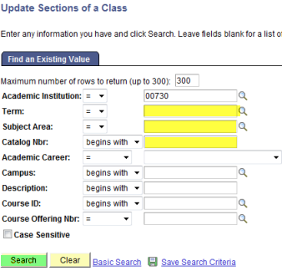

When you enter the course and catalog you will get a return of ALL sections for that course in that term. Notice it is giving you a view of 1-8 of 12. You can scroll to the other sections…

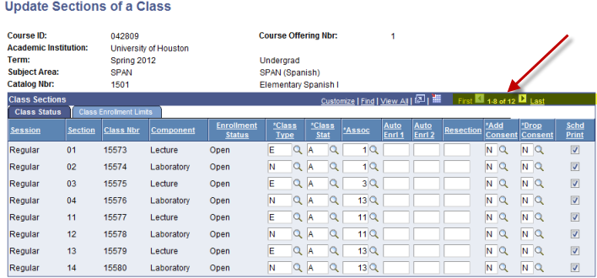
Most commonly used fields for the Class Status tab:
- Assoc
- Sched Print

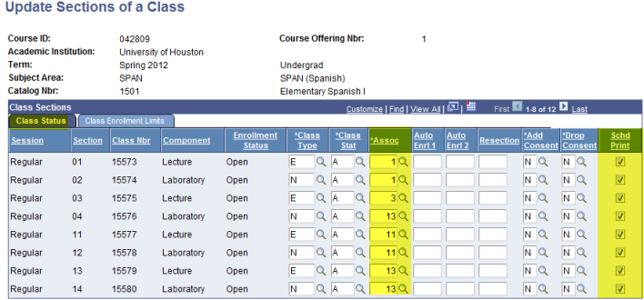

The Class Status tab allows you to change/correct the Associated Class-as long as there is NO enrollment. You may also either change the schedule print, making the section either viewable by the student or “hidden”.

Most commonly used fields for the Class Enrollment Limits tab:
- Enrl Cap

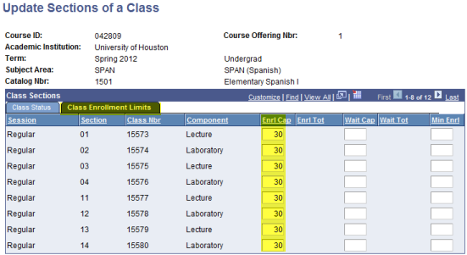

You may change the Enrollment Capacity using this component.

Practice:

Access PeopleSoft, Sandbox SA9SBX
Find PeopleSoft URL information at http://www.uh.edu/infotech/php/template.php?nonsvc_id=536
Make sure you access SA9SBX, not another database. Login should be your regular PSID/password, unless you changed it just before the refresh. In that case it will be the one prior.

SA9SBX is normally refreshed every Friday morning and may be unavailable during the refresh process.

Access Update Sections of a Class and perform the following tasks:

What is the navigation in PS to Update Sections of a Class?

Using SPAN 1501 (for the upcoming term):

Correct the Association of section 4 (lab) to be associated with section 3 (lecture)

Change the enrollment capacity of section 04 and 12 to 15.

Change the enrollment capacity of the LECTURES to which those classes are associated to 15.

Make sections 01 and 02 hidden sections.

Make sections 15 and 16 to where the students will be able to see them in the class schedule.

