PeopleSoft
Curriculum Management
Print Class Schedule
Navigation: Main Menu > Curriculum Management > Schedule of Classes > Print Class Schedule

Goals: To be able to guide schedulers in how to print the class schedule either totally, or only by college or department.

This is a REPORT

When you access Print Class Schedule you will need to enter a Run Control ID. One normally develops a routine to where they use the same pattern…for this report I usually use the TERM_LLD (my initials)_NSM(or whatever college/dept). It will end up looking like: 1860_LLD_NSM, or if I run it for a department it may be 1860_LLD_AAS.

This is what you will see when you access Print Class Schedule:

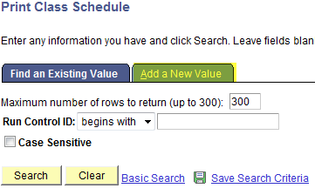

To run a new report, click on the Add A New Value tab. You will see the following:

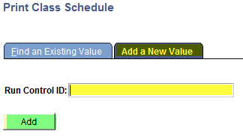

Enter your Run Control ID and click the Add button. You will get a box with two tabs, Print Class Schedule and Report Options:
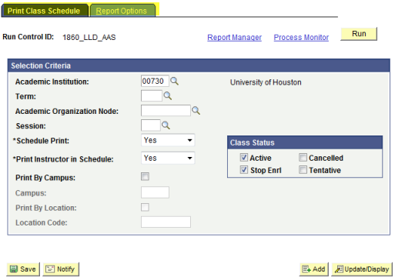

Tab 1 – Print Class Schedule tab:
Fields to be entered
- Term
- Academic Organization Node
- Session
- Print by Campus
- Campus
Optional Fields to be entered
- Schedule Print
- Print Instructor in Schedule
- Class Status
  - Active
  - Stop Enrl
  - Cancelled
  - Tentative

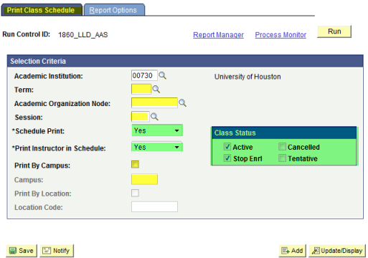

Tab 2 – Report Options tab:
Fields usually checked
- Print Meeting Pattern/Instr
- Print Class Notes
- Print Global Notes
- Print Class Nbr for Non-Enroll
Other fields that may be checked
- Print Meeting Pattern Topic
- Print Class Attributes
- Print Sections Combined
- Print Class Characteristics
- Print Class Enrollment Limits
- Print Requirement Designation
- Print Reserve Capacities
The REPORT ONLY box must be checked!
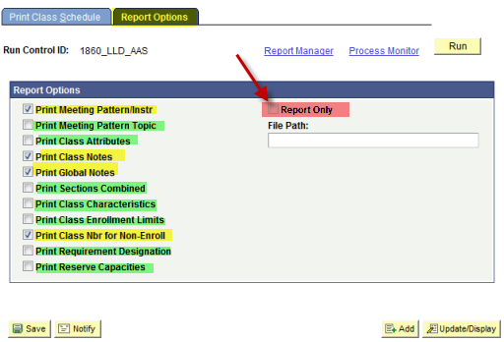

Your view should look like this for the example in running the Print Class Schedule for AAS:
Tab 1 – Print Class Schedule Tab:
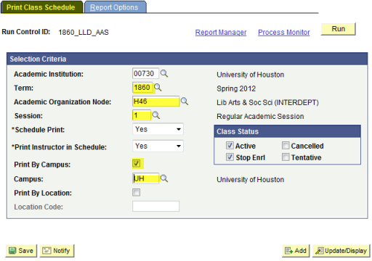

NOTE: For AAS, the department is very small, so to find out what the Academic Organization Node is, you can go to Maintain Schedule of Classes, and look on the Basic Data tab to see what Academic Organization AAS belongs. Larger departments may have their own code.

Tab 2 – Report Options Tab:
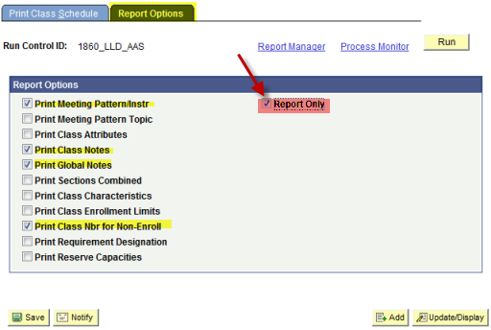
Once you have all your information in, the correct boxes checked, you will click the SAVE button, then click the RUN button. The Process Scheduler Request will appear. It is usually not necessary to enter a Server Name, however, if it asks for one, use PSNT. Click the OK button.
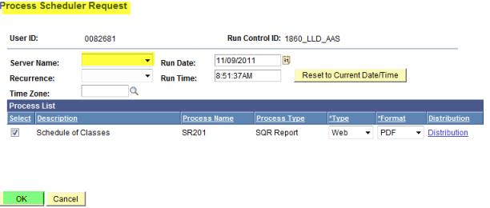

Once you click the OK button you will see it takes you back to the Report Options tab. Underneath the Process Monitor link, there will be a Process Instance number:
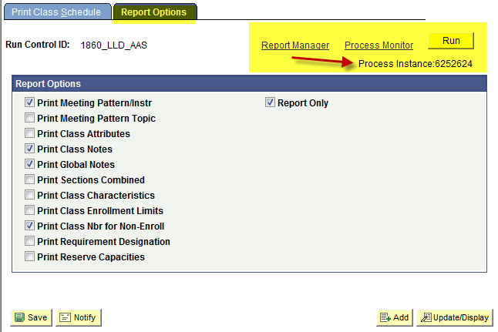
Click on the Process Monitor link and it will take you to the Process List page. You will see your PSID number under the User ID. When you process says SUCCESS, POSTED, then you may click on the DETAILS link:
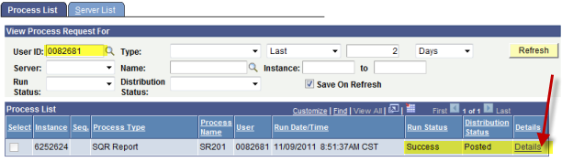

This will take you to the Process Detail page. You will click on the View Log/Trace link:
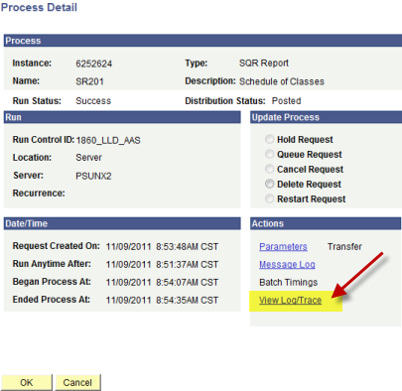
Once you get to the View Log/Trace page, you will click on the PDF link (middle line):
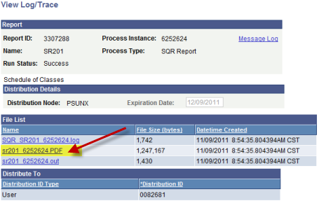

A new window will open, giving you your results.
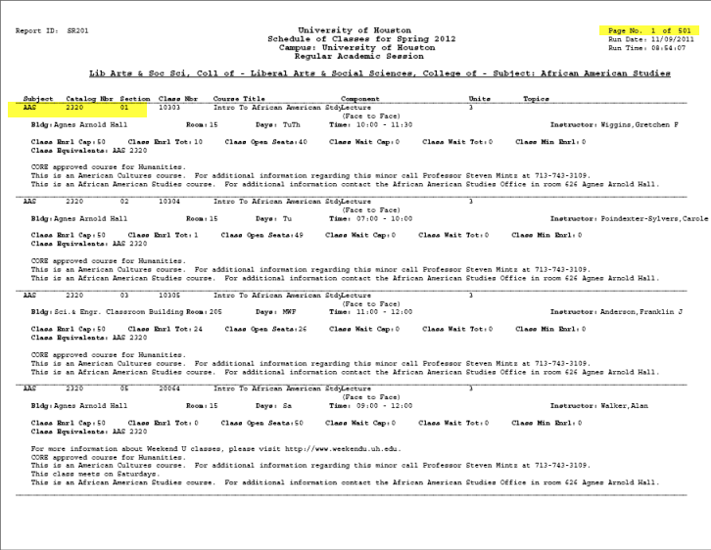

Notice that the report returned 501 pages. As mentioned earlier, since AAS is such a small department it is not possible to run a report for ONLY AAS, so the report printed the entire CLASS (College of Liberal Arts) schedule. One is able to print, however, only those pages needed if one chooses to print. Some of the larger departments will have their OWN print class schedule capability. AAS actually only has two pages (see following).

Practice:
Access PeopleSoft, Sandbox SA9SBX
Find PeopleSoft URL information at http://www.uh.edu/infotech/php/template.php?nonsvc_id=536
Make sure you access SA9SBX, not another database. Login should be your regular PSID/password, unless you changed it just before the refresh. In that case it will be the one prior.

SA9SBX is normally refreshed every Friday morning and may be unavailable during the refresh process.

Access the Print Class Schedule
What is the navigation in PS to Print Class Schedule?

Run a report to print a schedule for term 1860, MATH department.

Print only the pages that show MATH 1310.

A scheduler, from the department of English, calls and wants to print a class schedule for the mini session in term 1860. List the steps you would have the scheduler follow:

