PeopleSoft
Curriculum Management
Adjust Class Associations
Navigation: Main Menu > Curriculum Management > Schedule of Classes > Adjust Class Associations

Goals: Understanding of how to change the Grading Basis of a section, enter a Requirement Designation (most common, HONORS), and Class Requisites

When accessing Adjust Class Associations, you will need to enter the identifying information for the course you are searching and click the SAVE button:

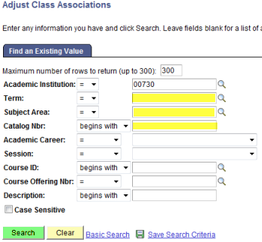

If there is more than one session (summer or mini for example) in the term, you will get the choice as to which to choose:

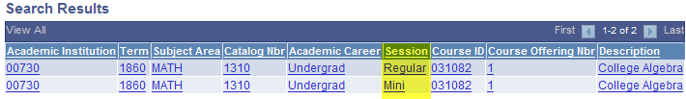

Once you choose, you will see a page with three tabs:

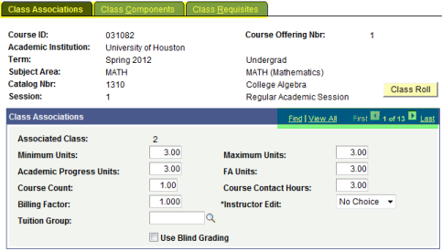

Class Associations, Class Components and Class Requisites
You will see that you have all the sections and can scroll through them to choose the one you wish to view.

Tab 1 – Class Associations Tab
There is no information here that should be altered by our department. This information is catalog information and should only be changed by the IR (Institutional Research) office.

Tab 2 – Class Components Tab
Normal Updates
- Grading Basis
- Requirement Designation

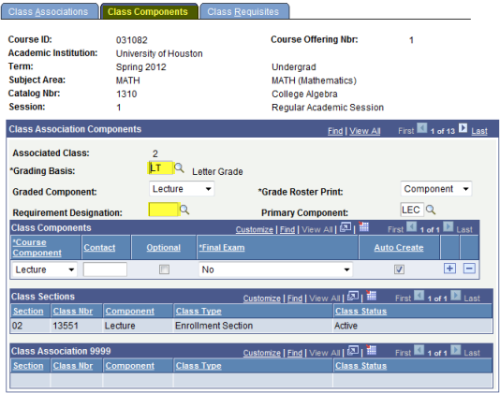

Grading Basis may only be changed BEFORE any enrollment. The scheduler should get the permission of IR to change the grading basis as it was approved in the catalog to be this way.

Requirement Designation is where you may designate a section to be HONORS (etc). This also must be done BEFORE enrollment. If there is enrollment in the class, the students must be dropped, designation assigned, and then reenroll the students. Otherwise it will not pertain to those students who were registered BEFORE the change was made.

Tab 3 – Class Requisites Tab
We will be receiving more information on this tab at a later date.

Practice:

Access PeopleSoft, Sandbox SA9SBX
Find PeopleSoft URL information at http://www.uh.edu/infotech/php/template.php?nonsvc_id=536
Make sure you access SA9SBX, not another database. Login should be your regular PSID/password, unless you changed it just before the refresh. In that case it will be the one prior.

SA9SBX is normally refreshed every Friday morning and may be unavailable during the refresh process.

Access Adjust Class Associations and perform the following:

Change the Grading Basis for SPAN 1501-3 (regular session) to MU.

Make the same class an HONORS class.

Change the maximum units of MATH 1310 to 5.

A scheduler calls you to say they want HIST 1377 to have a designation of U.S. History. List below the steps, in detail, you will direct the scheduler to make:

