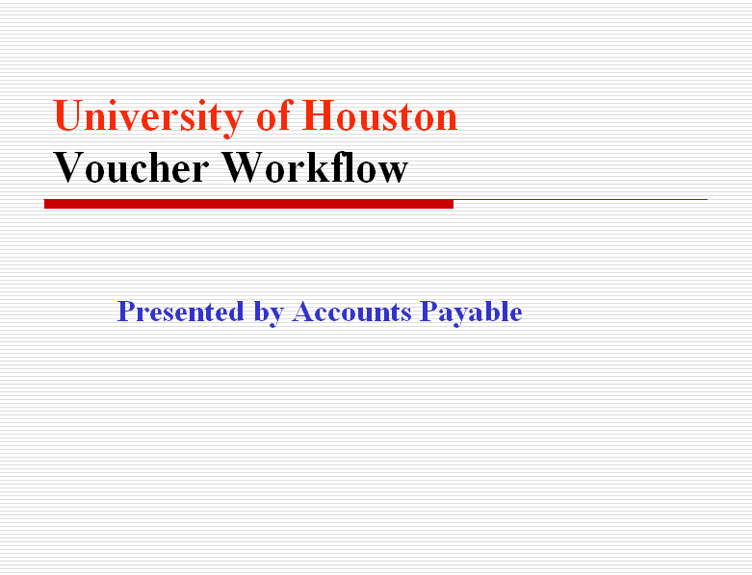

Voucher Workflow – General Information

Definition
Voucher Workflow is an electronic routing and approval process for Vouchers.

Key Elements of Voucher Workflow
Voucher Workflow will have the following impacts:
- Voucher Coversheets are no longer required to be printed, signed, and mailed to AP.
- Approvals by Voucher Creator, Department Approver (Certifying Signatory), Intermediate Approver (Financial Aid, Tax, or OCG), and Final Approver (Accounts Payable) are electronically captured in the Finance System. The approval history can be reviewed on the Approval page or Voucher Coversheet.
- Once a voucher is placed in Workflow, the voucher can only be modified by the person who first approved the voucher (i.e., placed the voucher into workflow).
- If additional approval is required per the department policy, the voucher coversheet/form/memo can be printed, signed, scanned, and uploaded to the voucher page.
- Voucher information, including approval history and backup documents, can be obtained quickly from the Documents page.

Voucher Workflow Roles
You will be assigned to one of the following roles:
- Voucher Creator
Create vouchers, select appropriate routes, and submit the vouchers into Workflow. The vouchers will be sent to the Department Approvers’ worklists.
- Department Approver (Certifying Signatory)
Approve vouchers. Can also create vouchers and place them into Workflow. The vouchers will be sent to Intermediate Approvers’ worklists or Final Approvers’ worklists, depending on the approval route selected.
- Intermediate Approver (Financial Aid, Tax, or OCG)
Approve vouchers as required by University Policy.
- Final Approver (Accounts Payable)
Approve vouchers for payment in accordance with MAPP.
Approval Routes (Paths)
When you submit a voucher into Workflow, your must select an appropriate approval route (Path). You will have the following options:
- Dept/Coll/Div – AP (don’t need Financial Aid, Tax, or OCG approval)
- Dept/Coll/Div – Scholarships and Financial Aid – AP
Vouchers for the following accounts and payee classification:
Account | Account Description | Payee Classification | Workflow Path
50054 | COST REIMBURSEMENTS-NON-SPECIFIC | Student (Employee or Non-Employee) | Scholarships
54812 | EMPLOYEE STIPENDS (Upload Foreign Natl. Info. Addendum w/Tax Approval) | Student Employee | Scholarships
54819 | UH-NON-EMPLOYEE STIPENDS (Upload Foreign Natl. Info. Addendum w/Tax Approval) | Non-Employee Student | Scholarships
54820 | UH-PARTICIPANT INSURANCE STIPEND | Student | Scholarships
54821 | UH-NSF PARTICIPANT STIPEND (Upload Foreign Natl. Info. Addendum w/Tax Approval) | Student | Scholarships
54823 | UH EMPLOYEE PARTICIPANT STIPEND (Upload Foreign Natl. Info. Addendum w/Tax Approval) | Student Employee | Scholarships
54825 | NON-UH EMPLOYEE PARTICIPANT STIPEND (Upload Foreign Natl. Info. Addendum w/Tax Approval) | Non-Employee Student | Scholarships
54900 | TUITION-REIMB, NOT JOB RELATED | Student | Scholarships
54904 | UH-EMPLOYEE AWARDS (NON-CASH > $50) (Include Taxable Payments form on Finance Forms page w/Tax approval) | Student Employee | Scholarships
54906 | TUITION REIMB, JOB RELATED | Student (Employee or Non-Employee) | Scholarships
54907 | EMPLOYEE NON-TAX AWARDS | Student Employee | Scholarships
54912 | STUDENT AWARDS (Upload Foreign National Information Addendum w/Tax Approval) | Student | Scholarships
55300 | UH-SCHOLARSHIPS FROM UNIV OR ENTITLEMENT PROGRAM | Student | Scholarships
55301 | UH-SCHLRSHP INDIRECT AWARD | Student | Scholarships
55302 | UH-SCH-QUALIFIED-TUIT/FEES/BOOKS | Student | Scholarships
55303 | UH-SCHOLAR-RES HALLS-NON-EXEMPT | Student | Scholarships
55304 | UH-SCHOLAR RM/BOARD OFF CAMP NON-TAXABLE | Student | Scholarships
55305 | UH-SCHOLARSHIP QUALIFIED TUITION & FEES - FUND 5 | Student | Scholarships
55306 | UH-THESIS GRANTS | Student | Scholarships
55307 | UH-ATH SCHOL FTB(M) | Student | Scholarships
55308 | UH-ATH SCHOL BKT(M) | Student | Scholarships
55309 | UH-ATH SCHOL BSB(M) | Student | Scholarships
55310 | UH-ATH SCHOL GLF(M) | Student | Scholarships
55311 | UH-ATH SCHOL TEN(M) | Student | Scholarships
55312 | UH-ATH SCHOL TRK(M) | Student | Scholarships
55313 | UH-ATH SCHOL C-C | Student | Scholarships
55314 | UH-ATH SCHOL BKT(W) | Student | Scholarships
55315 | UH-ATH SCHOL SWM(W) | Student | Scholarships
55316 | UH-ATH SCHOL TEN(W) | Student | Scholarships
55317 | UH-ATH SCHOL TRK(W) | Student | Scholarships
55318 | UHATH SCHOL VOL(W) | Student | Scholarships

Student - Refers to University of Houston students only
w/Tax Approval - Some vouchers sent to Scholarships also need Tax approval. Email Tax the voucher number. Tax puts their approval in Comments. Then route to SFA.
Taxable Payments or Reimbursements Form - Exhibit B from SAM 03.D.06 www.uh.edu/Finance/Forms/Taxable Payments or Reimbursements to Employees
Foreign National Information Addendum - www.uh.edu/Finance/TaxInformation

- Dept/Coll/Div – Tax – AP
Vouchers for the following accounts and payee classification:
Account | Account Description | Payee Classification | Workflow Path
52404 | LECTURERS AND ARTISTS (Upload Foreign National Information Addendum) | Non-Employee | Tax
52405 | RECEIPTED EXPENSES-LECTURES & ARTISTS (Upload Foreign Natl. Info. Addendum) | Non-Employee | Tax
53523 | ROYALTIES (Upload Foreign National Information Addendum) | All Classifications | Tax
54802 | UH-CLUB MEMBERSHIP DUES | Employee | Tax
54804 | KEY EMPLOYEE INSURANCE (Include Taxable Payments form on Finance Forms page) | Employee | Tax
54806 | MOVING CO PAYMENT - NONTAXABLE (Refer to Tax Website for required forms) | Moving Company | Tax
54810 | HUMAN SUBJECT TESTING (Include Taxable Payments form on Finance Forms page) | Employee | Tax
54812 | EMPLOYEE STIPENDS (Upload Foreign National Information Addendum) | Non-Student Employee | Tax
54814 | OTHER TAXABLE WAGE BENEFITS (Include Taxable Payments form on Finance Forms page) | Employee | Tax
54815 | HOUSING ALLOWANCE (Include Taxable Payments form on Finance Forms page) | Third Party (Not Paid to Employee) | Tax
54816 | EMPLOYEE DISCOUNT > 20% (Include Taxable Payments form on Finance Forms page) | Employee | Tax
54817 | PARTICIPANT-TRAVEL EXPENSES (Upload Foreign National Information Addendum) | Non-Employee | Tax
54819 | UH-NON-EMPLOYEE STIPENDS (Upload Foreign Natl. Info. Addendum) | Non-Employee and Non-Student | Tax
54821 | UH-NSF PARTICIPANT STIPEND (Upload Foreign Natl. Info. Addendum) | Non-Student | Tax
54823 | UH EMPLOYEE PARTICIPANT STIPEND (Upload Foreign National Information Addendum) | Non-Student Employee | Tax
54825 | NON-UH EMPLOYEE PARTICIPANT STIPEND (Upload Foreign Natl. Info. Addendum) | Non-Employee and Non-Student | Tax
54902 | UH-NON-EMPLOYEE AWARDS (Upload Foreign National Information Addendum) | Non-Employee and Non-Student | Tax
54904 | UH-EMPLOYEE AWARDS (NON-CASH > $50) (Include Taxable Payments form on Finance Forms page) | Non-Student Employee | Tax
56120 | MOVING-DIRECT EXPENSES NON-TAXABLE (Refer to Tax Website for required forms) | Employee (Current or Future) | Tax
56121 | MOVING-NON-DIRECT EXPENSES TAXABLE (Refer to Tax Website for required forms) | Employee (Current or Future) | Tax
56122 | MOVING-HOUSEHUNTING TAXABLE (Refer to Tax Website for required forms) | Employee (Current or Future) | Tax
56123 | MOVING-STORAGE > 30 DAYS TAXABLE (Refer to Tax Website for required forms) | Employee (Current or Future) | Tax
56129 | UH-PROSPECTIVE STUDENT TRAVEL (Upload Foreign National Information Addendum) | Prospective Student | Tax
56132 | MOVING-STORAGE < 30 DAYS NON-TAXABLE (Refer to Tax Website for required forms) | Employee (Current or Future) | Tax
56138 | UH-SPOUSAL TRAVEL NON-BUSINESS (Include Taxable Payments form on Finance Forms page) | Employee | Tax

Student - Refers to University of Houston students only
w/Tax Approval - Some vouchers sent to Scholarships also need Tax approval. Email Tax the voucher number. Tax puts their approval in Comments. Then route to SFA.
Taxable Payments or Reimbursements Form - Exhibit B from SAM 03.D.06 www.uh.edu/Finance/Forms/Taxable Payments or Reimbursements to Employees
Foreign National Information Addendum - www.uh.edu/Finance/TaxInformation

- Dept/Coll/Div – OCG – AP
Vouchers with sponsored project cost centers that are one of the following:
      - Expense reallocations from State to Local or from Local to State
      - Capital equipment payments in the last 6 months of a federal grant
      - Invoice payments after the federal grant end date
      - Generally unallowed accounts charged to a federal grant (see Account List at http://www.uh.edu/finance/pages/References.htm)

Approval Actions
When you submit a voucher into Workflow or approve a voucher, you need to use the voucher approvals page. There are three approval actions:
- Approve
Select “Approve” to send a voucher to the next approvers’ Worklist
- Deny
Select “Deny” to send a voucher back to the person who placed it in Workflow
- Recycle
Select “Recycle” to send a voucher back to the person who sent it to your Workflow

Voucher Worklist
- Voucher Creator’s Worklist
Lists vouchers denied/recycled by Department Approvers, Intermediate Approvers, and Final Approvers.
- Department Approver’s Worklist
Lists vouchers that need to be approved. Also, list their own vouchers that are denied/recycled by Intermediate/Final Approvers.
- Intermediate Approver’s Worklist
Lists vouchers that need to be approved.
- Final Approver’s Worklist
Lists vouchers that need to be approved.

Voucher Worklist Functions
Voucher Worklist can be filtered by the following columns:
- Business Unit
- Source
- From
For example, if you want to review vouchers submitted by NSM only, you can select “Source”, enter “NSM”, and click on . Worklist will show NSM vouchers only.
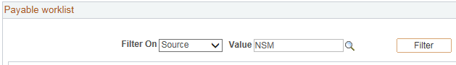

Also, Voucher Worklist can be sorted by each column.

Source
Source indicates College/Division. When voucher creators create vouchers, the voucher sources are defaulted to the College/Division they are employed. If a creator need to send a voucher to a different College/Division, they should go to the voucher approvals page and select the appropriate source on their voucher. Source determines to which Department Approvers’ worklist the vouchers are sent.

HOW TO SETUP YOUR VOUCHER PAGELET

Step 1: Go to your Home Page. Then, Click on “Content” on your home page.

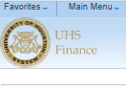

Step 2: The system displays the Personalize Content Page. Place a checkmark for Payable Worklist and click on .

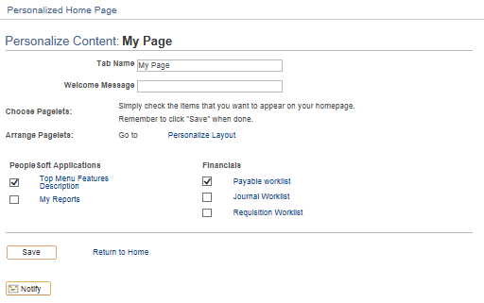

Now the Pagelet is setup on your home page.

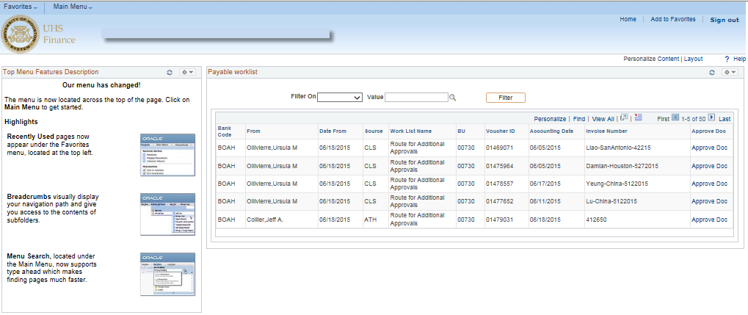

HOW TO SUBMIT A VOUCHER INTO WORKFLOW
(VOUCHER CREATOR/DEPARTMENT APPROVER)

Step1: Go to the Voucher Approval page.
Navigation: Accounts Payable>Vouchers>Approval> Approve Voucher

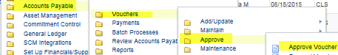

Step 2: The system displays the following screen:

Enter the voucher number and click on .

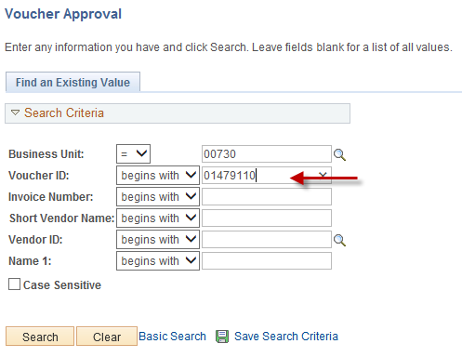

Step 3: The system displays the following screen:

Select the Approval Route, Source, and Approval Action.

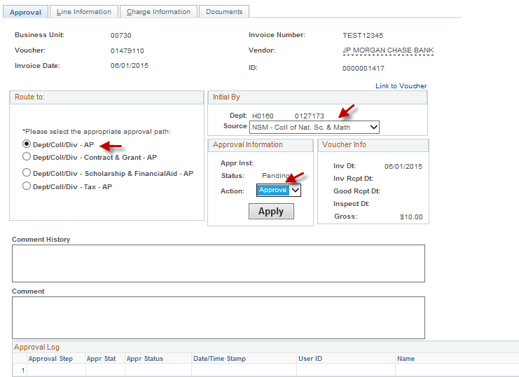

- Select Approval Route
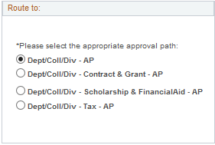

- Review Source
Source is defaulted to the College/Division of the person who created the voucher. If the voucher needs to be submitted to a different College/Division approver, select the appropriate College/Division.

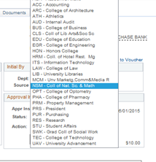

- Select Approve for action and click on .
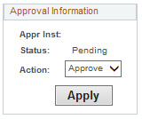

Step 4: The system displays the following message indicating that the voucher needs to be approved by the next approver. Click on .

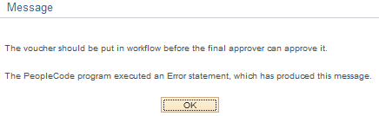

Step 5: Now the voucher is in Workflow. The Comment History and Approval Log sections will show your name/user ID indicating that the voucher was submitted to Workflow by you.

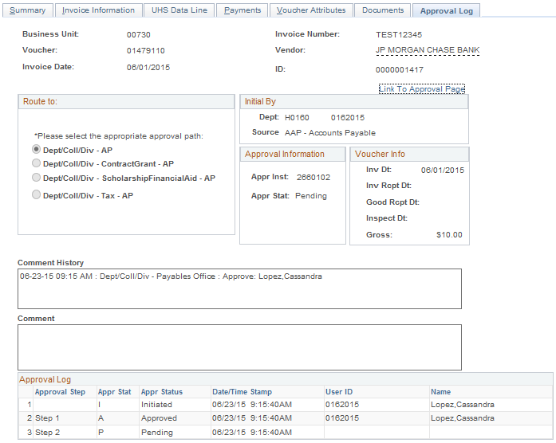

HOW TO APPROVE/DENY A VOUCHER
(DEPARTMENT/INTERMEDIATE/FINAL APPROVER)

Step 1: Go to your Home Page and review the Voucher Worklist. Select a voucher for review by clicking on the hyperlink Approve Doc.

Step 2: The system displays the following page. Click on the “Documents” tab.
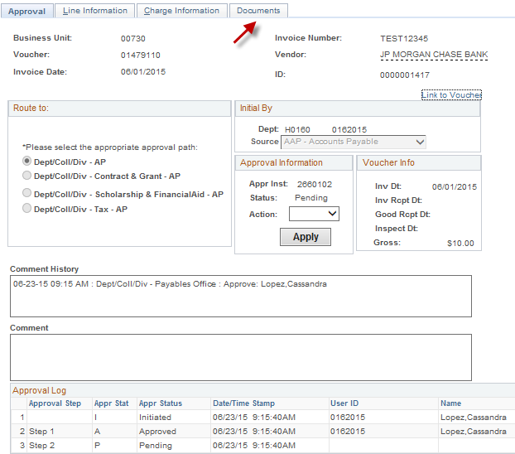

Step 3: The system displays the following page.
Click on the hyperlink Print Voucher Coversheet to review the voucher coversheet.
Click on to review the backup documents.

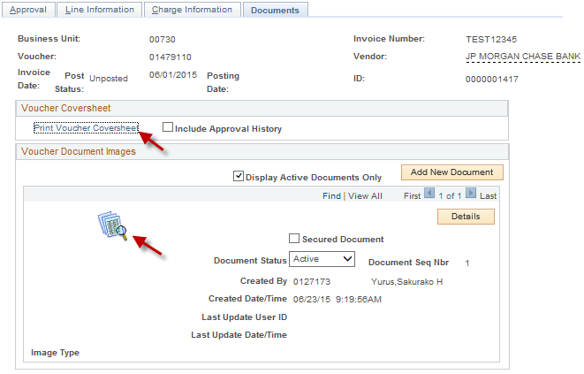

Step 4: When you are ready to approve the voucher, click on the “Approval” tab. The system displays the following page. Select “Approve” or “Deny” for Action and click on .

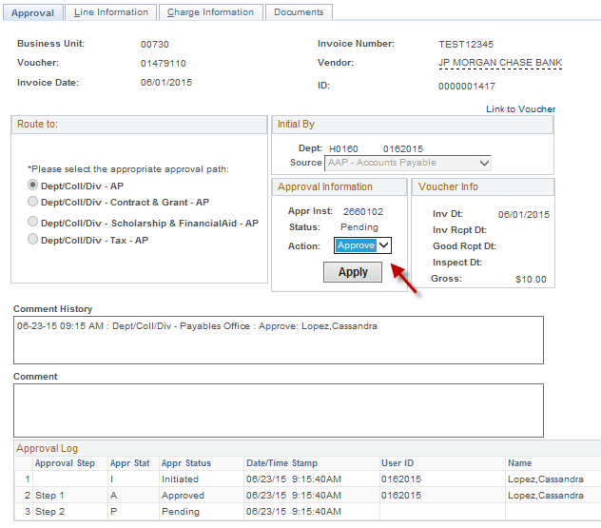

Comments can be entered by anyone at anytime. Enter the comment then click on .

HOW TO REVIEW VOUCHER STATUS

Step1: Go to the voucher entry page:
Navigation: Accounts Payable>Voucher>Voucher Entry

Step 2: The system displays the following page. Slick on “Find an Existing Value”, select Business Unit, and enter Voucher Number. Then click on

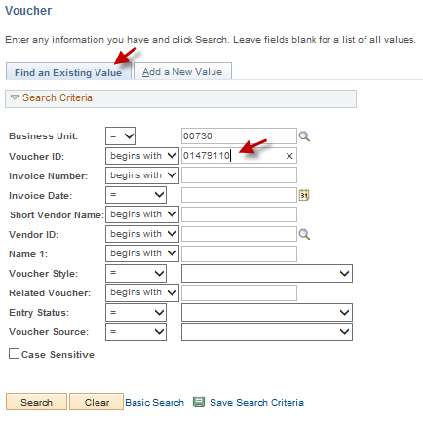

Step 3: The system displays the Summary page. Click on the Approval Log tab.

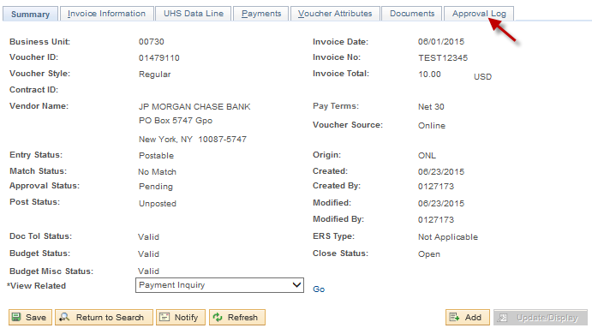

Step 4: The system displays the approval information. The Comment History contains information about who approved/denied the voucher and when. The Approval Log records the most recent approve history (previous voucher deny actions are not recorded).

