Technology Purchases (Dell and HP)

The University of Houston has multiple options when purchasing technology. When using Dell, the university can receive HUB credits. When using HP, products can be ordered through DIR and receive HUB credits, as well. Purchasing thresholds must be followed. Contact your Buyer for more information.

Dell
Dell’s Premier website allows for Departments to order Standard Configurations, Laptops/2-in-1, Desktops/All-in-Ones, Workstations, Servers, Storage, Networking, Software, Accessories and Peripherals.

Dell Representative: Ezekiel Adewusi, Inside Sales Rep, ezekiel_adewusi@dell.com, (512) 513-8850
Website: https://www.dell.com/premier/us/en/rc1378895/#/home
How to Order:
- Log into the Dell Premier webpage (link below). If the individual ordering does not have access, contact the department administrator for assistance. Alternatively, reach out to a Dell representative to generate a quote.
http://premier.dell.com/premier/acc_lgn.asp?58C2798C5D118973D6EFDEAE12A90380F36BABD7398D082F7B469EDD12ADCE8D
- Create an order.
- Save order as a quote.
- Attach the quote to a Purchase Requisition.
- Submit a Requisition to Purchasing referencing the Quote Name, the total order amount, the correct vendor ID and comments.
- Purchasing will review the requisition, process a purchase order, and place the order with Dell.

Thresholds:
All Dell purchases over $500 need to be submitted to the Purchasing Department via Requisition. Dell purchases under $500 can be paid via Procurement Card or AP Voucher.
For purchases that require a requisition, follow the How to Create Requisitions guide at:
https://uh.edu/office-of-finance/purchasing/Purchasing%20Training/

CFI Asset Tag Requirement:
All quotes subject to UH Inventory tags must include a CFI tracking tag itemized into the quote. This will be at the end of the specifications on a system build. This ensures that the system ships pre-tagged and that all University discounts were applied. Quotes received without a CFI ID will be denied by Purchasing and/or cancelled by Dell. To avoid delays you must generate your quote through the “Shop Your Standard Configuration” link when you log in to Dell Premiere. you can also contact a Dell Premier Inside Account representative to generate or modify a quote.
See steps below ensure CFI Asset Tag is included in your order:
- Log into Dell Premiere.
- Click Shop Your Standard Configuration.
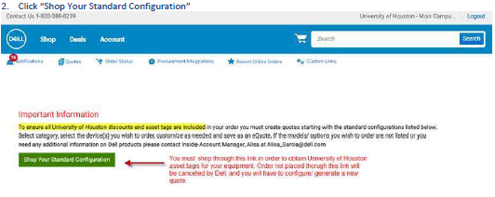
- Select an item, then add to quote or customize specifications.
- Click on quick specs, or verify on the quote specs, that CFI/ Asset Tag are itemized.
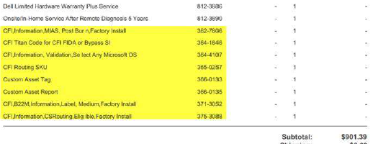
- If you don’t see these tags, contact a Dell Premier Inside Account representative to generate or modify a quote.

Billing Requirement:
Per agreement with HiED, all Dell quotes generated by Cougarbyte, Dell Premier, or by a Dell representative, must have the correct HiED billing address and customer number below. The billing process is as follows: UH orders from Dell using HiED’s customer number Dell will bill HiED, HiED will bill UH.

Customer Number: 530019039858
Billing Address: HIED INC
80 E MCDERMOTT DR
ALLEN TX 75002-2802 US
Ph: 1 (800) 876-3507 Ext. 7213 Email: AP@HIED.COM
NOTE: If you generate a quote using the incorrect customer number and/or address above, the requisition will be denied by Purchasing and/or canceled by DELL. To avoid delays, please verify your quote information.
Quotes starting with 3xxx or 1xxx:
For quotes generated through a Dell Representative (starting with 3xxx), the customer number and billing address are identified near the top of the quote. Make sure the correct billing information is used before creating a requisition.
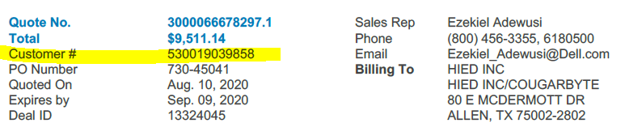
For quotes generated through Dell Premier (starting with 1xxx), you will see the address, but the customer number will not be identified in the quote. The individual generating the quote must verify that the correct customer number is used, which must be selected when the quote is generated.
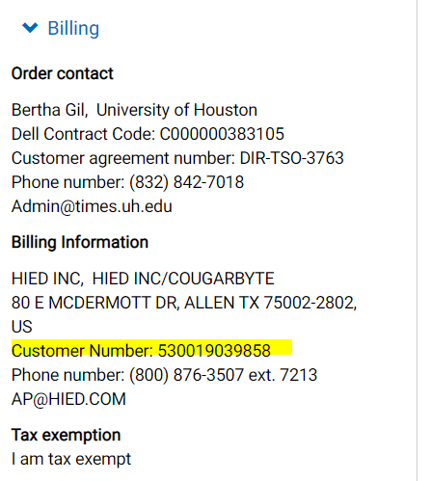
NOTE: If you have incorrect billing information, please reach out to a Dell Premier Inside Account representative for modification.
Requisition Requirements:
For all Dell quotes generated by Cougarbyte, Dell Premier, or by a Dell representative, over $500, create a requisition with the correct vendor information below:
UH VENDOR ID 0000009918
HIED INC
80 E MCDERMOTT DR
ALLEN TX 75002-2802 US

Please note: the only address option through requisition for HiED INC is “Address# 3, DALLAS, TX”, this is fine, Purchasing will modify to “Address# 13, ALLEN TX”.
Additionally, please state the correct SHIP TO address in the requisition comments. Dell representatives may generate quotes with default shipping address. Purchasing will use the SHIP TO address in requisition comments at checkout.
Leasing Note:
If you plan to lease Dell equipment, please contact the Purchasing Department first. These are processed directly with Dell Financial Services LLC, not HIED INC.

HUB Credit:
UH Departments/Dell Rep places an order through the Dell Premier page. HiED is a HUB business and are used as the “bill to”. Delivery is to the department. Purchasing makes POs to HiED to obtain HUB credit.

For contact information, visit HUB Operations’ website: https://www.uh.edu/office-of-finance/hub/

Order Status/Invoice Issues:
The Premier website has the feature to check order history and status. If further assistance is needed, the Dell Rep can also be contacted for invoice issues and other information.
Website: https://www.dell.com/premier/us/en/rc1378895/#/home
Representative: Ezekiel Adewusi, Inside Sales Rep, ezekiel_adewusi@dell.com, (512) 513-8850

HP
HP allows for departments to order computers, laptops, tablets, servers, printers, peripherals and other technology products and services through DIR-TSO-4159 contract. Departments must order HP products through our campus technology store, Cougarbyte/HiEd, or a HUB HP Reseller listed on the DIR website.
HP Through Cougarbyte/ HiED:
Departments can order HP products through our campus technology store, Cougarbyte. Cougarbyte is a HiED store that allows the University to receive HUB credits.
Contact Info:
https://cougarbyte.com/cougarbyte/
1.888.500.2932
store@cougarbyte.com
Cougarbyte Representative: Brian Johnson, Manager, bjohnson@cougarbyte.com, (713) 743-8507
How to Order from Cougarbyte/ HiED:
- Visit the Cougarbyte website and click “Department Purchases” at the top. Departments can also reach out to a Cougarbyte representative to generate a quote.
- Department will make a requisition based off of the quote received.
- Attach the quote to a Purchase Requisition.
- Submit a Requisition to Purchasing referencing the Quote Name, the total order amount, the correct vendor ID and comments.
- Purchasing will review the requisition, process a purchase order, and place the order with Cougarbyte.
Billing Requirement:
Per agreement with HiED, all Cougarbyte quotes must have the correct HiED billing address. The billing process is as follows: UH orders from Cougarbyte (HiED). Cougarbyte (HiED) will place the order and will bill UH.

Billing Address: HIED INC
80 E MCDERMOTT DR
ALLEN TX 75002-2802 US
Ph: 1 (800) 876-3507 Ext. 7213 Email: AP@HIED.COM

HP Through HP Resellers through DIR (Texas Department of Information Resources):
Departments can order HP products through one of the HUB HP resellers below. Since the vendors are HUB businesses, the University receives HUB Credits.

Contact Info:

Regional HP Representative: Alberto Chaidez, HP SLED Inside Account Manager, alberto.chaidez@hp.com
DIR HP Representative: Debra Lee Ph. (847) 537-0344
DIR Representative: Thuvan Huynh Ph. +15124754620
Website: https://dir.texas.gov/View-Search/Contracts-Detail.aspx?contractnumber=DIR-TSO-4159
How to Order using Texas Department of Information Resources (DIR):

The HUB resellers for HP are listed under DIR contract DIR-TSO-4159. Departments must take the following steps:
- Go to https://dir.texas.gov/View-Search/Contracts-Detail.aspx?contractnumber=DIR-TSO-4159 and select a HUB HP reseller. Do not select a Non HUB vendor (see the HUB type column on the list).
- Department contacts a HUB vendor from the list below to obtain a quote. The quote must refer to the DIR contract.
- Department will make a requisition based off of the quote received.
- Attach the quote to a Purchase Requisition.
- Submit a Requisition to Purchasing referencing the Quote Name, the total order amount, the correct vendor ID and comments.
- Purchasing will review the requisition, process a purchase order, and place the order with the vendor.
- For product and pricing information, visit the DIR HP Inc. website or contact Christof Wunderlich, Inside Sales Representative at (800-888-0381) or email christof.wunderlich@hp.com. Reseller Vendors are also available through this contract. Select from any Reseller Vendor contact listed below to also obtain product and pricing information.
- Generate a purchase order made payable to HP Inc. or any Reseller Vendor listed below. DIR Contract Number DIR-TSO-4159 must be referenced on your purchase order.
- E-mail (psorderprocessing@hp.com) or fax (800-825-2329) your purchase order and quote form to HP Inc. or your reseller sales representative.

Thresholds:
All Cougarbyte & HP reseller purchases over $500 need to be submitted to the Purchasing Department via Requisition. Cougarbyte & HP reseller purchases under $500 can be paid via Procurement Card or AP Voucher.
For purchases that require a requisition, follow the How to Create Requisitions guide at:
https://uh.edu/office-of-finance/purchasing/Purchasing%20Training/

HUB Credit:
Cougarbyte/ HiED is a HUB business and are used as the “bill to”. Purchasing makes POs to HiED to obtain HUB credit.

If not from Cougarbyte, the vendor selected above is a HUB business. Purchasing makes POs to the selected vendor to obtain HUB credit.

For contact information, visit HUB Operations’ website: https://www.uh.edu/office-of-finance/hub/

Additional Information
See the UIT webpage (Information and Services from University Information Services (UIT)) for additional information concerning the IT associated items and services.

