**Form: Notice of Incorrect or Incomplete Invoice Received by the University of Houston**

This form is used when vendors send invoices that do not meet the required standards set by the university in accordance with Texas Government Code. Complete this form and e-mail it to the vendors to notify them that their invoices need to be corrected and re-submitted. Copy the e-mail to Accounts Payable (AP) Dispute-form@uh.edu, so AP can maintain the completed forms in the central file. It should be noted that AP will maintain the forms for tracking purpose only, and departments are responsible for contacting and following up with the vendors to make sure they receive corrected invoices for processing payments.

The form contains the following sections:

* Complete the vendor information in this section.

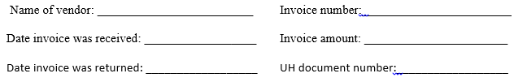

* Complete this section if the original invoice sent by the vendor was missing the required information.

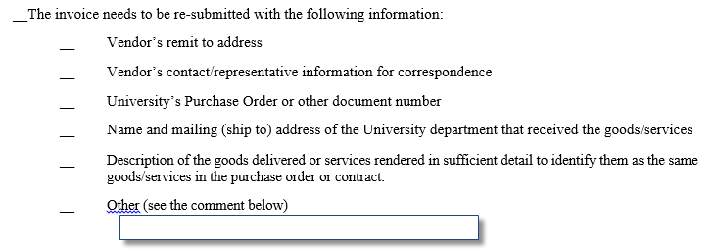

* Complete this section if the original invoice sent by the vendor had incorrect information.

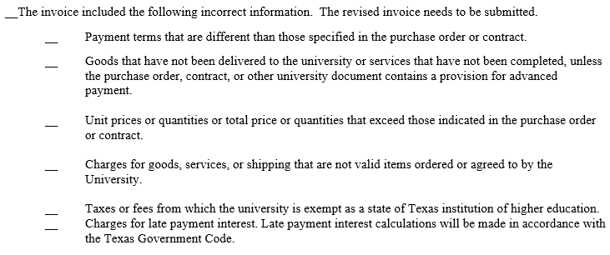

* Complete this section if the original invoice was charged for a disputed amount and provide a detailed statement of the amount of the invoice which is disputed.

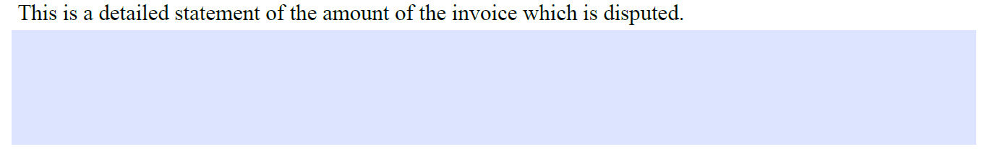

* Complete the department contact information in this section.

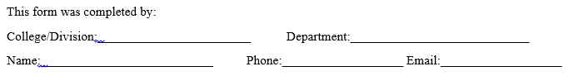

**Form: Notice of Non-compliant Delivery of Goods or Services**

This form is used when vendors delivered goods and/or services that are not in compliance with the terms and/or condition of the order, contract, or other agreements. Complete this form and e-mail it to the vendors to notify them that your department is returning goods, disputing, or requesting action(s) by the vendors. Copy the e-mail to Accounts Payable (AP) Dispute-form@uh.edu, so AP can maintain the completed forms in the central file. It should be noted that AP will maintain the forms for tracking purpose only, and departments are responsible for contacting and following up with the vendors to make sure the issues are resolved.

The form contains the following sections:

* Complete the vendor and goods/services information in this section.

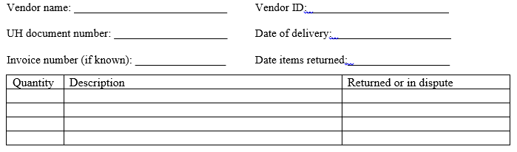

* Describe the issue(s) in this section.

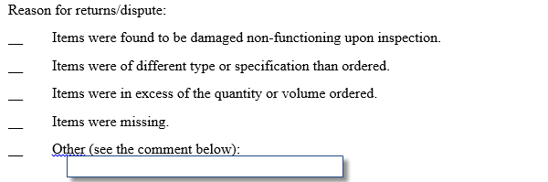

* Complete this section if the original invoice was charged for a disputed amount and provide a detailed statement of the amount of the invoice which is disputed.



* Complete the department contact information in this section.

