- Checklist for Getting Started 2

- Relating Processes to Transactions 3

- Voucher Corrections: state to local or local to state 4

- Running Queries from Production 5

- Running Queries from Reporting 6

- Accounts Payable Queries 7

- Creating a Template Voucher 9

- Creating an Adjustment 11

- Payment Inquiry 12

- Budget Checking Errors 15

Checklist for Getting Started
- Bookmark the FAST website, which contains training schedules and materials, reference information, forms, and other information about PeopleSoft systems at UH. The FAST home page is located at: http://www.uh.edu/fast/ Click on Finance for information about the General Ledger, Payables, or Purchasing.

- Subscribe to one or more of the FAST list servers to receive email updates on changes to the system, scheduled downtimes, training, and other up-to-the-minute announcements. The FAST-FINANCIAL listserv provides updates related to the General Ledger, Payables, and Purchasing. Instructions for joining the list servers can be found at: http://www.uh.edu/fast/FAST-contact.htm

- Complete the following forms located on the Reference and Forms page of the FAST Financial website (http://www.uh.edu/fast/financial/FS-refandforms.htm):

- Request for Financial System Operator ID¹
- Request for Financial System General Ledger Access²
- Request for Financial System Accounts Payable Access²

¹ Mail the Operator ID form (including Confidentiality Statement) to Tricia Spinks at mail code 0934 or fax to 713-743-1962.
² Mail the GL and AP Access forms to Catherine Chan at mailcode 0913 or fax to 713-743-8799.

Your operator ID will be the first six letters of your last name, followed by your first and middle name initials. For example, the operator ID for Betty Jane Williams would be WILLIABJ. The operator ID for John Doe (no middle name) would be DOEJ. Once your operator ID is setup, you will be emailed a temporary password for the Financial database (GL, Payables, and Purchasing). Select Set Password when logging into PeopleSoft to change your password.

- Attend the following classes to become familiar with entering or viewing vouchers:

- General Ledger Orientation (required to view the General Ledger)
- FAST Start Payables (required to create vouchers in Payables)
- Advanced Payables (take FAST Start Payables first)
- Travel Requests and Vouchers (take FAST Start Payables first)
- Travel Voucher Audit Class(take Travel Request and Voucher first)

These and other training classes are listed at the following web address, where you can also register online: http://www.uh.edu/fast/FAST-training.htm

Relating Processes to Transactions

Process/Document Type of Payment/Transaction

Voucher Non-PO payments to vendors
Unencumbered contracts
Reimbursements
Correct posted voucher or non-voucher error (state/local)

Adjustment Credit memo
Follow-up payment to previous invoice

Journal Entry Form Correct voucher error( State/State or Local/Local)

Recurring Voucher
Contract Recurring payments to same vendor (same amount)
(optional) Examples: Office lease payments, stipends

Template Voucher Frequent payments to same vendor (different amounts)
(optional) Examples: Boise Cascade, Airborne Express

Voucher Correction
Move Voucher Expense from State to Local or from Local to State

1. Navigate as follows to add a Voucher:

Go
Administer Procurement
Enter Voucher Information

Use
Voucher
Invoice Header Information
Add

3. Add -- Voucher dialog box
Select Business Unit
Click OK

4. Invoice Header Information panel
Vendor: If moving an expense from state to local, type vendor ID 00026730 (Texas Comptroller); tab
If moving an expense from local to state, type vendor ID 00026780 (Univ of Houston); tab
Click calculator next to Date (Date Calculation Basis): enter today’s date for all of the dates; click OK
Invoice: invoice number of original voucher
Gross: total amount transferred with this voucher

5. Line Information and Charges panel
Amount (Voucher Line): amount to be transferred
Description: brief description of expenditure (30 characters max)
Amount (Distribution): amount to be transferred
Input: Account, Fund, DeptID, Program, and Project

6. UHS Data Line panel
UHS PCC: change to PCC 8
Description2: enter additional description, if needed (50 characters max)
Third Party Vendor Information: click on arrow next to Short Name
Short Vendor Name: type up to first 10 characters of the original vendor name; select from list; tab
Addr: click on arrow next to Addr; select remit to address from list

7. Schedule Payment-Dept Use panel
Click green diskette (Save) and note voucher ID
Bank and Account: If moving the expense to a local fund, do not change Bank or Account.
If moving the expense to a state fund, change Bank to State and Account to TREA.
Scheduled Due Date: should default to today’s date
Payee Remit To Address: If the payee is the Texas Comptroller, select address 002.
If the payee is the University of Houston, select address 001.
8. Comments panel
Voucher Comments: enter explanation for transferring expense

9. Accounting Information panel
Click Budget Check to budget check Voucher; save Voucher

10. Print Voucher Coversheet and obtain certifying signature
Attach FRS or GL report that shows where original expense posted
Forward Voucher Coversheet and backup to Accounts Payable

Running Queries from the Production Database

1. Log into the Financial Production database.

2. Navigate as follows:

View
Navigator Display
Query
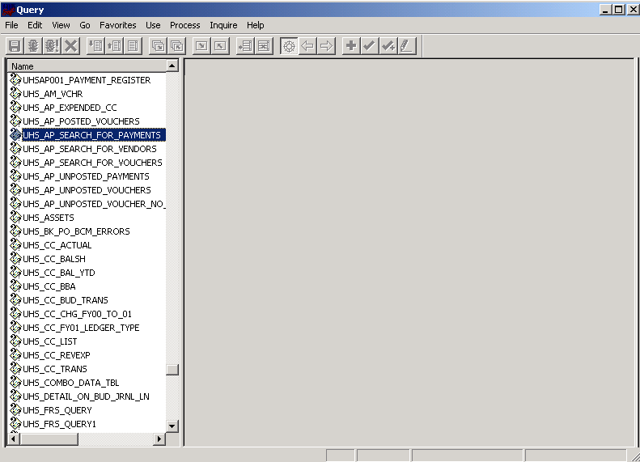 | 2. Click on any query name.  3. Begin typing the query name, such as UHS for queries that begin with UHS.  The scroll bar moves down to the first query that begins with those letters.
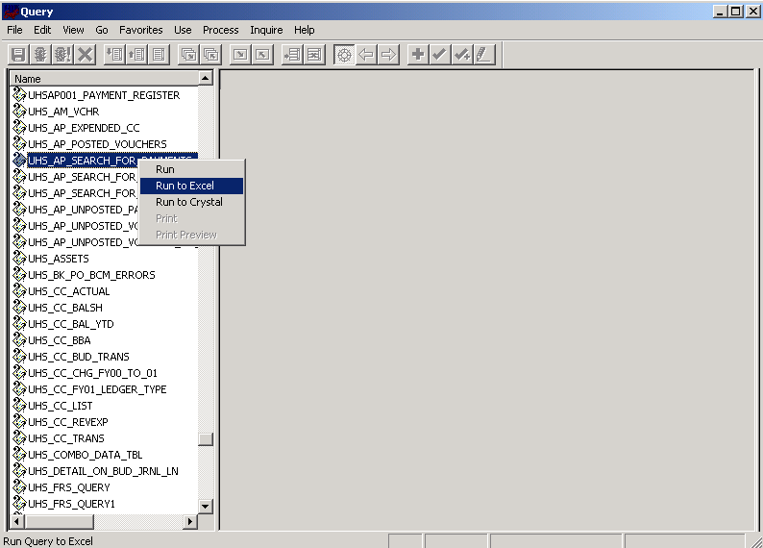 | 4. Right-click on the selected query and choose Run, Run to Excel, or Run to Crystal.  Note: Run to Crystal will not work if a Crystal report has not been developed for that query.

Running Queries from the Reporting Database

1. Log into the Financial Reporting database.

2. Navigate as follows:

Go
PeopleTools
Query

File
Open
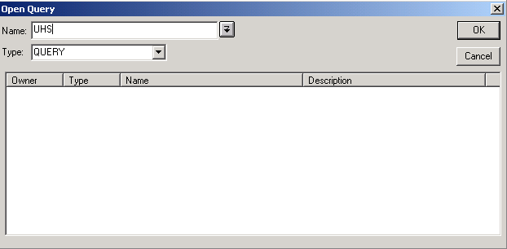 | 3. Type the beginning of the query name in the Name box.  4. Click on arrow next to the Name box.
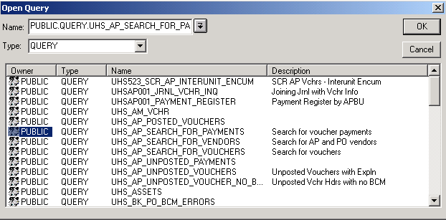 | 5. Double-click on selected query.
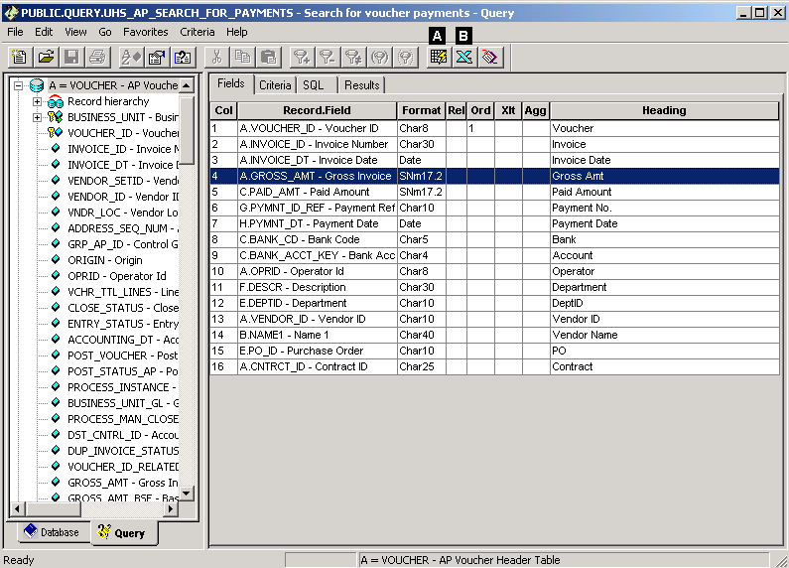 | 6. Run the query by selecting the appropriate icon:  A. Run to window  B. Run to Excel

Accounts Payable Queries
Query 1: UHS_AP_ SEARCH_FOR_PAYMENTS: Lists only voucher payments by business unit, department, vendor ID, purchase order, contract ID, and/or invoice number. Run from the Financial Reporting database.

Query 2: UHS_AP_ SEARCH_FOR_VOUCHERS: List all vouchers by business unit, department, vendor ID, purchase order, contract ID, and/or invoice number. Run from the Financial Reporting database.
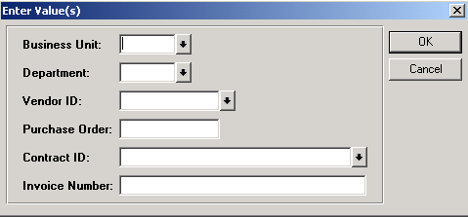 | Search Criteria  Business Unit: 00730 or 00783 (required)  Department: DeptID or %  Vendor ID: 10-digit vendor ID or %  Purchase Order: PO number or %  Contract ID: contract ID or %  Invoice Number: invoice number or %
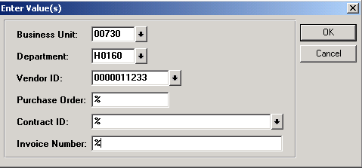 | Example 1  Search for vendor payments or vouchers charged to a certain department for a certain vendor.  UHS_AP_ SEARCH_FOR_PAYMENTS and UHS_AP_SEARCH_FOR_VOUCHERS have the same search criteria.
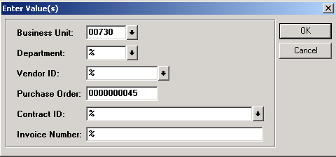 | Example 2  Search for vendor payments or vouchers associated with a certain purchase order.  Put a wildcard (%) in all fields that do not contain search criteria. However, business unit must contain a valid value.

Query 3: UHS_AP_ SEARCH_FOR_VENDORS: Search for vendor by primary name, DBA/department, and/or federal ID/social security number. Run from the Financial Production database.

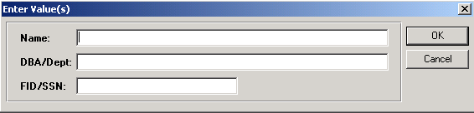 | Search Criteria  Name: primary name of vendor in the following format, LAST, FIRST  DBA/Dept: DBA or department  FID/SSN: federal ID or social security number
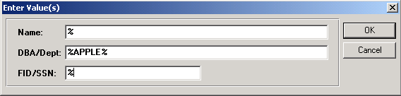 | Example 1  Search for all vendors with Apple in the DBA/Dept name.  Always put a wildcard (%) in fields that are not used in the search.  Put % before and after any names or partial names used in the search.
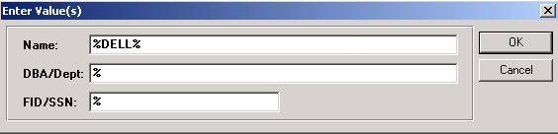 | Example 2  Search for all vendors with Dell in the primary name.
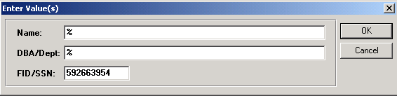 | Example 3  Search for a vendor with a federal ID or social security number.

Creating a Template Voucher: Saving the Template
Template Vouchers are used to save time when making frequent payments (different amounts or intervals) to the same vendor.

1. Log into the Financial Production database.

2. Navigate as follows:

Go
Administer Procurement
Enter Voucher Information

Use
Voucher
Invoice Header Information
Update/Display*

*Note: Existing vouchers can be saved as a Template Voucher until they are posted. If a suitable voucher does not already exist, create a new voucher and save it as a Template Voucher.

3. Update/Display—Voucher
- Enter Voucher ID
- Click OK

4. Navigate to Template Information panel

5. Template Information panel
- Click Save as Template Voucher
- Enter Template ID (suggested format: 10-digit vendor ID or first 10 digits of vendor name)
- Enter Description (suggested format: name of vendor)
- Click on green diskette to save voucher
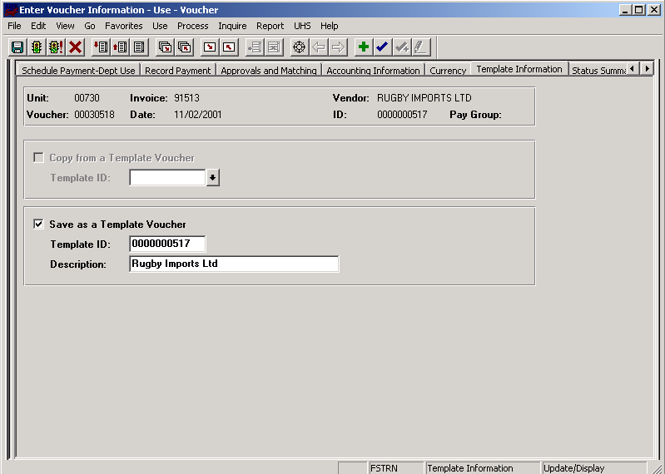

Creating a Template Voucher: Copying from the Template
1. Log into the Financial Production database.

2. Navigate as follows:

Go
Administer Procurement
Enter Voucher Information

Use
Voucher
Invoice Header Information
Add

3. Add—Voucher
- Select Business Unit (leave Voucher ID at NEXT)
- Click OK

4. Invoice Header Information panel
- Select vendor

5. Template Information panel
- Click Copy from a Template Voucher
- Click arrow next to Template ID
- Select Template ID from list

6. Complete/change fields on voucher, as needed
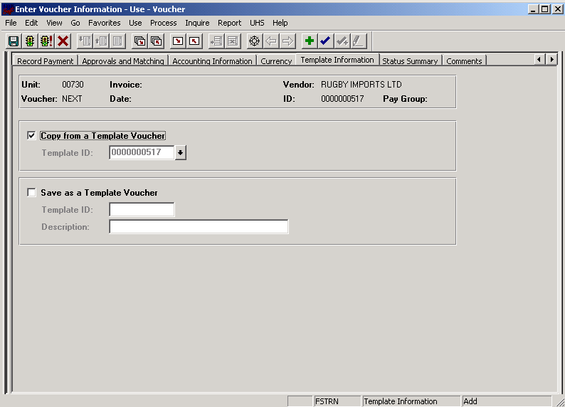
Creating an Adjustment
1. Navigate as follows to add an Adjustment:

Go
Administer Procurement
Enter Voucher Information

Use
Adjustment
Adjustment Information
Add

2. Add – Adjustment Dialog Box
Select Business Unit (leave Voucher ID at NEXT)
Click OK

3. Adjustment Information panel
Select vendor
Related Voucher: Choose the previous voucher for the same vendor that relates to this voucher. (This is the only difference between an Adjustment and a Voucher.)

4. Complete the Adjustment like you would a regular Voucher.
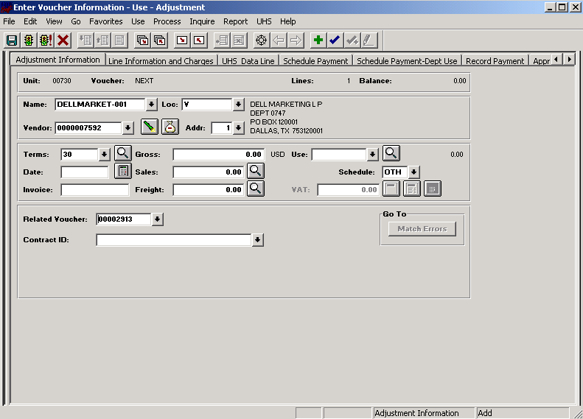

Journal Entry Request Form

 | University of Houston System |  |  |  |  |  |  |  |  |  |  |  |  |  |  |  |  |  |  |  |  |  |  |  | Originating
 |  |  |  |  |  |  |  |  |  |  |  |  |  |  |  |  |  |  |  |  |  |  |  |  | Campus: |  |  |  |  |  |  |  |  |  |  |  |  |  |  |  |  |  |  |  |  |  |  |  |  |  |  |  |  |  | Inter-Campus Journal
 | Journal Entry Request Form
 |  | Date Prepared |  |  |  |  |  |  |  |  |  |  |  |  |  |  |  |  |  |  |  |  |  |  |  |  |  |  |  |  |  |  |  |  |  |  |  |  |  |  |  |  |  |  |  |  |  | Department |  |  |  |  |  |  |  |  | Enter your department
 |  | Prepared by |  |  |  |  |  |  |  |  |  | Enter your name here |  |  |  |  |  |  |  |  |  |  |  |  |  |  |  |  |  |  |  |  |  |  |  |  |  |  |  |  |  |  |  |  |  |  |  | Extension |  |  |  |  |  |  |  |  | Enter your phone
 |  | Filename |  |  |  |  |  |  |  |  |  | #VALUE! |  |  |  |  |  |  |  |  |  |  |  |  |  |  |  |  |  |  |  |  |  |  |  |  |  |  |  |  |  |  |  |  |  |  |  | Jnl Reference |  |  |  |  |  |  |  |  | #VALUE!
 |  | Effective Date: |  |  |  |  |  |  |  |  |  |  |  |  |  |  |  |  |  |  |  |  |  |  |  |  |  |  |  |  |  |  |  |  |  |  |  |  |  |  | 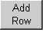  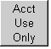 |  |  |  |  |  |  | Justification
 |  |  |  |  |  |  |  |  |  |  |  |  |  |  |  |  |  |  |  |  |  |  |  |  |  |  |  |  |  |  |  |  |  |  |  |  |  |  |  |  |  |  |  |  |  |  |  | Enter justification for this transaction
 |  | Description /
 |  | Explanation: |  |  |  |  |  |  |  |  |  | Enter journal description / explanation
 |  | Approvals: |  |  |  |  |  |  |  |  |  | Enter approver names
 |  | Certifying Signatures: |  |  |  |  |  |  |  |  |  |  |  |  |  |  |  |  |  |  |  |  |  |  |  |  |  |  |  |  |  |  |  |  |  |  |  |  |  |  |  |  |  |  |  |  |  | Debit Total |  |  |  |  |  |  |  |  |  | Credit Total
 |  |  |  |  |  |  |  |  |  |  |  |  |  |  |  |  |  |  |  |  |  |  |  |  |  |  |  |  |  |  |  |  |  |  |  |  |  |  |  |  |  |  |  |  |  |  |  | 0.00 |  |  |  |  |  |  |  |  |  | 0.00
 |  |  |  |  |  |  |  |  |  | Speed
 |  | Line |  |  | Bus Un |  |  |  |  | Type |  |  |  |  | Account |  |  |  |  |  | Fund |  |  |  | Dept ID |  |  |  |  | Program |  |  |  |  |  | BP |  |  |  |  | Proj/Grant |  |  |  |  |  |  | Debit Amount |  |  |  |  |  |  |  |  |  | Credit Amount |  |  |  |  |  |  | Description
University of Houston System
Journal Entry Comments
Date |  |  |  |  |  |  |  | Entered By |  |  |  |  |  |  |  |  | Conversation With |  |  |  |  |  |  |  |  |  |  |  |  |  |  | Comment

Journal Edits and Defaults

Actuals Journal Edits:
 | Data Validation Edits
 | User cannot complete entry in the cell until the error is corrected
 | Cell | Name | Edit
 | AD3 | Originating Campus | Must be selected from the drop-down list
 | AZ3 | Inter-Campus Flag | Must be "X" or blank
 | L7 | Date Prepared | Must be a valid date between 09/01/2000 and 08/31/2999
 | AS8 | Department (header) | Must be 5 characters
 | L8 | Prepared By | Must be more than 1 character
 | AS8 | Extension | Must be more than 4 characters
 | L11 | Effective Date | Must be a valid date between 09/01/2000 and 08/31/2999
 | L14 | Description/Explanation | Cannot exceed 30 characters
 | M22 | Fiscal Year | Whole number between 2001 and 2999
 | M23 | Ledger | none
 | M24 | Source | none
 | AF22 | Journal ID | none
 | AF23 | Reversal Code | none
 | AF24 | Reversal Date | none
 | F28:44 | Business Unit | Must be selected from the drop-down list
 | J28:44 | SpeedType | Must be 5 characters
 | O28:44 | Account | Must be an integer between 10000 and 60000
 | T28:44 | Fund | Must be an integer between 1000 and 9999+D3
 | X28:44 | Dept ID (line) | Must be 5 characters
 | AC28:44 | Program | Must be 5 characters
 | AH28:44 | Budget Period | Must be 6 characters
 | AM28:44 | Project/Grant | Must be 7 characters
 | AT28:44 | Debit Amount | Must be a decimal greater than zero
 | BC28:44 | Credit Amount | Must be a decimal greater than zero
 | BL28:44 | Description | Cannot exceed 30 characters
 | Formula Edits
 | Errors result in warning messages displayed in worksheet cells
 | Cell | Name | Condition Resulting in Error
 | L7 | Date Prepared | Blank
 | AS8 | Department (header) | Blank
 | L8 | Prepared By | Blank
 | AS8 | Extension | Blank
 | L11 | Effective Date | Blank
 | M22 | Fiscal Year | Blank
 | M23 | Ledger | Blank
 | M24 | Source | Blank
 | AF22 | Journal ID | Blank
 | AF23 | Reversal Code | Blank
 | F28:44 | Business Unit | Blank or "N/A" when Inter-Campus flag is "X"
 | AT25:BC44 | Debit/Credit Amount | Entries in both amount fields
 | AT25:BC44 | Debit/Credit Amount | Sum of Debits and Credits is out of balance
 | Formula Defaults
 | User can edit if defaulted value is not appropriate
 | Cell | Name | Default Value
 | J7 | Date Prepared | System date
 | L11 | Effective Date | Date Prepared
 | M22 | Fiscal Year | Fiscal Year of Effective Date
 | C28:44 | Line | Sequential number (defaults upon entry of SpeedType)
 | AH28:44 | Budget Period | Budget Period of Effective Date (defaults upon entry of SpeedType)
 | AM28:44 | Project/Grant | "N/A" (defaults upon entry of SpeedType)

Payment Inquiry – Method 1

1. Navigate as follows:

Go
Administer Procurement
Enter Voucher Information

Inquire
Payment Information

2. Update/Display – Payment Information
Bank SetID: change to appropriate SetID (00730, 00783, etc.)
Payment Reference: type the check number, if known*
Click Search
Click OK

*Note: You can also search for payments by vendor name (Name 1) or number (Remit SetID = 00797 and Remit Vendor ID).

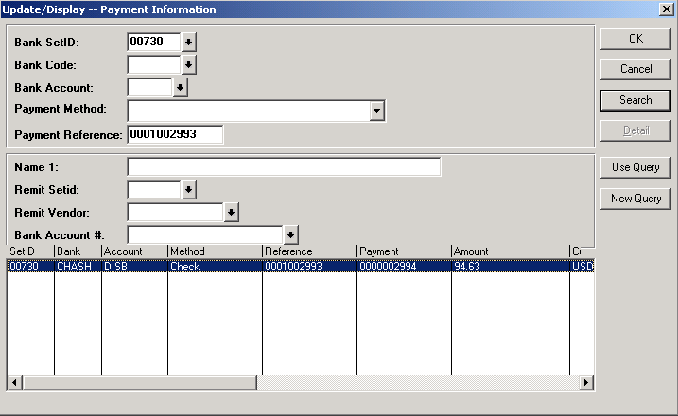

Payment Inquiry – Method 2

Another way to get to the Payment Information panel is by clicking on the Payment Information button on the Schedule Payment-Dept Use panel of the voucher. This button will only be active after a payment has been issued.

Schedule Payment-Dept Use panel
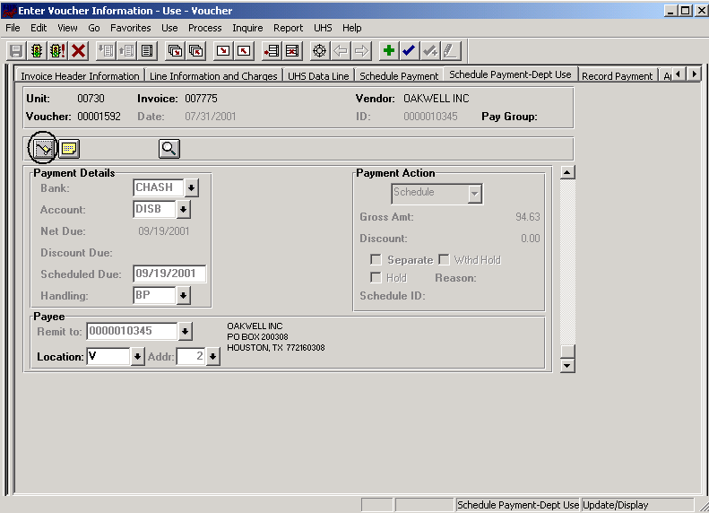

Payment Inquiry – The Results

Payment Information panel
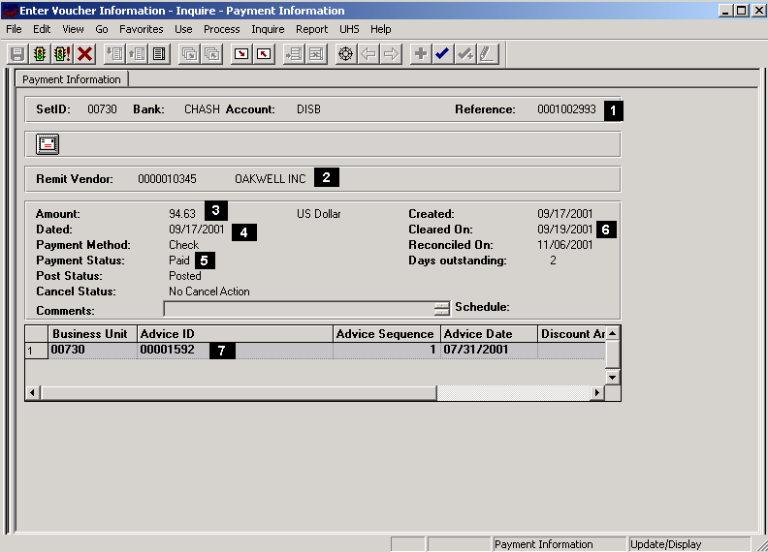

1. Payment (check) number

2. Vendor/payee

3. Payment amount

4. Payment date

5. Payment status (Paid, Void, or Stopped)

6. Date payment cleared the UH bank

7. Voucher number(s)

Budget Checking Errors: What They Mean and What to Do

1. When the voucher is complete, budget check by clicking the Budget Check icon 
on the Accounting Information panel.

2. Click OK when the following message appears:
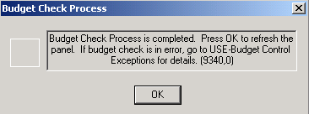

3. Take the appropriate action indicated by the budget checking status.

Budget Checking Status on the Accounting Information Panel | Action Required
Valid | None. Budget checking was successful. The cost center budget has been reduced by the amount of the voucher.
Not Checked | Verify each distribution line on the voucher contains an Account, Fund, DeptID, Program, Budget Period, and Project.
Error | Navigate as follows to view the error message: Use, Budget Control Exceptions.  See step 4 below.

4. If Budget Check status is “Error,” review the error message on the Budget Control Exceptions panel. Each voucher distribution line will have its own error message. Possible error messages include:

Error Messages on Budget Control Exceptions Panel  (Partial List) | Meaning of Error Message | Possible Actions | Contact for Questions or Help with Action
Org Budget Data Not Found  Project/Grant Data Not Found  Revenue Est Data Not Found | A budget was not created for the budget node (pool) of the cost center that corresponds to the PeopleSoft account on the voucher distribution line | 1. Change the cost center.  2. Submit a budget request to setup a budget.  3. Delete the distribution line with the error message. | For grants, email Nancy Ward at nward@uh.edu  For organization, project, or revenue estimate budgets, call the Budget Office at x30650.
Outside Proj/Grant Budget Date  Invalid Project/Grant Date | The date of the voucher is not within the project/grant budget period or start and end dates of the project/grant. | 1. Change the cost center.  2. Request a change to project/grant budget dates.  3. Delete the distribution line with the error message. | For grants, email Nancy Ward at nward@uh.edu  For projects, call the Budget Office at x30650.
Insufficient Org Budget  Insufficient Proj/Grant Budget | Insufficient funds exist in the cost center budget node that corresponds to the PeopleSoft account on the voucher distribution line. | 1. Change the cost center.  2. The college/division administrator may request to override budget checking if expenditure or budget transfers to correct the cost center are in process (on a case by case basis).  3. Delete the distribution line with the error message. | For grants, email Nancy Ward at nward@uh.edu  For organization or project budgets, call the Budget Office at x30650.
Not Budget Checked | This distribution line passed budget checking but one or more distribution lines on the same voucher did not. All distribution lines must pass budget checking in order for the voucher to be budget checked. | Review the error messages for the distribution lines that did not pass budget checking and take corrective action. | For grants, email Nancy Ward at nward@uh.edu  For organization, project, or revenue estimate budgets, call the Budget Office at x30650.

