- Review the travel profile information and make necessary updates.
The information in the travel profile will be used to book your travel. In this section, you can also select travel arrangers/assistants to help you with travel arrangements.

- Click on “Profile” and select “Profile Settings”.
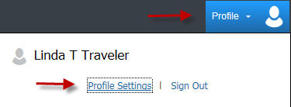
- Under the Profile Options, select “Personal Information”.
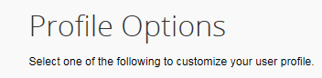

Traveler Name
Review your full name. Your legal name should be entered since the name will be used to book air ticket. If a change is needed and the fields are grayed out, contact Accounts Payable Travel (see contact information at the end).
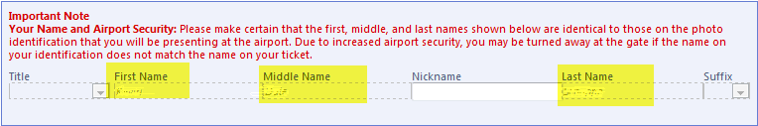
Employee ID
Review your Employee ID. This ID is critical for the Concur system since it will be tied to your Travel Requests, Expense Reports, Cash Advances, and Reimbursements, etc. If the ID needs to be changed, contact Accounts Payable Travel.
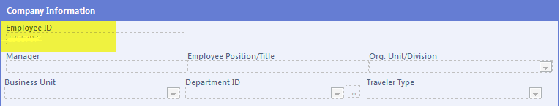
Contact Information
Enter your phone numbers.
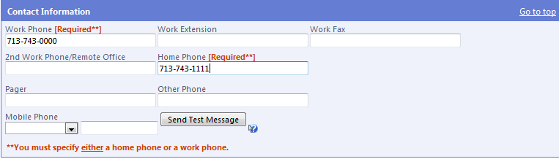
E-mail Address
Verify your e-mail address. If your e-mail address is not verified, click on “Verify” and follow the instruction to complete the verification.
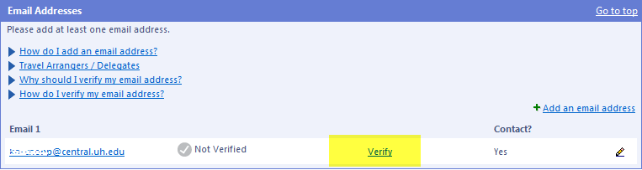

TSA Secure Flight Information
Complete the required information in the TSA Secure Flight section. The information is required for flight reservation.
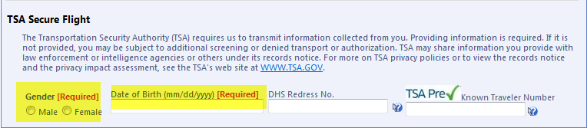
Travel Arrangers/Assistants
If you want someone else (UH employee) to arrange or assist with travel arrangements, add the person in the “Assistants and Travel Arrangers” section.
Click on “Add an Assistant”
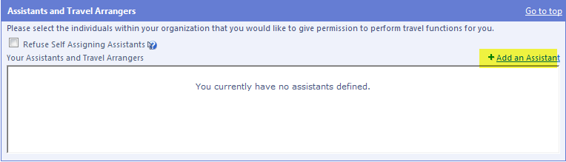

Type the person’s last name in the field highlighted below. Concur will give you a list of people under their last name. Select one.
Select one of the boxes and place a checkmark. Then click on “Save”.
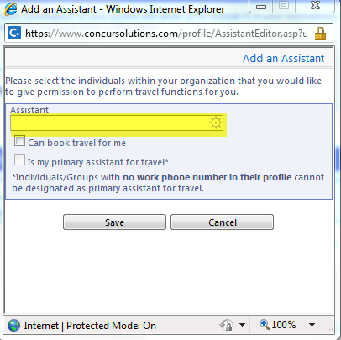
Note: This is not a delegation for someone to create a Travel Request or Expense Report on your behalf. You must notify AP Travel if you need a delegate to create a Travel Request or Expense Report.
Credit Card(s)
In the Credit Cards section, click on “Add a Credit Card” and enter the credit card information (optional). After you enter a credit card, most of the credit card number will be hidden. If you enter a credit card here, you don’t have to enter it each time you book travel through Concur. You can select from a list of available credit cards or enter another one.


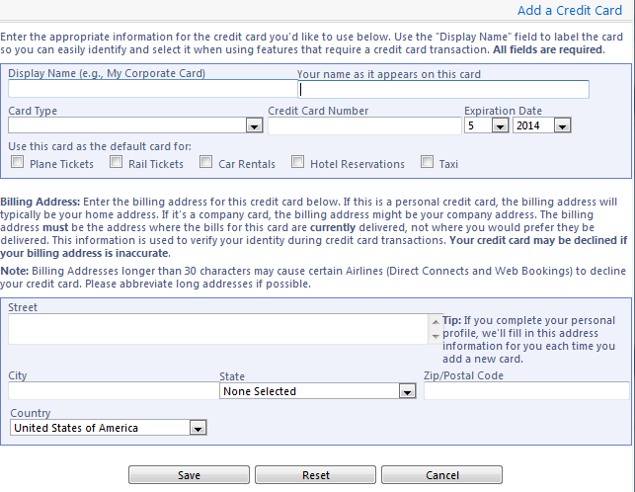
After entering the information, click on the “Save” button.
Note: You may complete your travel preferences in this section. The information will be provided to CTP (travel agency) when you are booking your travel.

- Sign up to receive e-receipts (optional).
Many national vendors (e.g., hotel, rental car, etc.) participate in the Concur e-receipt program. When you use your UH Individual Travel Card or personal credit card registered in your personal profile, those vendors that participate in the e-receipt program can automatically send e-receipts to your queue in Concur. If you have an e-receipt, you don’t need a paper receipt.

On the Concur main page;
- Click on “Sign up here” for e-receipts.
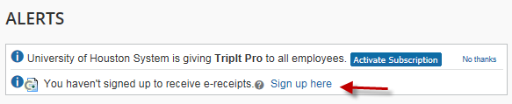
- Click on “E-Receipt Activation”
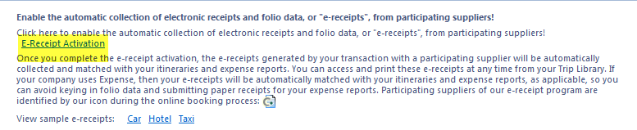
- Accept the agreement by clicking on “I Accept”.
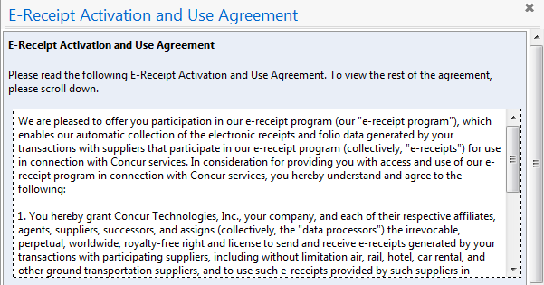
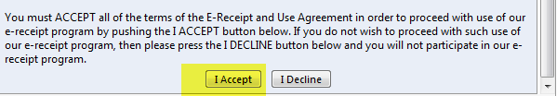
- You will get the confirmation indicating that you enabled e-receipts.


- Download the app for Mobile Registration (optional).
By downloading the Concur Mobil App, you can book travel, review your itinerary, capture the receipt photos and send them to your Concur access, or submit/approve Travel Requests and Expense Reports anytime, anywhere.

  - Click on the Profile and select “Profile setting”.
  - Under the Profile Options, select “Mobile Registration”.
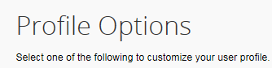
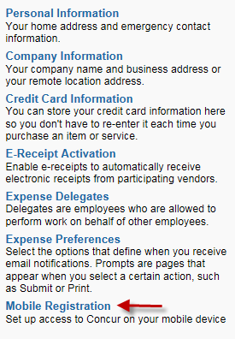
  - Download the app by selecting an appropriate icon. Or send a link to your device by entering your e-mail address or mobile phone number in the field provided. You will be required to create your mobile PIN.
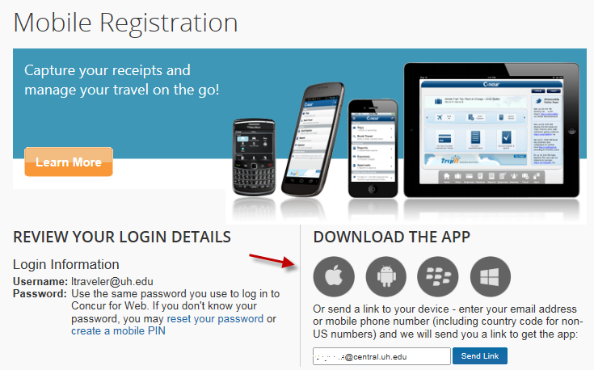
- Download the free ExpenseIt app to turn paper receipts into e-receipts (optional)
Once you download the Concur Mobile App and obtain your mobile PIN, ExpenseIt will be available for download in Google Play and IOS App Store. Travelers can take a picture of their receipts using IOS and Android mobile devise and ExpenseIt will automatically create the expense entries with itemizations in your Concur access.

- Use TripIt to create an electronic itinerary – even when you don’t book through Concur (optional)
TripIt “automagically” takes all your trip details and creates one truly helpful master itinerary that’s there when and where you need it – on your mobile device, sync'd with your calendar, and online at tripit.com.
  - Click on the TripIt Pro icon in Concur
  - Download the free app
  - TripLink will use your travel confirmation emails to automatically create an itinerary
  - Share trip information with colleagues, family and friends

UH Accounts Payable Travel Group – Contact Them If You Need Help Updating Your Profile
Sandra Silva, 713-743-5883, ssilva@uh.edu
Rachel Underwood, 713-743-8705, raunderwood@uh.edu
Hector Bonilla, 713-743-7521, hmbonilla@uh.edu

