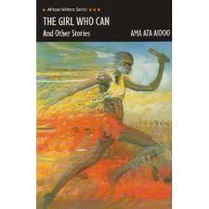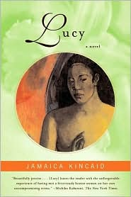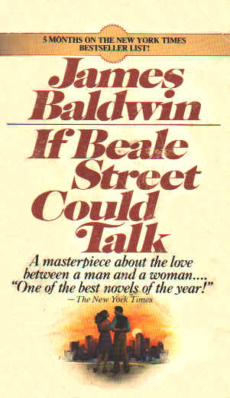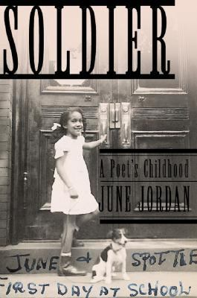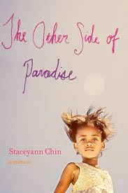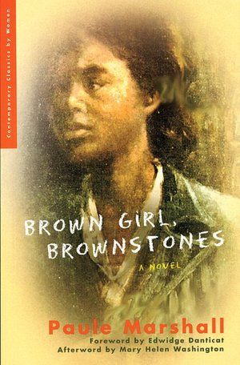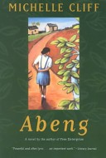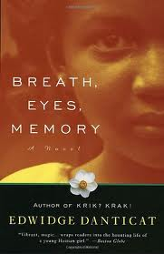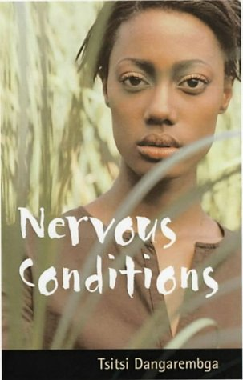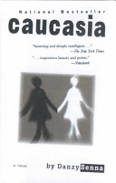

**Intersectionalities of Race, Class, Age, Disability & Gender**

WOST 3395-1 (26405)/ ANTH 3350-01 (26342)

**Tuesday/Thursday 1-2:30pm – Spring 2014**

Dr. Rachel Afi Quinn

**Brown Girls, Brown Stories: Black Female Protagonists in Novels & Films**

In this course we will analyze and respond to black female adolescent protagonists’ experiences of race, gender, and class and national identity. Focusing on narratives of the lives of adolescent girls and young women of African descent, we will explore themes such as transnational identity, migration, labor, agency, rebellion, disability, colonialism, blackness, colorism, racial ambiguity, gender ambiguity, queer identity, sexuality and sexual violence.

Undergraduates should come to this course with some exposure to issues of gender, race, and feminist theory. Students will develop close reading skills with which to analyze literature and film—from short stories and short films to novels and feature length films and documentaries—and will learn to produce critical writing about these types of texts. With an intersectional lens of analysis, they will identify and respond to tropes of blackness and femaleness that these authors and filmmakers both rely on and push back against in their portrayals of what it means to be young, black and female.