Adding an Image on a PowerPoint Slide
- To add an image on a PowerPoint slide, click on Insert

- Click on Picture.

- Browse to locate where you have saved your image and double click. For example, if I want the light house, I would put my cursor on the light house and click the lighthouse twice

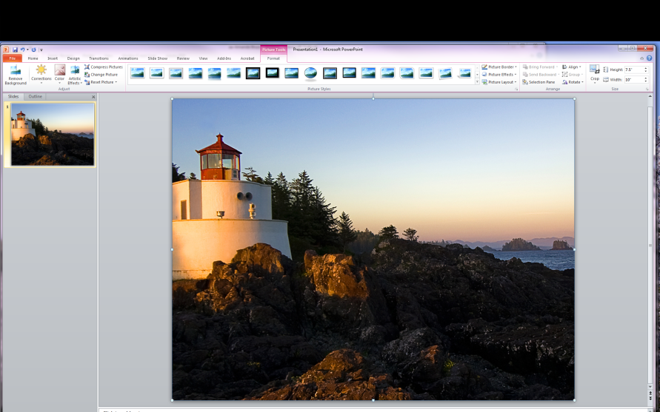
- Most of the time the image is not the correct size!

- You may have a very large or very small image on your slide. It can be resized to your preference. To resize an image, there are usually 8 tiny resize buttons—see below!

- If you click and hold on to a resize button in the right hand corners (red ovals above), the image will resize proportionally to any size you choose.

- However, if you select the buttons with the yellow ovals, your picture will be distorted.

- Don’t forget to save!

